Evolving Pattern of Global Trade in Goods and Services and World Market Integration: The Bangladesh Perspective

Selim Raihan

Contents

1. Introduction 4
2. Review of the Pattern of Growth and Structural Change in Trade in Goods and Services of Bangladesh 5
2.1. Import Regimes in Bangladesh 5
2.2. Export Regimes in Bangladesh 8
3. The Evolving Role of Trade Policy in Influencing External Trade of Bangladesh 11
4. Challenges and Opportunities in an Evolving Global Economy and Bangladesh’s Trade Strategies 13
4.1. Bangladesh’s Comparative Advantages 13
4.2. Emphasis on Export diversification: Myths and Realities 17
4.3. Bangladesh’s Emphasis on Sub-Regional Cooperation for Regional Integration in South Asia 19
4.4. Bangladesh Should Also Try for Larger Integration with East and Southeast Asia 20
4.5. Graduation from the LDC status and Challenges 26
4.6. Structural Transformation in China and its Implications 28
4.7. Dealing with Non-Tariff barriers (NTBs) 30
4.8. Bangladesh’s Future Growth Trajectories and Trade 31
4.9. Bangladesh and Fourth Industrial Revolution 32
4.10. Digitization of Global trade: Opportunities and Challenges for Bangladesh 33
5. Prospect of Future Trade Liberalization and Continuing Harmonization of Standards and Regulations to Reduce Barriers to Trade in Bangladesh 34
6. Integration with the Global Value Chain: Opportunities and Challenges for Bangladesh 37
6.1. Potential Sectors for Integration with GVC 38
6.1.1. The Agro-processing Sector 38
6.1.2. Leather and Leather Goods 42
6.1.3. Pharmaceuticals 47
6.1.4. Electronics 49
6.1.5. Jute and Jute Diversified Products 50
6.1.6. ICT 51
6.2. Supply-side Factors Constraining Effective Participation in the GVC 55
6.2.1. Lack of investment funds and high interest rate 55
6.2.2. Weak physical infrastructure 56
6.2.3. Ports and transport costs 56
6.2.4. Shortage of skilled workers 56
6.2.5. Technological bottlenecks 57
6.2.6. Lack of entrepreneurship and management skills 57
6.2.7. Information 58
6.2.8. Invisible costs of doing business 58
7. Conclusion 58
References 61
Annex 1: The Description of the GTAP Model 64
Annex 2: The Description of the Recursive Dynamic CGE Model 66

List of Tables

Table 1: Average Custom-duties and Para-tariffs in Bangladesh 12
Table 2: Percentage change in real GDP 23
Table 3: Percent change in export to RCEP region (Scenarios 1: RCEP FTA) 24
Table 4: Percent change in export to RCEP region (Scenarios 2: Extended RCEP FTA) 24
Table 5: Scenario 1: Impact on Bangladesh’s export (% change from the bau scenario) 32
Table 6: Scenario 2: Impact on Bangladesh’s export (% change from the bau scenario) 32

List of Figures

Figure 1: Trend in total imports of goods and services of Bangladesh (million US$) 5
Figure 2: Trend in the import-GDP ratio of Bangladesh 6
Figure 3: Evolving composition of import of Bangladesh 7
Figure 4: Trend in the total exports of goods and services of Bangladesh (million US$) 8
Figure 5: Trend in the export-GDP ratio of Bangladesh 8
Figure 6: Evolving composition of export of Bangladesh 9
Figure 7: Share of RMG in total exports of Bangladesh 10
Figure 8: Regional market share of Bangladesh’s export in 2015-16 11
Figure 9: Bangladesh’s imports and exports of services 11
Figure 10: Bangladesh's export capacity 14
Figure 11: Dynamics of Bangladesh's RCA 14
Figure 12: Concentration of Bangladesh's RCA 15
Figure 13: Magnitude of RCA in the readymade garments 16
Figure 14: Bangladesh’s economic progress in a comparative perspective 27
Figure 15: Food, beverages and tobacco (% share in GDP) 38
Figure 16: Food, beverages and tobacco (% of value added in manufacturing) 38
Figure 17: Food, beverages and tobacco (% share in total employment) 39
Figure 18: Food, beverages and tobacco (exports in million US$) 39
Figure 19: Food, beverages and tobacco (composition of exports) 40
Figure 20: Food products (FDI in million US$) 41
Figure 21: Leather and leather goods (% share in GDP) 43
Figure 22: Leather and leather goods (% of value added in manufacturing) 43
Figure 23: Leather and leather goods (% share in total employment) 44
Figure 24: Leather and leather goods (exports in million US$) 45
Figure 25: Leather and leather goods (composition of exports) 45
Figure 26: Leather and leather goods (FDI in million US$) 46
Figure 27: Export of Pharmaceuticals 47
Figure 28: Export of Electronics 50
Figure 29: Export of Jute and Jute Goods 51
Figure 30: ICT sector (exports in million US$) 53
Figure 31: ICT sector (FDI in million US$) 54

1. Introduction

Bangladesh economy’s impressive growth performance over the past two and half decades has raised hopes about the country’s graduation from the least developed country (LDC) status and its transition towards an upper middle income country in the near future. In 1990, in the global ranking of top gross domestic product (GDP) of countries (in PPP, constant 2011 US$), Bangladesh’s position was 50th. Impressively, by 2015, Bangladesh could improve its position in this ranking to 31st. According to the PWC projection, Bangladesh should become the 28th largest economy by 2030 and 23rd largest economy by 2050.

In the 7th Five Year Plan of Bangladesh, the aim is to achieve 8% growth rate in GDP by 2020. Also, government’s other vision documents project for a 9-10% growth rate in GDP by 2030. Furthermore, the Sustainable Development Goals (SDGs) put forward a number of stiff economic, social and environmental goals and targets to be achieved by 2030.

During the past two and half decades, the major features which outline the growth and development processes in Bangladesh include both internal and external factors and their interactions. The major internal factors include an overall stable macroeconomy, large expansion of the private sector, robust growth in exports driven by the performance of the readymade garment exports, robust growth in remittances, resilient growth in the agricultural sector, a reasonably stable political situation (albeit sporadic political conflicts and clashes), some expansion of social protection programs and wide coverage of the economic and social activities of non-governmental organizations (NGOs). The major external factors include favorable market access in major export destinations, reasonably stable economic condition in Bangladesh’s major trading partner countries, Bangladesh’s stable political relations with neighboring countries leading to some degree of regional cooperation, and Bangladesh’s ‘weak’ financial linkages with the global economy which cushioned Bangladesh from the Global Financial Crisis.

The growth and development processes in Bangladesh over the past two and half decades contributed to some important positive economic and social as well as some structural changes in the economy. Now the fundamental question is whether Bangladesh can achieve the aforementioned statuses with the business as usual growth and development processes. Furthermore, what does it mean for Bangladesh to climb up in the GDP ranking ladder as far as meeting those stiff economic, social and environmental targets are concerned? These concerns are reinforced with the fact that Bangladesh is now facing persistent development challenges such as lack of economic and export diversification, poor physical infrastructure, poor working conditions, low productivity of labor, shortage of skilled workers, a high degree of informality, technological bottlenecks, low tax-GDP ratio, sluggish private investment and very high invisible costs of doing business. Furthermore, the emergence of ‘new-protectionism’, fueled by the BREXIT and recent presidential election in the USA, has posed worrying uncertainly and associated challenges in the global trade regime, which is not conducive for countries like Bangladesh.

Theoretically, trade liberalization results in productivity gains through increased competition, efficiency, innovation and acquisition of new technology. In particular, the changing relative prices induced by trade liberalization cause a re-allocation of resources from less efficient to more efficient uses. Trade liberalization is also thought to expand the set of economic opportunities by enlarging the market size and increasing knowledge spillover effects. Empirical research on international trade also shows that, in general, larger trade-orientation and freer trade, with supporting policies and institutions, can lead to higher welfare for a country than otherwise.

Against this backdrop this paper analyzes the evolving pattern of global trade in goods and services and world market integration from Bangladesh’s perspective. The overview of the paper is as follows: Section II provides a review of the pattern of growth and structural change in trade in goods and services of Bangladesh; Section III analyzes the evolving role of trade policy in influencing external trade of Bangladesh; Section IV explores emerging challenges and opportunities in an evolving global economy and Bangladesh’s trade strategies; Section V explores the prospect of future trade liberalization and continuing harmonization of standards and regulations to reduce barriers to trade in Bangladesh; Section VI analyzes opportunities and challenges for Bangladesh for integration with the Global Value Chain; and finally Section VII concludes.

2. Review of the Pattern of Growth and Structural Change in Trade in Goods and Services of Bangladesh

2.1. Import Regimes in Bangladesh

The liberal import policies during 1990s and onwards led to large growth in imports into Bangladesh as shown in Figure 1. In 1972, total imports of good and services was only US$ 864 million, which rose to US$ 47,172 million in 2016.

Figure 1: Trend in total imports of goods and services of Bangladesh (million US$)
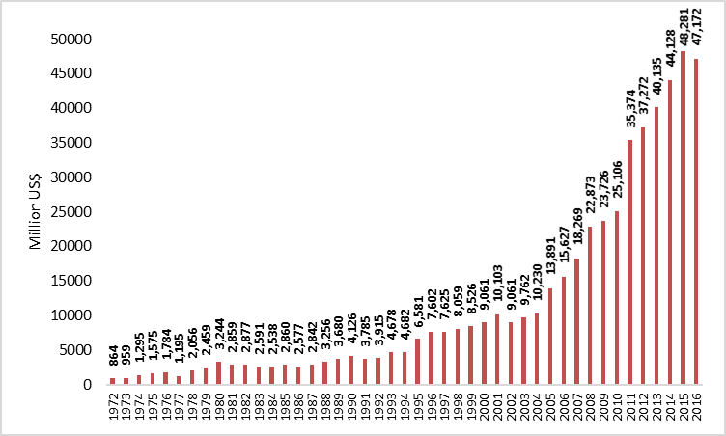
Source: World Development Indicator, accessed on 15 October 2017

The surge in imports also resulted in rising import penetration ratio, defined as the share of total imports in GDP. Figure 2 shows that the average import penetration ratio was only around 12 percent during the early 1970s, and the average increased to more than 25 percent in recent years.

Figure 2: Trend in the import-GDP ratio of Bangladesh
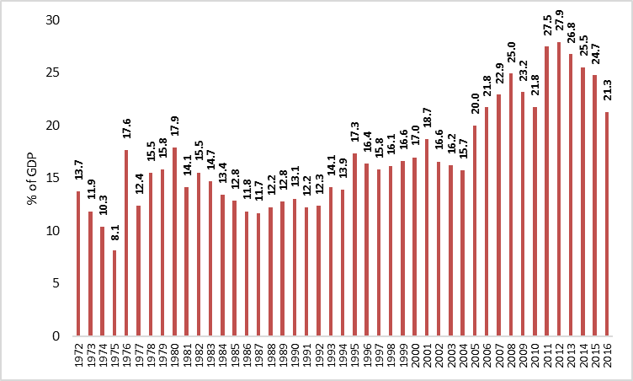
Source: World Development Indicator, accessed on 15 October 20170

Figure 3 suggests that the composition of imports in Bangladesh changed from the heavy dominance of food imports in the early 1970s to industrial raw materials and machinery during the recent decades.

Figure 3: Evolving composition of import of Bangladesh

1972 | 1980
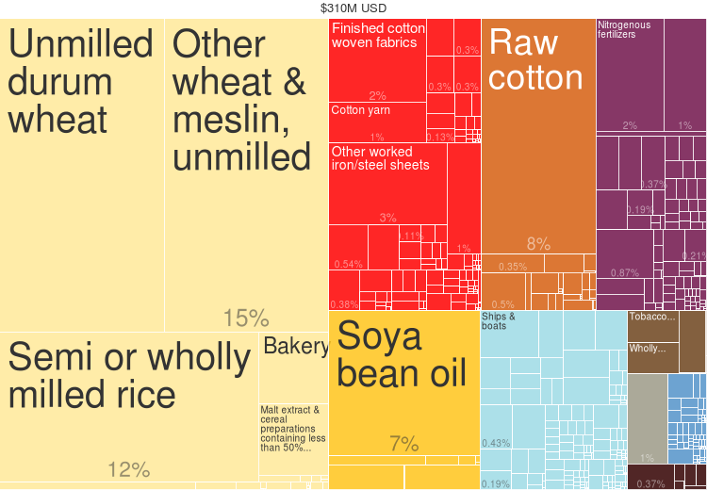 | 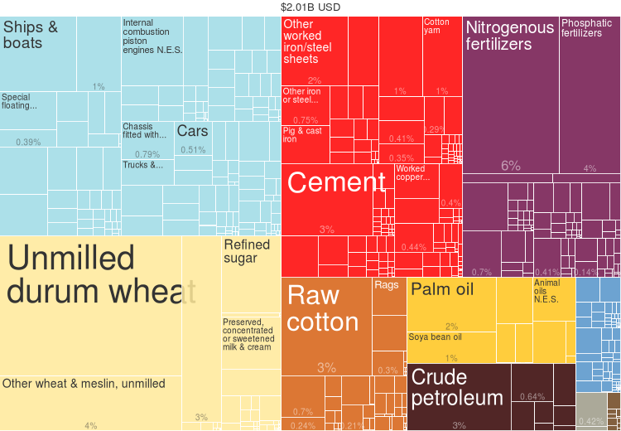
1990 | 2000
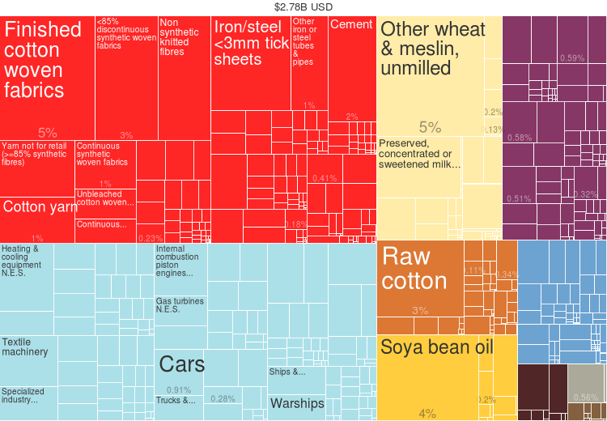 | 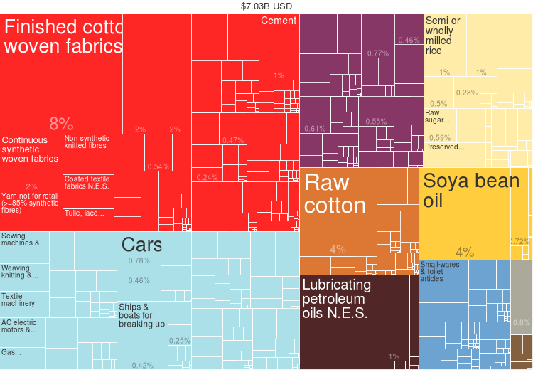
2010 | 2015
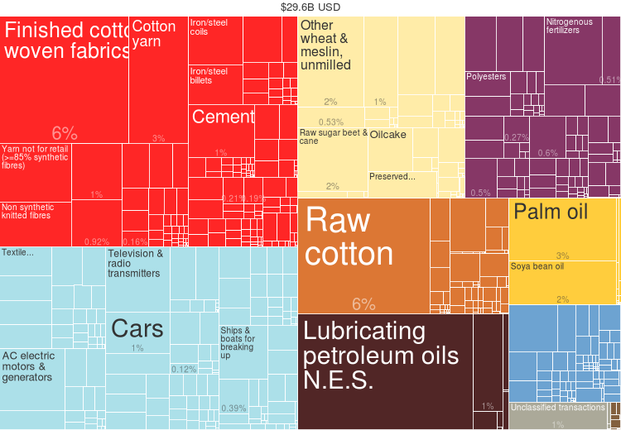 | 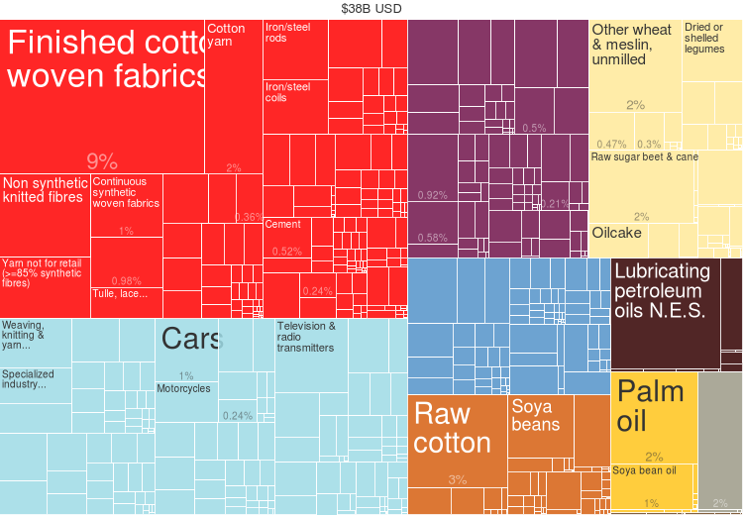
Source: http://atlas.cid.harvard.edu, accessed on 15 October 2017

2.2. Export Regimes in Bangladesh

Extensive export-promotion measures and favorable market access in the EU and USA helped Bangladesh’s exports rise remarkably during the past 40 years to so. Figure 4 shows from a figure of only US$ 357 million in 1972, Bangladesh’s exports of goods and services increased to US$ 36,865 million by 2016.

Figure 4: Trend in the total exports of goods and services of Bangladesh (million US$)
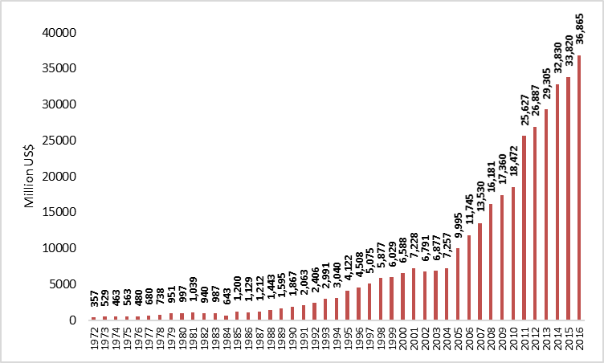
Source: World Development Indicator, accessed on 15 October 2017

Figure 5: Trend in the export-GDP ratio of Bangladesh
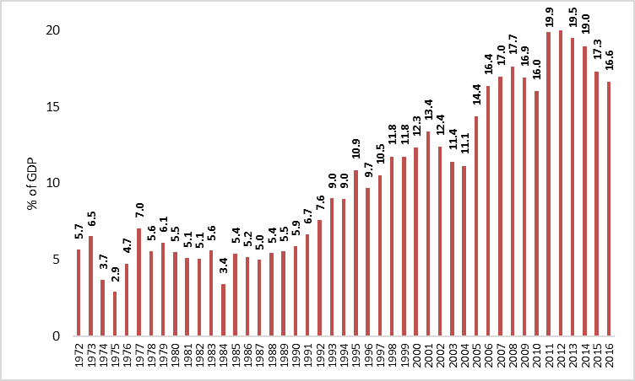
Source: World Development Indicator, accessed on 15 October 2017

With the considerable rise in export earnings at a rapid pace, the export-orientation ratio, i.e. the ratio of exports to GDP, also rose significantly from only 5.7 percent in 1972 to 16.6 percent in 2016 (Figure 5). However, the export growth is overwhelmingly dominated by the dynamism in the readymade garment sector alone. Figure 6 shows that the composition of exports in Bangladesh changed heavily in favour of the RMG sector since early 1990s.

Figure 6: Evolving composition of export of Bangladesh

1972 | 1980
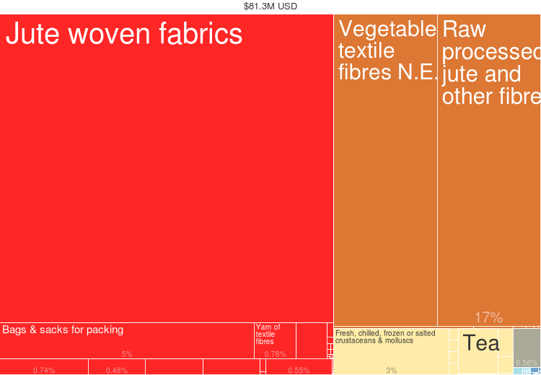 | 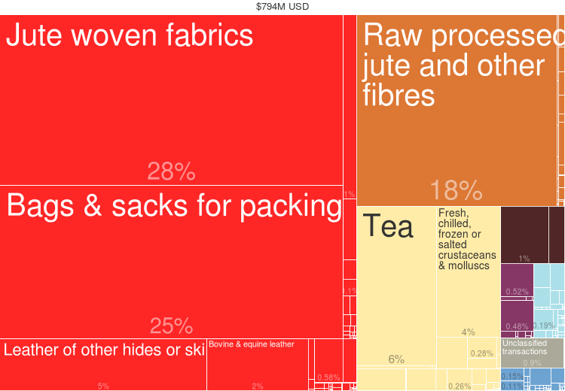
1990 | 2000
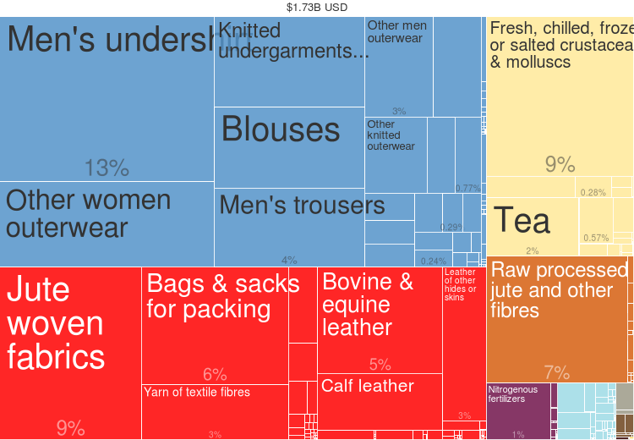 | 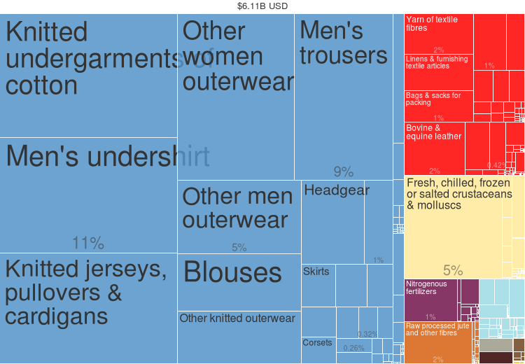
2010 | 2015
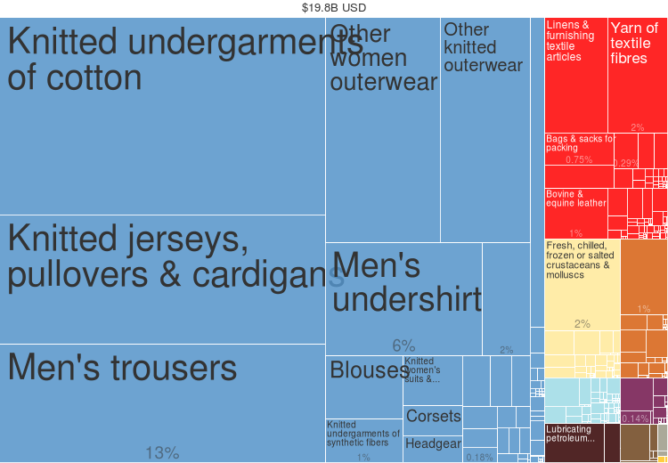 | 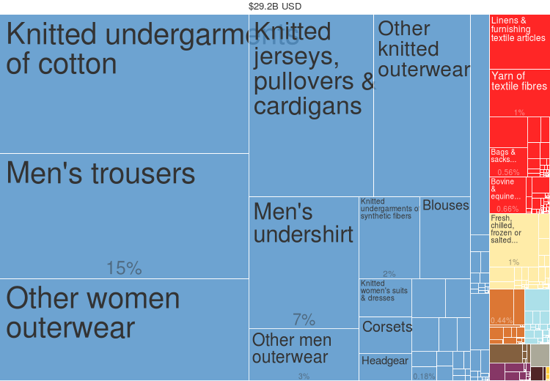
Source: http://atlas.cid.harvard.edu, accessed on 15 October 2017

Figure 7 shows that more than three-quarters of total export earnings, since late 1990s, had been due to woven and knit-RMG products, with the relative significance of all other sectors declining. The growth of Bangladesh’s RMG exports had largely been attributable to international trade regime in textiles and clothing, which, until 2004, was governed by the Multi fibre Arrangement (MFA) quotas. The quota system restricted competition in the global market by providing reserved markets for a number of developing countries including Bangladesh, where textiles and clothing items have not been traditional exports. The Duty-free access for Bangladesh’s RMG products in the EU has also greatly supported the growth of the sector. It then follows from the above that despite the impressive growth record, the export base and the export markets have remained rather narrow for Bangladesh, which is a matter of great concern. Undiversified exports both in terms of product range and markets are likely to be much more vulnerable to various shocks than well-diversified exports. Despite the policy reforms and various incentives offered, it seems that Bangladesh has failed to develop a diversified export structure.

Figure 7: Share of RMG in total exports of Bangladesh
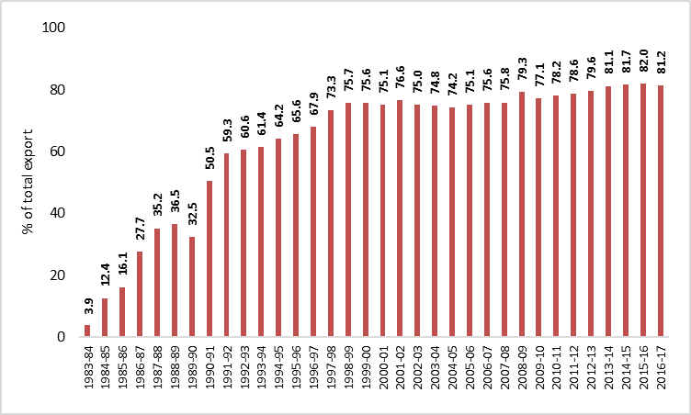
Source: BGMEA website, accessed on 15 October 2017

It also important to note that, export markets for Bangladesh have been highly concentrated with North America and the EU being the major destinations. In 2015-16, around 55 percent of the country’s total exports went to the EU, while another 22 percent was destined to the North America (Figure 8).

Figure 8: Regional market share of Bangladesh’s export in 2015-16
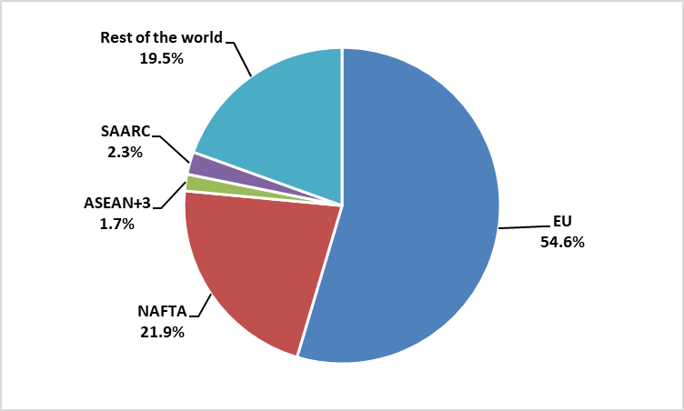
Source: Bangladesh Bank (2016)

Bangladesh’s imports services also increased considerably since mid-2000s (Figure 9). Also, in recent years the exports of services increased. However, the trade gap in services during the recent years.

Figure 9: Bangladesh’s imports and exports of services
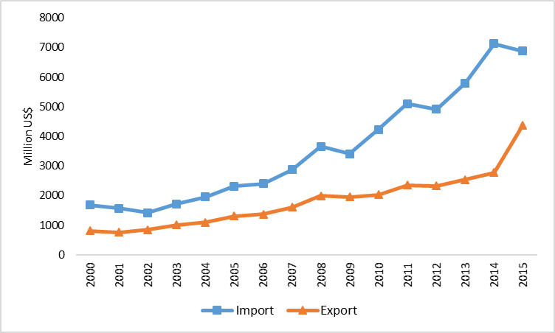
Source: UNCOMTRADE, accessed on 15 October 2017

3. The Evolving Role of Trade Policy in Influencing External Trade of Bangladesh

Trade policy during 1972 and 1980 consisted significant import controls. Under the Import Policy Orders (IPOs), items were specified whether their importation were allowed, prohibited or required special authorization. With the exception of a few cases, licenses were required for all other imports. The import-licensing system was subject to criticism for not being sufficiently flexible to ensure its smooth functioning under changing circumstances. Moreover, it was characterized by complexity, deficiency in administration, cumbersome foreign exchange budgeting procedures, poor inter-agency coordination, rigid allocation of licenses and time-consuming procedures (Bhuyan and Rashid, 1993).

Since early 1980s, import liberalization had started to take place. The import-licensing system was abolished and imports were permitted against letters of credit (L/C). The long Positive List in the IPOs of importable was replaced by two lists, namely the Negative List (for banned items) and the Restricted List (for items importable on fulfillment of certain prescribed conditions) and imports of any items outside the lists were allowed. Since 1990, the Negative and Restricted Lists of importable had been consolidated into one list, namely the ‘Consolidated List’ (Raihan, 2007). The range of products subject to quantitative restrictions (QRs) had been curtailed substantially during 1980s, 1990s and 2000s. Whereas during mid-1980s, about 40 percent of all import lines at the HS 4-digit level was subject to trade-related QRs, these restrictions had drastically been reduced to less than 2 percent towards the end of 2000s (Raihan and Razzaque, 2007).

Beginning from the late 1980s the tariff regime had become increasingly liberalized. In 1991-92 the un-weighted average rate of tariff was around 70 percent (Raihan and Razzaque, 2007) and by 2013-2014 it fell down to 13.2 percent (Sattar, 2014). Much of this reduced protection was achieved through the reduction in the maximum rate. In 1991-92 the maximum tariff rate was 350 percent, which came down to only 25 percent in 2004-2005 (Raihan and Razzaque, 2007), and it has been kept at this rate in recent years. The number of tariff bands was 24 in the 1980s, 18 in the early 1990s and only 4 in recent years (Raihan & Razzaque, 2007). Bangladesh has no tariff quotas, seasonal tariffs and variable import levies (WTO, 2000). All these measures have greatly simplified the tariff regime and helped streamline customs administration procedures. A drastic reduction in un-weighted tariff rates during the 1990s also resulted in the fall in import-weighted tariff rates. The import-weighted average tariff rate declined from 42.1 percent in 1990-91 to around 13 percent towards the end of 2000s (Raihan and Razzaque, 2007).

One important aspect of the tariff structure in Bangladesh relates to the use of import taxes which have protective effects (also known as para-tariffs) over and above the protection provided by customs duties (World Bank, 2004). These taxes have been the infrastructure development surcharge (IDSC), supplementary duties (SD), Regulatory duties. One of the major reasons behind this is because of the fact that though the VAT was instituted in the early 1990s as a revenue replacing tax, the VAT was not successful in early years as the tax base for the VAT was too low. Therefore, it appears that, despite the lowering of customs duties, the presence of para-tariffs did not significantly lower the total protection rate during the 2000s and in recent years (Table 1).

Table 1: Average Custom-duties and Para-tariffs in Bangladesh
Year | Customs Duties | Para-Tariffs | Total protection rate
1991-92 | 70.6 | 3.0 | 73.6
2001-02 | 21.1 | 7.1 | 28.2
2011-12 | 13.6 | 12.9 | 26.5
2013-14 | 13.2 | 14.1 | 27.3
Source: World Bank (2004) and Sattar (2014)

An important element of trade policy reform has been the use of a set of generous support and promotional measures for exports. While the import liberalization was meant to correct the domestic incentive structure in the form of reduced protection for import-substituting sectors, export promotion schemes were undertaken to provide the exporters with an environment where the previous bias against export-oriented investment could be reduced significantly. Important export incentive schemes available in Bangladesh include, amongst others, export performance benefit (XPB), bonded warehouse, duty drawback, duty free import of machinery, back to back letter of credits (L/Cs), cash subsidy, interest rate subsidy, tax holiday, income tax rebate, retention of earnings in foreign currency, export credit guarantee scheme, special facilities for export processing zones (EPZs) (Raihan and Razzaque, 2007). Apart from the incentive schemes, the Government has also provided generous institutional support to the exporters. A few sectors, especially the ready-made garments (RMG), have been major beneficiaries of these reforms.

4. Challenges and Opportunities in an Evolving Global Economy and Bangladesh’s Trade Strategies

4.1. Bangladesh’s Comparative Advantages

The analysis of comparative advantage is important from the policy perspective. Trade policies of a country should be tuned to promote export items where the country has comparative advantage. The Revealed Comparative Advantage (RCA) analysis, suggested by Bela Balassa in 1965, is an ex post analysis of comparative advantage and has been used in many studies. RCA index is used to calculate the relative advantage, disadvantage and trade potential of a certain product in a country.

The RCA index is measured as the ratio of a product’s share in the country’s total export relative to its share in the world’s total export. The formula for the RCA is equal to (Xij/Xit)/(Xwj/Xwt) where, Xij and Xwj are country i’s export and world export of product j respectively, while Xit and Xwt are country i’s total export and world total export respectively. If RCA is greater than unity, the country is said to have comparative advantage in that product; and if RCA is less than unity, the country has comparative disadvantage in that product. The RCA index is popular because of its simplicity, availability of data and for cross-country comparisons. The index is consistent with country’s factor endowment and productivity.

Here, we are interested to know in which products Bangladesh has comparative advantage, and the dynamic changes of its comparative advantage. We have calculated RCA at 6-digit level of the harmonized system (HS) of classification for the periods between 2001 and 2013. RCA indices for Bangladesh are calculated using the data of export volumes of Bangladesh and the world from the Trade Map database.

Figure 10: Bangladesh's export capacity
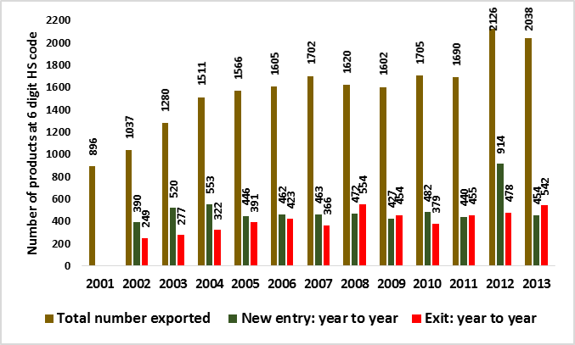
Data source: ITC Trade Map database

Before going into the RCA analysis, let’s first explore how many products Bangladesh exports. At the 6-digit HS code level, there are approximately 5300 products. Figure 10 shows that in 2001, Bangladesh exported 896 products, which, by 2013, increased to a number of 2038. In 2012, Bangladesh exported 2126 products which was the highest among the years under consideration. This suggests that, not only in terms of volume but also in terms of number of products, Bangladesh’s export capacity increased by more than double during 2001 and 2013. On a year-to-year basis, some new products were added to the export basket and some were ceased to be exported. However, there were 375 common products which Bangladesh exported all the years under consideration.

Figure 11: Dynamics of Bangladesh's RCA
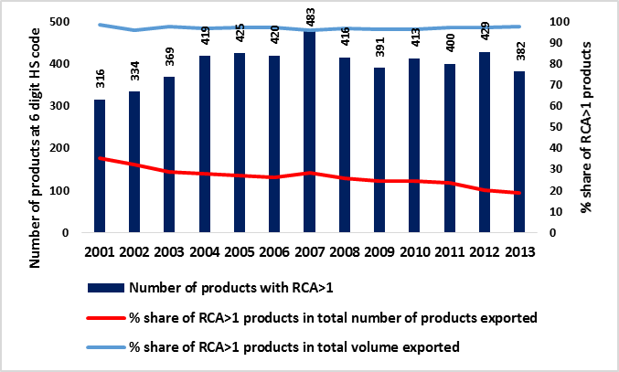
Data source: ITC Trade Map database

Figure 11 presents the numbers of products at 6-digit HS code where Bangladesh had comparative advantage during 2001 and 2013. In 2001, the number of products with RCA>1 was 316, which, with some year-to-year fluctuations, increased to 382 by 2013. The highest number of RCA>1 was observed in 2007 consisting 483 products. Figure 11 also suggests that the percentage share of RCA>1 products in total number of products declined over time: from 35 percent in 2001 to 19 percent in 2013. However, as a percentage of total exports, throughout those years, Bangladesh enjoyed comparative advantage in more than 97 percent of its total export. Furthermore, over those years, comparative advantage had been consistent for 130 products at the 6-digit level among which 115 products were from readymade garment industries. All these suggest that although Bangladesh was able to expand its export basket during 2001 and 2013, the number of products it had comparative advantage didn’t increase proportionately, which indicates escalated concentration of RCA in certain products.

Figure 12: Concentration of Bangladesh's RCA
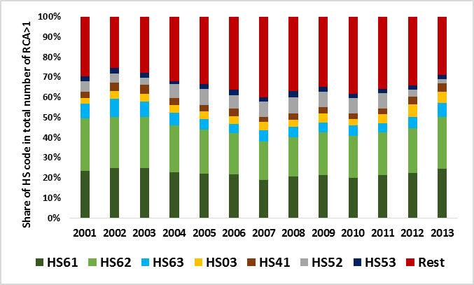
Data source: ITC Trade Map database

The escalated concentration of RCA in certain products during the period under consideration is manifested by the fact that Bangladesh’s RCAs had been concentrated around the products in the HS codes 03 (fish and shrimp), 41 (raw hides and skins and leather), 52 (cotton yarn), 53 (raw jute), 61 (knitted readymade garments), 62 (woven readymade garments) and 63 (home textile and jute hessian bags). However, a close look at Figure 12 suggests that Bangladesh’s comparative advantage has been highly concentrated around the readymade garments sector. In 2013, number of products with RCA>1 under the HS codes 61, 62 and 63 accounted for 57 percent of the total number of products with RCA>1. In 2007, such number was 43 percent. It should also be mentioned here that, readymade garments account for more than 80 percent of total export earnings of Bangladesh in recent years.

Figure 13: Magnitude of RCA in the readymade garments
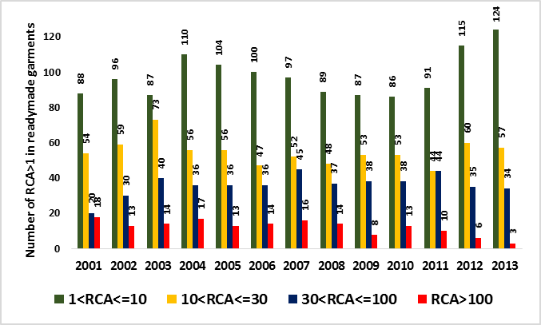
Data source: ITC Trade Map database

Although RCA had been concentrated around the readymade garments sector, the average value of RCA declined. The maximum value of RCA in the readymade garments was 495 in 2001, which declined to 184 by 2013. Bangladesh had also been losing the very high comparative advantage it had in garments exports. Figure 13 suggests that, in 2001, Bangladesh enjoyed very high RCA (RCA>100) in 18 garments products, which declined to only 3 in 2013. In contrast, the number of products with RCA less than or equal to 30 increased over time: from 142 in 2001 to 181 in 2013.

Similar analysis, with respect to the leather and leather goods, suggests that there had not been much variations in the number of products having RCA in this sector. And, as in readymade garments sector, Bangladesh had been losing very high comparative advantage it had in this sector. In contrast, Bangladesh had been enjoying consistently very high comparative advantage in jute and jute products, where, in all of 6 products, RCA ranged between 53 and 1068.

The aforementioned analysis shows that during the period under consideration, Bangladesh’s comparative advantage had been concentrated around low-skilled labor intensive readymade garments exports. However, in recent years, compared to early 2000s, there had been some products where Bangladesh gained comparative advantage. These include edible fruits, animal and vegetable fats and oil, preparations of cereals, flour, starch or milk and pastry cooks’ products, preparation of vegetable, fruits, nuts, residues from food industries, rubber and rubber products, copper and copper products, and furniture. However, Bangladesh lost comparative advantage in fertilizers, printing industry’s products, articles of iron and steel, and miscellaneous manufactured articles.

Finally, we are interested to know how tariff rates, both at home and partner country, affect Bangladesh’s revealed comparative advantage at the sectoral level. For this exercise, we have constructed a panel data at 6-digit HS code level for the period between 2001 and 2013. The dependent variable is the RCA which is a binary variable, where it takes a value of 1 if RCA is greater than unity and zero otherwise. The first explanatory variable is the domestic tariff rate at 6-digit HS code level, which is the effectively applied tariff rate and its data is taken from the WITS database. The second explanatory variable is the partner country’s tariff rate, which is calculated as the weighted average of simple tariff rates imposed by top export destination partners of Bangladesh namely USA, EU, Canada and India. Data of partner countries’ tariff rates are taken from the WITS and OECD-WTO database. The fixed effect panel logit regression results suggest that domestic tariff rate is negatively associated with RCA and the coefficient is statistically significant. This suggests that a cut in domestic tariff raises the likelihood of RCA greater than unity among the sectors. In contrast, the coefficient of the partner countries’ weighted tariff rate is not statistically significant. The reason behind the non-association between the RCA and partner countries’ tariff rate could be because of the fact that the large part of Bangladesh’s export to its major partner countries are under different preferences schemes; for example, Bangladesh’s exports enjoy duty free and quota free market access in the EU market.

4.2. Emphasis on Export diversification: Myths and Realities

Export diversification has been an important policy agenda in Bangladesh. It is commonly viewed that export diversification is a necessary condition for a sustained and long-term growth of the economy and job creation. The current discourse of ‘global value chain’ also highlights the importance of diversification of export portfolio for an effective integration with the global value chain. Among the developing countries, the problem of export concentration is more acute for most of the Least Developed Countries (LDCs). Many of the LDCs are still the exporters of primary products, mainly agricultural, which are not only susceptible to large volatility in the international market, but also provide limited opportunity for value addition. Few LDCs like, Bangladesh and Cambodia, have been able to move from agricultural exports to manufacturing exports, but still their export baskets remain highly concentrated around few low value-added manufacturing products. For many of these economies, export diversification is argued to be playing an important role in structural transformation of their economies from producing low value-added products to high value-added products.

One strong view related to the policy for diversification of exports is its heavy emphasis on extensive tariff liberalization with the aim of reduction in anti-export bias. The policy conclusion that emerges from this stance is for low and uniform tariffs and a seamless export-import regime that facilitates least-cost transactions at the border. Tariff liberalization, under this view, is seen as a kind of ‘auto’ driver of export expansion and diversification of the export basket.

While the importance of tariff liberalization for export promotion and diversification can’t be undermined, tariff liberalization alone can’t by itself be sufficient to trigger ‘auto’ large supply response in terms of expanding export volumes and diversifying the export basket. A number of supply-side constraints can prevent local producers from expanding exports, and the lack of an enabling environment can strangle entrepreneurship and innovation. Studies have indicated that most of the LDCs and a large number of other developing countries face several supply-side constraints. High lead-time is an important challenge in many LDCs. Inefficiencies at ports and related internal road transportation further aggravate the problem. Amongst others, lack of investment fund and working capital, high interest rate, poor physical infrastructure, shortage of skilled workers, technological bottlenecks, lack of entrepreneurship and management skills, poor law and order situation, lack of information, invisible costs of doing business, etc. are major impediments to export prospects and export diversification. Therefore, the policy options and support measures for exports are much more difficult and involved than mere reduction of tariffs. It is also essential to keep in mind that comparative advantage doesn’t necessarily translate into competitive advantage. While many of the developing countries have comparative advantages in producing and exporting several agricultural and manufacturing products, given a domestic environment of high cost of doing business, such comparative advantages are seized to be realized. Therefore, while many of the LDCs are provided with significant market access opportunities in most of the developed countries’ markets through different trade agreements and generalized system of preferences (GSP), the single major reason for their inability to take advantage of such opportunities is their supply side constraints, which undermines their competitive ability to supply to the global markets.

It is important to note that in the discourse of policy reforms for export diversification, the political economy perspective is generally ignored and reform of institutions is largely overlooked. A favorable overall incentive structure through the management and distribution of ‘rent’ is important for the diversification of the export basket. Experiences from many developing countries show that the dominant export sector becomes the main beneficiary of different export incentives (both formal and informal) while for other sectors, such schemes appear to be less effective primarily due to various structural bottlenecks as mentioned before. In this process, the dominant export sector grabs the lion’s share of the ‘rent’ being generated through such incentives.

This situation also raises a critical question as to whether ‘rents’ are needed for the promotion of other sectors. Experiences from successful countries highlight the importance of providing effective incentives to other sectors and removing structural bottlenecks in order to generate some ‘rents’ in those sectors. However, it should be kept in mind that while generating such ‘rent’ there is a need for a well-designed and effective industrial policy wherein monetary (interest rate subsidies) and fiscal incentives (reduced taxes or tax holidays) for the emerging dynamic export sectors should be transparent and time-bound. In addition, industrial policy needs to address issues of education and skill development for facilitating higher capabilities for export diversification, attracting FDI and integrating with the global value chain.

Experiences from different countries, who have been successful in diversifying their export portfolios, also suggest that institutional reforms should be considered as a key to overall policy reforms targeting larger export response and export diversification. Improving the bureaucracy quality, ensuring property rights, managing corruption, ensuring contract viability through reduction of the risk of contract modification or cancellation are examples of such institutional reforms. Furthermore, reducing political uncertainties or establishing political stability and generating political capital for a diversified export basket are critically important.

4.3. Bangladesh’s Emphasis on Sub-Regional Cooperation for Regional Integration in South Asia

Though there is a strong demand for a deeper regional integration in South Asia, the progress has been rather slow. Actual implementation of agreements often does not match the declared ambitions, and in this context, lack of political will and leadership, institutional weaknesses and capacity and resource constraints have been argued to be the major impeding factors. The political rivalry between India and Pakistan has often constrained the SAARC to be a functional regional forum.

In order to take forward the regional integration process in South Asia a good and effective initiative is the Bangladesh, Bhutan, India, Nepal (BBIN) initiative, which is a sub-regional coordinative architecture of countries in South Asia. BBIN operates through Joint Working Groups (JWG) comprising official representation from each member state to formulate, implement and review quadrilateral agreements. Areas of cooperation include water resources management, connectivity of power grids, multi-modal transport, freight and trade infrastructure. Focused on the subcontinent's north east, it endeavored to cooperate on trade, investment, communication, tourism, energy and natural resources development. Its objectives have been expanded over years to incorporate substantial land and port connectivity.

The economic needs and drivers for a deeper integration in the BBIN sub-region are more prominent compared to these countries’ integration with the rest of South Asia. Especially, a deeper integration among the BBIN countries is very important to place BBIN as the gateway for further integration with China and Southeast Asian countries. The political economy drivers also seem to be more favorable. In the context of some structural factors, especially the political rivalry between India and Pakistan which has confined the progress of SAARC, and landlockedness of Nepal and Bhutan, the BBIN sub-regional initiative has seen a great interest from the political elites from these four countries. The extra-regional drivers for BBIN are also favorable as there are growing interests from international organizations like the Asian Development Bank (ADB) and the World Bank for improvement in connectivity and infrastructural development in this sub-region.

As far as intra-BBIN trade is concerned, there are substantial potentials for the rise in intra-regional trade. However, despite that India has already provided almost full duty-free-quota-free of its market access to exports from South Asian LDCs, Bangladesh, Nepal and Bhutan are facing escalated challenges to at least secure and then to increase their exports to the Indian market. These challenges are related to their limited export capacities, lack of diversification of their export baskets, and various non-tariff measures (NTMs) and procedural obstacles (POs) due to inadequate infrastructure and lack of support facilities both at home and in the Indian market. However, streamlining of NTMs and removal of associated POs are very important as such actions are likely to intensify further market integration in the BBIN sub-region through development of regional value chains. These will also encourage larger intra and extra regional investments in the BBIN sub-region which can be instrumental for growth integration among these countries. To make these happen there is a need for policy integration among the BBIN countries.

Domestic capacities of the exporters in Bangladesh, Bhutan and Nepal need to be improved to meet different international standard requirements. Unless and until these exporters develop their capacities, they will not be able to diversify exports and become competitive in the regional and international markets. A number of supply side factors at home can actually undermine the exporters’ competitiveness and constrain economic and export diversification. These factors are directly associated with the domestic production and investment environment. Most prominent of these factors are access to finance, weak physical infrastructure, inefficient ports and high transport costs, shortage of skilled workers, technological bottlenecks, lack of entrepreneurship and management skills, lack of information, and high costs of doing business.

There are some signs of heightened ‘new’ commitment among political elites of the BBIN countries. The recent speedy resolution of land boundary agreement (LBA) between Bangladesh and India, the positive reception of the India-Bangladesh Maritime Arbitration Award announced in July 2014, establishment of border haats along the border between India and Bangladesh, and the BBIN Motor Vehicle Agreement are signs of such ‘new’ political commitments.

However, the aforementioned ‘new’ commitments have not yet been translated much to resolve the issues related to NTMs and POs discussed above. There is a need to put renewed emphasis on this. There are some recent initiatives by the Government of India to solve the trade infrastructural problems at the border by setting up of Integrated Check Posts (ICPs) at major entry points on the land borders between Bangladesh and India. Two such ICPs have been put in place recently. Such ICPs need to be established at the borders between India and Nepal and India and Bhutan.

There is also a need for cooperation among different institutions in the BBIN countries to deal with NTMs and removal of POs. Cooperation is needed in a number of areas for harmonization of TBT and SPS measures, Mutual Recognition Agreements (MRAs) among respective organizations of these countries, and for introduction of increased automation of their customs clearance procedure.

4.4. Bangladesh Should Also Try for Larger Integration with East and Southeast Asia

The Bangladesh economy over the past two and half decades has been experiencing steady rise in economic growth rate which has been accompanied by country’s increasing trade-GDP ratio. The economy has become more and more trade-oriented. However, when it comes to integrating with its neighboring countries, there are still large untapped potentials for Bangladesh to gain from such integration. Effective regional integration, through enhanced scope for larger economies of scale and pathway for integration with global and regional value chains, can be a critical tool for Bangladesh to boost its economic growth process. Over the past three decades, regional integration agenda for Bangladesh has focused primarily on integrating with its South Asian neighboring countries. However, there are reasons to believe that Bangladesh can also gain significantly by integrating more with the East Asian countries (China, Japan and South Korea) and Southeast Asian countries (10 ASEAN countries. i.e. Brunei, Myanmar, Cambodia, Indonesia, Laos, Malaysia, the Philippines, Singapore, Thailand and Vietnam). Bangladesh government also wants to pursue the “Look East Policy”, and for this it is high time for Bangladesh to begin the quest for expanded trade and investment opportunities with these countries.

The Bangladesh economy is now at a cross-road. Further growth acceleration is essential to make a transition to a higher growth path in order to obtain the upper-middle income country status. The country needs to promote economic diversification, with a simultaneous diversification of the export basket, in order to boost its growth rate. When it comes to export diversification, in terms of both product and destination, integration with East and Southeast Asian countries is very important for Bangladesh. A major reason why integration with East and Southeast Asia will prove to be beneficial for Bangladesh is because East and Southeast Asia are essentially integrated with the Global Value Chains (GVCs) in a number of manufacturing products. Thus, such integration will pave the way for linking Bangladesh with wider GVCs and in diversifying its export basket. In addition, flows of Foreign Direct Investment (FDI) from these countries to Bangladesh will be beneficial for the economy. Among the Southeast Asian countries, Indonesia, Malaysia and Vietnam are large exporters of electronics, machinery and leather goods, primarily driven by the leading multinational companies in the world. Therefore, integration will lead to a number of multinational companies specialized in electronics, machinery and leather goods investing in Bangladesh, thus generating large spill-over benefits to the domestic economy.

However, Bangladesh’s level of integration with East and Southeast Asian countries is mixed. Bangladesh’s imports from East and Southeast Asia are significantly higher compared to exports to these regions. With a share of around 30 percent of total import, China in 2014 was the major source of import for Bangladesh. Singapore also had more than 8 percent share. Except Philippines, Thailand and Vietnam, all other countries accounted for more than 1 billion US$ import for Bangladesh. In contrast, Bangladesh’s exports to most of these countries were very low. The largest export was to Japan, which was close to 1 billion US$, followed by export to China by 760 million US$. The lowest export was to Philippines with an amount of only 21.4 million US$.

The current scenario clearly portrays that Bangladeshi exports to East and Southeast Asia are significantly low and immediate initiatives need to be adopted in order to raise export levels. Product diversification followed by market and need assessments in those countries will help Bangladesh accelerate the desired integration process. Bangladesh’s exports to these countries can be improved if Bangladesh engages in exports of non-traditional goods. Bangladesh should actively pursue the agenda of free trade agreements (FTAs) with these countries, either bilaterally or with the region as a whole (i.e. with ASEAN). In this context, it is important to mention that four Southeast Asian countries (Brunei Darussalam, Malaysia, Singapore and Vietnam) are part of the recently signed Trans-Pacific Partnership Agreement (TPP), which is a free trade agreement among nine countries. The other countries are the United States, Australia, Chile, New Zealand and Peru. Furthermore, all 10 ASEAN countries are part of the proposed Regional Comprehensive Economic Partnership (RCEP), which is a free trade agreement (FTA) between these ten countries and the six states with which ASEAN has existing FTAs (Australia, China, India, Japan, South Korea and New Zealand). With the emergence of these mega FTAs, where a large number of East and Southeast Asian countries are involved, there are risks of negative impacts on Bangladesh as Bangladesh is not part of these FTAs. Therefore, it is imperative for Bangladesh to proactively take up the FTA agenda with the East and Southeast Asian countries. At this moment, Bangladesh is part of BIMSTEC, where two of the Southeast Asian countries (Thailand and Myanmar) are members. However, the BIMSTEC FTA is yet to be implemented.

The most comprehensive regional integration initiative in Asia so far has been the Regional Comprehensive Economic Partnership (RCEP) which is a proposed FTA between the ten member states of the ASEAN and the six states with which ASEAN has existing FTAs (Australia, China, India, Japan, South Korea and New Zealand). RCEP is one of the proposed mega trading blocs of recent time. RCEP negotiations were formally launched in November 2012 and until now 18 rounds of negotiations have taken place. RCEP represents 45% of the world’s population, accounts for about 40% of the world’s GDP, and makes up around 30% of world trade. As the sole party from South Asia, RCEP has created significant opportunities for India to integrate with the advanced economies in Asia and the Pacific and to participate further with the global value chains. There are views that RCEP can help reduce the overlaps among Asian FTAs, rationalize rules of origin, and promote FDI flows and technology transfers by multinational corporations. However, being the non-members, RCEP has led to some important implications for the other South Asian countries. There are concerns that the RCEP will lead to the escalation of bars in standards and trade governance which might work as significant non-tariff barriers for the South Asian countries, especially for the LDCs, while exporting to the RCEP countries. Therefore, there is a need for strong efforts to improve the quality of trade infrastructures, capacities, and institutions in these countries.

There are also risks of other South Asian countries with respect to the potential loss of market access from the erosion of trade preferences. This paper uses the Global Trade Analysis Project (GTAP) global general equilibrium model to explore trade and economic impacts of scenarios related to regional integration in Asia and implications for the Bangladesh economy. The global CGE modelling framework of the GTAP (Hertel, 1997) is a useful tool for the ex-ante analysis of the economic and trade consequences of multilateral or bilateral trade agreements. The GTAP model is a comparative static model, based on neoclassical theories. The GTAP model is a linearized model, and it uses a common global database for CGE analysis. The model assumes perfect competition in all markets, constant returns to scale in all production and trade activities, and profit maximizing behavior by firms and utility maximizing behavior by households. The model is solved using the GEMPACK software (Harrison and Pearson, 1996). The Annex provides the details of the GTAP model.

This paper undertakes the following two scenarios in the GTAP model:

Scenario 1: The RCEP scenario - an FTA among RCEP countries
Scenario 2: The ‘extended RCEP’ scenario – the other South Asian countries also join the RCEP FTA

Table 2 presents the results from three simulations with respect to the potential impacts on the real GDPs of the countries under consideration. Under the RCEP FTA scenario, all the RCEP member countries would accrue gains, in terms of the rise in real GDP. The largest gain, in terms of the percent change in real, would for South Korea (2.89 percent) and smallest gain would be for New Zealand (0.19 percent). India’s real GDP would rise by 0.73 percent. In contrast, all the non-member countries would experience loss in real GDP from the RCEP FTA scenario. Among the South Asian countries, the largest loss would be incurred by Nepal (-3.13 percent) followed by Bangladesh (-0.39 percent), Sri Lanka (-0.38 percent), Pakistan (-0.24 percent), and Rest of South Asia (-0.1 percent). The major reason for the negative impacts on the other South Asian countries is that these countries would experience some important losses in preferences of their exports in the markets of the RCEP countries once the RCEP FTA comes into the picture.

However, under the Scenario 2 – the extended RCEP FTA – where all other South Asian countries can also join the RCEP FTA, the gains in terms of the rise in real GDP for all the original RCEP member countries become larger than those under Scenario 1. In addition, all the other South Asian countries would also experience the rise in real GDP. Among the other South Asian countries, the largest gain would be for Nepal (2.87 percent), followed by Bangladesh (1.8 percent), Sri Lanka (1.08 percent), Pakistan (0.37 percent), and Rest of South Asia (0.33 percent).

Table 2: Percentage change in real GDP
Regions | Scenarios 1:  RCEP FTA | Scenario 2: Extended RCEP FTA
RCEP countries and region
ASEAN | 0.70 | 0.73
Australia | 0.61 | 0.62
New Zealand | 0.19 | 0.21
China | 0.32 | 0.33
Japan | 0.48 | 0.49
South Korea | 2.89 | 2.91
India | 0.73 | 0.75
Non-member countries and regions
Bangladesh | -0.39 | 1.80
Nepal | -3.13 | 2.87
Pakistan | -0.24 | 0.37
Sri Lanka | -0.38 | 1.08
Rest of South Asia | -0.10 | 0.33
North America | -0.01 | -0.01
European Union 25 | -0.01 | -0.01
Rest of World | -0.02 | -0.03
Source: GTAP model simulation

Tables 3 and 4 present the simulations results for two aforementioned scenarios with respect to the change in sectoral and total exports from all countries to the RCEP region. Table 3 shows that under the RECP FTA scenario, the intra-regional trade among the RCEP countries would increase considerably. All RCEP member countries would experience rise in exports to the RCEP region by varying degrees. The largest percent rise would be observed for India (35.4 percent) followed by South Korea (24 percent). India would experience a very high increase in exports of agricultural and livestock and meat products. Also, India’s exports of processed food, textile and clothing, light manufacturing and heavy manufacturing would increase by large margins. In contrast, the excluded countries, especially the other South Asian countries, would experience significant decline in exports to the RCEP region. The largest fall in exports would be for Nepal (27.7 percent) followed by Bangladesh (13.4 percent). In the case of Nepal, the major negative impacts would be observed for exports of minerals, processed food and livestock and meat products. In the case of Bangladesh, the exports from sectors like processed food and textile and clothing would incur major losses. Similarly, for Pakistan and Sri Lanka, processed food, textile and clothing and light engineering would experience sizeable fall in exports to the RCEP region.

Table 3: Percent change in export to RCEP region (Scenarios 1: RCEP FTA)
 | Grains and Crops | Livestock and Meat Products | Mining and Extraction | Processed Food | Textiles and Clothing | Light Manufacturing | Heavy Manufacturing | Utilities and Construction | Transport and Communication | Other Services | Total
RCEP countries and region
ASEAN | 53.3 | 11.8 | -0.1 | 46.6 | -3.5 | 9.4 | 8.2 | 6.1 | 0.8 | -0.4 | 10.1
Australia | 0.3 | 162.7 | -1.0 | 95.0 | 6.0 | 1.3 | 4.3 | -1.0 | -3.1 | -3.4 | 9.2
New Zealand | 11.9 | 51.0 | 2.7 | 26.4 | -20.5 | -10.7 | 0.4 | 1.4 | 0.6 | 0.6 | 10.6
China | 125.1 | 14.5 | 31.9 | 36.0 | 30.8 | 27.5 | 15.2 | 5.1 | 3.9 | 4.0 | 20.4
Japan | 10.4 | -4.6 | 57.6 | 38.5 | 43.0 | 72.5 | 13.8 | -8.9 | -8.0 | -8.7 | 22.7
South Korea | 251.3 | 193.3 | 24.9 | 251.9 | 39.5 | 61.5 | 16.5 | 3.1 | 1.1 | -6.0 | 24.0
India | 247.4 | 98.8 | 6.2 | 16.0 | 23.0 | 34.3 | 21.8 | 13.2 | 6.0 | 5.6 | 35.4
Non-member countries and regions
Bangladesh | -13.1 | -11.8 | 7.8 | -49.4 | -23.7 | 1.5 | -3.5 | 11.6 | 6.8 | 7.6 | -13.4
Nepal | -15.3 | -27.7 | -88.8 | -63.9 | -5.0 | -17.9 | -11.1 | -19.4 | -8.5 | -1.4 | -27.7
Pakistan | -3.3 | -13.8 | 4.3 | -21.5 | -14.2 | -7.1 | -1.5 | 9.9 | 6.3 | 6.5 | -7.4
Sri Lanka | -15.0 | -6.6 | 6.9 | -19.8 | -22.4 | -15.4 | -3.6 | 11.8 | 7.6 | 7.6 | -7.8
Rest of South Asia | -17.1 | -21.0 | 1.0 | -7.7 | -23.8 | -12.3 | -11.1 | 6.8 | 5.4 | 5.9 | -3.8
North America | -13.0 | -31.3 | 1.3 | -13.7 | -18.8 | -8.0 | -0.2 | 11.0 | 5.8 | 6.7 | -2.0
European Union 25 | -11.7 | -28.4 | -0.9 | -13.0 | -20.3 | -9.4 | -2.2 | 7.9 | 4.1 | 4.7 | -2.4
Rest of World | -5.8 | -27.2 | 1.0 | -18.0 | -14.5 | -9.8 | -3.3 | 6.7 | 4.4 | 4.9 | -1.1
Source: GTAP model simulation

In contrast, under the extended RCEP FTA scenario, as presented in Table 4, the exports from other South Asian countries to the RCEP region would increase significantly. The largest increase in exports would be observed for Pakistan (45.7 percent) with sizeable increase in exports from agriculture and livestock, processed food and light engineering. Also, other South Asian countries would experience rise in exports in agriculture, textile and clothing, light and heavy manufacturing.

Table 4: Percent change in export to RCEP region (Scenarios 2: Extended RCEP FTA)
 | Grains and Crops | Livestock and Meat Products | Mining and Extraction | Processed Food | Textiles and Clothing | Light Manufacturing | Heavy Manufacturing | Utilities and Construction | Transport and Communication | Other Services | Total
RCEP countries and region
ASEAN | 52.2 | 11.4 | -0.4 | 46.6 | -4.5 | 9.3 | 8.0 | 5.9 | 0.6 | -0.7 | 9.8
Australia | 0.1 | 163.1 | -1.0 | 94.0 | 5.3 | 1.7 | 4.6 | -0.8 | -2.9 | -3.2 | 9.3
New Zealand | 11.3 | 50.0 | 2.5 | 25.8 | -21.8 | -11.0 | -0.1 | 1.0 | 0.3 | 0.2 | 10.1
China | 124.5 | 14.4 | 31.7 | 35.4 | 29.9 | 27.6 | 15.2 | 5.2 | 3.9 | 4.0 | 20.3
Japan | 9.5 | -4.7 | 57.2 | 37.4 | 41.0 | 71.9 | 13.4 | -9.1 | -8.2 | -8.9 | 22.3
South Korea | 249.8 | 194.4 | 24.7 | 252.7 | 38.6 | 61.6 | 16.6 | 3.3 | 1.1 | -6.0 | 24.0
India | 245.9 | 98.1 | 5.2 | 15.7 | 21.1 | 34.1 | 21.7 | 13.1 | 5.7 | 5.3 | 34.9
Non-member countries and regions
Bangladesh | 1.2 | 7.9 | 14.4 | 0.7 | 13.1 | 28.4 | 9.6 | 1.9 | 2.9 | -1.5 | 11.6
Nepal | 3.5 | 40.2 | 45.3 | -55.9 | 4.9 | 33.7 | 36.9 | 28.2 | 20.9 | 20.2 | 15.3
Pakistan | 93.1 | 125.5 | 22.6 | 88.0 | 39.9 | 51.9 | 27.9 | 20.3 | 12.7 | 12.4 | 45.7
Sri Lanka | 100.2 | 5.2 | 7.3 | 5.7 | 37.7 | 14.8 | 24.4 | 14.8 | 7.9 | 5.8 | 22.7
Rest of South Asia | -9.5 | 29.4 | 3.6 | 24.9 | 58.1 | 74.0 | 6.4 | 14.1 | 10.9 | 10.7 | 7.0
North America | -12.8 | -30.9 | 1.4 | -13.6 | -19.2 | -7.6 | 0.2 | 11.4 | 6.1 | 7.0 | -1.7
European Union 25 | -11.7 | -28.0 | -0.7 | -12.9 | -20.6 | -9.0 | -1.9 | 8.3 | 4.4 | 5.0 | -2.1
Rest of World | -5.7 | -26.8 | 1.1 | -17.8 | -15.0 | -9.4 | -2.9 | 7.0 | 4.7 | 5.2 | -0.9
Source: GTAP model simulation

The analysis in this paper suggests that as the sole party from South Asia, RCEP has created significant opportunities for India to integrate with the advanced economies in Asia and the Pacific and to participate further with the global value chains. RCEP can help reduce the overlaps among Asian FTAs, rationalize rules of origin, and promote FDI flows and technology transfers by multinational corporations. However, being the non-members, RCEP has led to some important implications for the other South Asian countries. There are concerns that the RCEP will lead to the escalation of bars in standards and trade governance which might work as significant non-tariff barriers for the South Asian countries, especially for the LDCs, while exporting to the RCEP countries. Therefore, there is a need for strong efforts to improve the quality of trade infrastructures, capacities, and institutions in these countries.

There are also risks of other South Asian countries with respect to the potential loss of market access from the erosion of trade preferences. Simulations using the global general equilibrium model (the GTAP model) suggest that the RCEP FTA would lead to gains, in terms of the rise in real GDP, for all RCEP member countries including India. In contrast, all other South Asian countries would experience fall in real GDP, and the major affected countries would be Nepal and Bangladesh as these two countries enjoy the largest trade preferences both in India and China. A hypothetical ‘extended RCEP’ scenario, where all other South Asian countries could join the RCEP FTA, would lead to gains for all South Asian countries, and India’s gain would become larger than what would be observed under the RCEP. Therefore, other South Asian countries should negotiate for their participation in the RCEP. The ‘extended RCEP’ scenario would certainly lead to the meaningful integration of South Asia, East Asia, Southeast Asia and the Pacific.

As far as Bangladesh’s imports from these countries are concerned, a major chunk of the imports are used as raw materials and capital machineries in the export industry as well as in the domestic industrial sector. Being the dominant export sector, until now the benefits from such imports have largely been enjoyed by the RMG sector in Bangladesh. However, the non-RMG export sectors and domestic manufacturing sectors have not been able to benefit much from such imports. In addition, there are a number of policy-induced and supply-side constraints for these non-RMG sectors which constrict their expansion. Sector specific infrastructural problems, poor overall physical infrastructure, lack of investment fund and working capital, high interest rate, shortage of skilled workers, invisible costs of doing business, etc. are major impediments to export prospects and export diversification. Therefore, while pursuing the deeper integration agenda, it is also imperative to address these supply side constraints; otherwise the country will not be able to make much progress
Bangladesh should also invite much larger FDIs from East and Southeast Asian countries. The current level of total FDI in Bangladesh is very low, and FDI inflows from East and Southeast Asia are also low. Bangladesh can immensely benefit from higher FDI inflows from these countries in terms of export diversification and large employment generation. The government’s initiative of setting up special economic zones should give priorities to the leading investors from East and Southeast Asian countries targeting electronics, leather and different processing industries. Finally, enhanced connectivity with China and other Southeast Asian countries through BCIM, Asian highway and Trans-Asian Railway network should be accentuated.

4.5. Graduation from the LDC status and Challenges

Bangladesh has successfully met all three criteria for LDC graduation in the first review in March 2018. It is expected that Bangladesh will be able to meet the graduation criteria in the second review in 2021 and will finally graduate from the LDC status in 2024. Benefits of graduation from the LDC status are cited to include an improved country-image and higher rating for investment by international rating agencies which may attract larger foreign direct investment. However, there are a number of risk factors for Bangladesh associated with its graduation from the LDC status. Simulation results from the global dynamic general equilibrium model suggest that the loss of preferences in the markets of European Union, Canada, Australia, Japan, India and China in 2027 (the year which will mark the end of preferences for Bangladesh if the country can officially graduate from the LDC status in 2024) might lead to an annual reduction in total exports of Bangladesh by 11% which would be equivalent to around US$ 6 billion given the current projection of growth in exports. Also, many of the exemptions of WTO provisions, including the cut in tariff and subsidies and adherence to intellectual property rights (especially for pharmaceuticals sector), which are currently enjoyed by Bangladesh as an LDC, will no longer be available after 2027. Furthermore, as Bangladesh has already graduated from the World Bank’s ‘low-income’ category to ‘lower-middle income’ category, the scope for loans at lower interest rates would be limited. It is important to mention here that much of the aforementioned prospective benefits is not ‘automatic’ as the country has to work quite a lot to materialize those benefits. In contrast, almost all of the possible losses would be ‘automatic’ as soon as the country graduates from the LDC status. Therefore, the country has to prepare itself over the next 9 years to counter these losses.

In order to have a better understanding of Bangladesh’s progress in the per capita Gross National Income (GNI) in a cross-country context over the period between 1980 and 2016, we have created a scatter plot for 140 countries (excluding the high-income countries) (Figure 14). The horizontal and vertical axes show the log of GNI per capita in 1980 and 2016 respectively. The larger dot shows Bangladesh’s position in 1980 and 2016. It is clear that Bangladesh was able to increase its per capita GNI from US$ 206 (log value of 5.33) in 1980 to US$ 1433 (log value of 7.23) in 2016. In the scatter plot, countries in block E (Somalia, Cambodia, Nepal, Chad, Myanmar) are the countries which had per capita GNIs lower than that of Bangladesh both in 1980 and 2016. Countries in block D (mostly the Sub-Saharan African countries) are the countries which had per capita GNIs higher in 1980 but lower in 2016 than that of Bangladesh. This suggests that Bangladesh outperformed those Sub-Saharan African countries in terms of growth in per capita GNI over the last three and half decades. Countries in block A (Vietnam and Lao PDR) had per capita GNIs lower in 1980 but higher in 2016 than that of Bangladesh. Both Vietnam and Lao PDR outperformed Bangladesh during the period under consideration. In 1980, per capita GNIs of Vietnam and Lao PDR were only US$ 43 and US$ 102 respectively (much lower than that of Bangladesh) but increased to US$ 2059 and US$ 2237 respectively in 2016. The countries in blocks B and C had per capita GNIs higher than that of Bangladesh both in 1980 and 2016. We have used a 45-degree line to have an equal divide between block B and block C, which suggests that though by 2016, Bangladesh has been able to reduce the gaps in per capita GNIs with the countries in block C (mostly the slow-growing upper-middle income countries), the gaps in per capita GNIs widened between Bangladesh and countries in block B (such as China, Singapore, Thailand, Botswana and Poland), compared to the gaps in 1980. This analysis evokes that though Bangladesh’s experiences in growth in per capita GNI over the past three and half decades was much better than those of a number of countries, especially the Sub-Saharan African countries, Bangladesh was outperformed by the leading growing economies of Southeast Asia and Africa. Given Bangladesh’s poor record of attracting foreign direct investment, the high concentration of exports, weak competitiveness, and poor physical and social infrastructures, the country has to learn how these high-performing countries have been able to attract the large volume of foreign direct investment, noticeably diversify their export baskets, enhance competitiveness, and significantly improve physical and social infrastructures. Also, experience of most these countries suggests that improvement in the quality of economic and political institutions and quality service delivery by the public institutions are very crucial in sustaining the development process.

Figure 14: Bangladesh’s economic progress in a comparative perspective
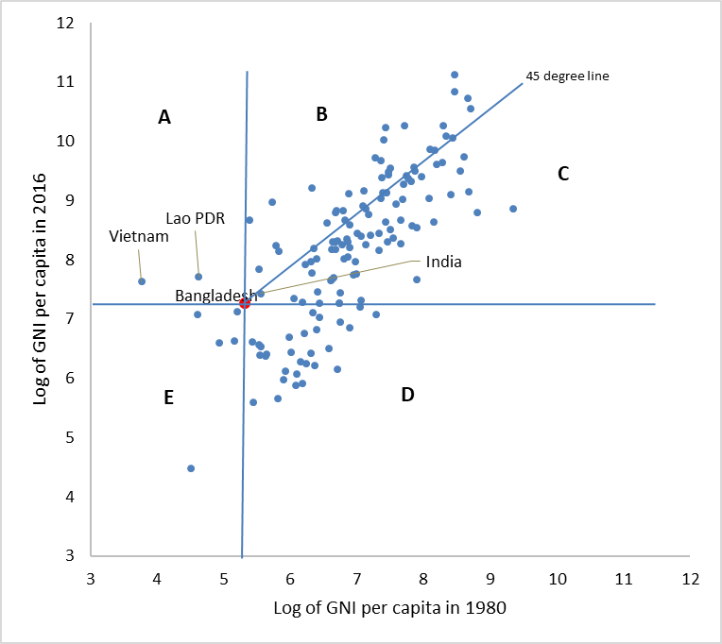
Data source: World Bank, WDI
LDC graduation is not a panacea. There are genuine concerns that though the business-as-usual process of economic and social development might lead Bangladesh to graduate from the LDC status by 2024, such business-as-usual process will certainly not lead to achieving the much larger and important development goals. Becoming a non-LDC and graduating from the current status of ‘lower-middle income’ country to an ‘upper-middle income’ country are not the same, and therefore, avoiding the 'middle-income trap' would be a forthcoming challenge. On top of all these, attaining the stiff targets of SDGs by 2030 would be a gigantic task for Bangladesh. The changing global and regional scenarios also appear to be much more challenging. All these suggest that Bangladesh has to make some extraordinary efforts in its economic and social development process in the days to come.

4.6. Structural Transformation in China and its Implications

China is a major export destination, accounting for about 20% of total exports for the rest of the Asia-Pacific region and 10% for a median country (weighted average is higher due to higher exposure by relatively large economies). China’s trade structure is changing, with less capital imports (which are now produced at home) and more consumer and raw material imports. At the same time, China is a growing source of imports for other countries in the region.

Gross trade figures could over-estimate actual exposure to changes in China, however, especially for countries highly engaged in GVCs. Analysis based on TiVA data for all countries in the Asia-Pacific region suggests that for every $10 exported to China, $8 is the domestic value-added component, of which $6 is channelled to Chinese final demand while the rest is re-exported. Further disaggregation reveals that the Asia-Pacific region is relatively more exposed to China’s investment demand rather than consumption demand; this suggests that China’s rebalancing towards consumption could have adverse effects, at least in the near-term. A cross-country comparison shows that exposure to China is now on a par with that to the United States, a significant increase compared to just a decade ago. This is especially so among ASEAN economies.

China’s outbound investment has steadily increased in the past decade. There are some concerns that linkages with the rest of the economy is often minimal in case of construction deals. There are some cases studies of Chinese enterprises in other countries (e.g. UNDP, 2017) but they are selective. China’s outbound investment is related to potential relocation of manufacturing to those countries. China’s share in global manufacturing has increased rapidly over the past decade or two, while the changes has been little for the rest of the region. In the medium-term, easing of China’s capital account restrictions would also significant impact Asia’s financial landscape, potentially providing more long-term capital for deficit economies, including for infrastructure development.

Such changes have profound implications for China’s trade patterns. Aside from the impact of China’s economic moderation on regional exports, structural changes in China’s trade are underway in line with the economy’s rebalancing (as import intensities vary across sectors and components of final demand) and upgrading (as population aging, higher wages and higher innovation capacity are changing China’s comparative advantage). For instance, recent years have seen a steady decline in the share of processing exports and imported inputs (ESCAP, 2016). Such changes in China’s trade patterns will have large and differentiated impacts on other Asia-Pacific economies. China is the top export destination for the majority of regional economies (accounting for about a fifth of their total exports). Moreover, relative exposure to China’s final demand is high, particularly on the investment side (IMF, 2016).

Empirical studies – including CGE, panel regression and VAR approaches – have arrived at varying estimates, but most of them point to sizeable impacts on the region. Using GTAP, Zhai and Morgan (2016) estimated that an investment-induced economic slowdown in China lowers output and export levels in the rest of the region by 0.26 and 0.50 percentage points respectively compared to baseline. Countries in China’s manufacturing chain (e.g. Republic of Korea, the Philippines) and commodity exporters (e.g. Mongolia) are the most affected and South Asian economies the least affected. Similarly, commodity sectors (e.g. coal, oil and gas, and other mining) and investment goods sectors (e.g. machinery, electronics, and chemicals) are negatively affected, whereas agricultural sectors are relatively unaffected.

IMF (2016) uses the gravity equation to estimate the extent to which China’s growing competitiveness in higher value-added production has affected export growth of upstream economies. At the opposite end, there is potential relocation of low-end manufacturing from China to lower-wage countries (e.g. Bangladesh, CLMV), but there appears to be few rigorous empirical studies. Mathai et al (2016) offer basic quantitative analysis for CLMV countries.

China’s rebalancing and upgrading is also reflected in the rapid growth of its digital economy and e-commerce. Regional trade impact would thus critical depend on the extent to which regional economies could penetrate and participate in this rapid growth (ITC, 2016). China’s services trade, including tourism, is growing rapidly in line with the economy’s rebalancing, but there appears to be relatively few empirical studies. China’s growing middle class is contributing to large tourist flows to countries like Thailand. Whether some of the losses in manufacturing and commodities sectors could be offset by gains in services trade would be worth investigating.

As China increasingly shifts towards a low-carbon, climate-resilient growth path, it is also likely that its trade in environmental goods and services is likely to grow rapidly. Technological innovations and large-scale investments in China could also contribute to lowering the cost of certain environmental goods and services, including for renewable energy.

There has been a growing literature on the near-term impacts of China’s slowdown in recent years. Several recent studies, including from the IMF, estimate that a 1 percentage point growth shock in China would affect growth in other Asian countries by about 0.3 percentage point on average; the impact on non-Asian countries would be about half of that. However, such estimates of GDP-to-GDP spillovers might not adequately capture the impact of China’s rebalancing and reforms. Another caveat is that some direct and indirect spillover effects may offset each other, such that the net impact is only mildly negative. For instance, for net commodity importers in Asia, lower commodity prices resulting from China’s rebalancing could partially offset the spillovers through trade (although for net commodity exporters, there would be no such offsetting effect).

4.7. Dealing with Non-Tariff barriers (NTBs)

In the initial years of formation of SAARC in the 1980s, the popular hypothesis for the reason behind limited intraregional trade was the prevailing high tariff rate among the member countries. High tariff rates have come down substantially over the years since the formation of SAARC due to increased globalization of trade, establishment of WTO regime, and South Asian Free Trade Agreement (SAFTA). Despite significant reduction in tariff rates in the region, the intra-SAARC trade has been quite static as before, about only 5 percent of the total trade of this region. Now the popular hypothesis is that it is not the high tariff rates, but the Non-Tariff Measures (NTMs) and the resulting trade barriers, i.e., Non-Tariff Barriers (NTBs) are the main reasons behind limited intra-regional trade in South Asia. This view is reflected in many contemporary studies and documents.

NTMs are generally defined as policy measures other than ordinary customs tariffs that can potentially have an economic effect on international trade in goods, changing quantities traded, or prices or both (UNCTAD, 2013). In contrast, NTBs are thought to be policy measures that surely affect the quantity traded and prices and have proven discriminatory effects against foreign firms (Nicita and Peters, 2013).

The UNCTAD classification of NTMs comprises technical and non-technical measures, such as sanitary or environmental protection measures, technical barriers to trade (TBTs) and other traditional instruments of commercial policy, e.g. quotas, price control, exports restrictions, or contingent trade protective measures, as well as other behind-the-border measures, such as competition, trade-related investment measures, government procurement or distribution restrictions. This classification acknowledges the existence of measures and does not judge on legitimacy, adequacy, necessity or discrimination of any form of policy intervention used in international trade (UNCTAD, 2013).

Detailed information, appropriate and specific analysis is required for better understanding of the impacts of NTMs on trade. It is important to emphasize that many NTMs are legitimate and thus cannot be negotiated away. For example, sanitary and phytosanitary (SPS) measures and TBT are there to protect consumers and environment; pricing and licenses are there to regulate domestic markets; anti-dumping duties, subsidies, quotas are there to protect domestic firms; and rules of origin is there to avoid unintended trade deflections.

Regardless of whether NTMs are imposed with protectionist intent or to address legitimate market failures, NTMs often impose additional costs on trading, and thus may have substantial effects on trade (Nicita and Peters, 2013). And these costs may be higher for some countries or firms than for others. For example, compliance costs are often fixed costs when small firms are in a disadvantageous position. Most of the small and medium sized firms in South Asia face this challenge, especially with respect to meeting the SPS and TBT standards. Therefore, there is a need to develop the capacities of these firms so that they can meet the justified SPS and TBT standards in other countries. In this regard, technical assistance in their production and export processes is required, and different aid for trade and similar initiatives should be put in place on a priority basis. Also, there is a need to strengthen the capacities of the National Standards Authorities so that certificates issued by them are accepted in other countries. Furthermore, there is a need for harmonization of standards, custom procedures and establishing mutual recognition principle in South Asia through regionally coordinated efforts.

Cost of complying is often dependent on infrastructures. Since the intra-regional trade in South Asia happens predominantly through the land borders, a large part of the NTM related complaints in South Asia are related to weak infrastructure at the land custom stations in the South Asian countries as well as due to lack of testing and laboratory facilities nearby the land custom stations. In this process, many of the legitimate NTMs turn into NTBs affecting the intra-regional trade. Therefore, improvements in relevant infrastructures should be on high priority.

Due to various procedural obstacles, which are related to complicated bureaucratic process, delays, corruption, and frequent changes in the policies, many legitimate NTMs turn into NTBs. In South Asia, a significant part of the NTBs is related to procedural obstacles. Therefore, policy effort is critical to ensure that NTMs serve their intended legitimate purposes.

The policy makers in Bangladesh, while negotiating for streamlining NTMs and reducing NTBs at the regional level, need very clear analysis, information and updated data on NTMs/NTBs for all South Asian countries. These data and analysis need to be relevant with concrete examples so that effective measurable actions can be undertaken. Analysis should emphasize on the respective roles and responsibilities for both home and partner countries in solving the problems.

4.8. Bangladesh’s Future Growth Trajectories and Trade

Using the recursive dynamic CGE model of Bangladesh we have simulated two scenarios to explore the trade impacts of future growth trajectories. Annex 2 presents the description of the model. These scenarios are:

Scenario 1: An annual increase in total factor productivity of the overall economy by 5 percent
Scenario 2: Doubling the share of manufacturing in GDP from its current level by 2030

Table 5 presents the impacts on Bangladesh’s exports under the Scenario 1. In 2030, Bangladesh’s exports would increase by 11.32 percent from the bau scenario, which by 2040 and 2050 would increase by 15.24 percent and 22.25 percent respectively from the bau scenario.

Table 5: Scenario 1: Impact on Bangladesh’s export (% change from the bau scenario)
 | 2030 | 2040 | 2050
Grains and Crops | 12.98 | 16.23 | 23.70
Livestock and Meat Products | 11.44 | 14.87 | 21.71
Mining and Extraction | 10.95 | 15.33 | 22.38
Processed Food | 10.44 | 14.93 | 21.80
Textiles and Clothing | 11.65 | 15.26 | 22.28
Light Manufacturing | 10.58 | 15.03 | 21.94
Heavy Manufacturing | 11.15 | 15.06 | 21.98
Transport and Communication | 11.72 | 15.47 | 22.59
Other Services | 10.95 | 15.00 | 21.90
Total | 11.32 | 15.24 | 22.25
Source: Recursive dynamic CGE model of Bangladesh

Table 6 presents the impacts on Bangladesh’s exports under the Scenario 2. In 2030, Bangladesh’s exports would increase by 20.58 percent from the bau scenario, which by 2040 and 2050 would increase by 27.91 percent and 40.74 percent respectively from the bau scenario.

Table 6: Scenario 2: Impact on Bangladesh’s export (% change from the bau scenario)
 | 2030 | 2040 | 2050
Grains and Crops | 11.73 | 14.67 | 21.41
Livestock and Meat Products | 10.64 | 13.83 | 20.19
Mining and Extraction | 10.37 | 14.51 | 21.19
Processed Food | 23.00 | 32.90 | 48.03
Textiles and Clothing | 33.07 | 43.33 | 63.25
Light Manufacturing | 29.33 | 41.65 | 60.82
Heavy Manufacturing | 25.28 | 34.13 | 49.83
Transport and Communication | 22.44 | 29.62 | 43.24
Other Services | 19.36 | 26.53 | 38.73
Total | 20.58 | 27.91 | 40.74
Source: Recursive dynamic CGE model of Bangladesh

4.9. Bangladesh and Fourth Industrial Revolution

Technological advances associated with the fourth industrial revolution – including artificial intelligence – allow the automation of an increasingly wide array of processes in increasingly interactive and sophisticated ways. These advances will likely give rise to many opportunities for economic and social development in a developing country like Bangladesh, for instance by increasing food production. But the new technologies also involve important risks, which have special significance in developing countries. They may build upon and exacerbate existing inequalities – both within developing countries as well as between developing and more developed regions. Also, there are risks of worsening unemployment and increasing concentration of economic power and wealth.

The concern that new technologies – especially artificial intelligence – will lead to widespread job losses has been widely discussed. Of course, the fear that new technologies replace workers is an old one. But it’s been pointed out that historically new technologies have often given rise to more new jobs than the ones that have been automated away. What’s perhaps different now is that the new, interconnected digital technologies will likely have a broader and more far-reaching array of abilities. And so the prospect of new kinds of jobs may well be diminished or limited to increasingly sophisticated domains, such as machine learning. In addition, new technologies are now not just replacing jobs, but they are also enabling the disruption and restructuring of entire industries. Lower labour costs in many developing countries like Bangladesh mean that investments in job replacing technologies will be lower. But other aspects of developing countries’ contexts increase the possible severity of this risk.

Also, existing high levels of inequality is a major concern. Elites will be more likely to make use of AI and other new technologies. This will further increase returns to capital widening the gap between elites’ productive capacity and that of everyone else.

New technologies’ advantages for capital are not just due to increasing productivity, but also because they allow new business models that may control or even dominate entire sub-sectors and stifle competition. For instance, it could become possible for a single company to control large fleets of automated vehicles in one or more large areas.

However, the effect of the aforementioned scenarios will depend on whether the country can keep up with these developments and respond effectively. Particular attention will need to be paid to intellectual property and competition law. For instance, the strict enforcement of intellectual property rights for AI algorithms may well support increasing economic concentration. The government ought to carefully assess the above risks in the national context and then establish corresponding policies and programs. This includes national skills development and work placement platforms, intellectual property and competition policies, and local technology adaptation and development.

4.10. Digitization of Global trade: Opportunities and Challenges for Bangladesh

The spread of digital technologies is transforming all types of global flows — those of goods, services, money, and people — and this transformation is only in its earliest stages. Already, more and more of people across the globe engage in instantaneous cross-border exchanges of digital goods, from books and music to design files that enable 3-D printing of physical objects. As the infrastructure that supports the Internet expands, barriers of distance and cost that once seemed insurmountable have begun to fall away. Digital trade represents an important, albeit hard-to measure, component of these global flows. As it grows, develops, and assumes new forms, it is both facilitating globalisation and transforming it.

Digitisation lowers marginal production and distribution costs, while broadening access to global commerce. The cost of participating in trade is reduced not just for large companies, but also for individuals, small firms, and entrepreneurs. This is already spurring innovations in business models and spawning the emergence of micro-multinationals, micro-work, and microsupply chains that are able to tap into global opportunities.

The Internet of Things (IoT) — the ability to monitor and manage objects in the physical world electronically — will enhance and accelerate these developments. Digitisation has already had a significant impact on trade by transforming logistics and supply chains; companies can readily track and collect information about a product, place, time, or transaction using sensors or other digital “wrappers,” to improve their operating efficiency and reduce costs. This process, too, is at an early stage, and we believe that its impact could be considerable over the next decade.

Manufacturers and oil and gas companies, among others, have already begun to see the initial payoff from IoT technologies in their operations. From monitoring machines on the factory floor to tracking the progress of ships at sea or parcels being shipped across frontiers, digital technologies are helping companies get far more out of their physical assets.

The digitisation of global flows has been a key contributor to the explosive growth of cross-border data flows. Crossborder Internet traffic has increased 500-fold since 2000 — and with conservative assumptions will expand another eightfold by 2025. Together, these transformations will have broad implications for the future of globalisation. They will impact companies large and small, in emerging economies as well as in developed ones. Governments will be challenged to adapt their regulatory and taxation systems to deal with this upsurge in digitisation and digital trade. Policymakers will need to address sensitive issues around data security, privacy, and Internet governance. Trade agreements must be updated to reflect the new realities of global commerce and expanded to address new forms of cross-border commerce and customs procedures.

Digitisation is opening the door to SMEs and even individual entrepreneurs to take part in cross-border commerce and exchanges, giving rise to a new era of “micro-multinationals.” Through e-commerce even small companies can export through online platforms. Digitisation has also cut the fixed costs of starting a business for entrepreneurs, since more and more inputs can be purchased on a marginal basis. In the past, online businesses needed to buy servers and hire large engineering teams to build their systems virtually from scratch. A company today can buy incremental server capacity from Amazon Web Services, for instance, and hire leaner development teams that can build on top of pre-existing platforms. Business-support services, such as legal and accounting services, can also be outsourced online through platforms, such as UpWork and Freelancer. This means that businesses can start up with far less up-front investment and can scale up much more quickly. The implication is that the pace of innovation has the potential to further accelerate as an increasing number of lean-and mean entrepreneurs and engineers test and iterate more ideas.

5. Prospect of Future Trade Liberalization and Continuing Harmonization of Standards and Regulations to Reduce Barriers to Trade in Bangladesh

One of the import issues in the import policy in Bangladesh is the further liberalization of the tariff regime. The main problem with further tariff rationalization is the concern related to the potential revenue shortfalls of the Government. Although the loss in revenue could arguably be made up either by expanding the domestic tax base or by increasing the VAT net or a combination of both, the tax administration in an LDC like Bangladesh is not as flexible as in developed countries for undertaking an increased revenue mobilization effort within a short period of time. Also, increasing the rates of revenue generating tax measures such as VAT is difficult given the dominance of the informal economy.

One difficult alternative for the future is to consider a tariff structure with the highest duty rate lower than the current one, but with necessary adjustment in other slabs (both across tariff lines and rates) so that on the aggregate it can be revenue neutral (or with a marginal effect on revenue) with respect to current collections from import taxes. This arrangement, however, may require considerable readjustment of tariffs rather than replacing the existing tiers with lower rates in a linear fashion. Also, the success in ensuring revenue neutrality will require information on tariff elasticity of imports (and/or price elasticity of import), which might not be readily available. It is to be noted that revenue neutral adjustments in tariff structure will keep the average nominal protection given to the domestic import-substituting activities unchanged and consequently the resultant policy-induced anti-export bias may not be affected.

Nevertheless, it would be unwise to reverse the process of liberalization and thus the progress achieved in the previous decade. The use of para-tariffs in recent years has increased the total protection rates, which appears to be incompatible with the liberalization measures that Bangladesh undertook earlier. It is, therefore, important to ensure the neutrality of supplementary duty and VAT by applying them to the domestic industries in a non-discriminatory fashion, which could contribute to increased government revenue on the one hand, and reduced anti-export bias on the other.

Another scope for tariff liberalization is the mutual exchange of tariff preference under Regional Trading Arrangements (RTAs) and Free Trade Areas (FTAs) involving Bangladesh. Such arrangements may result in significant trade creation with favorable effects on employment generation and poverty alleviation. While Bangladesh remains committed to multilateral trading system, options of trade expansion through regional cooperation should be given serious consideration.

In future Bangladesh may opt for an analytical approach to tariff liberalization. Under this approach there may be scopes to devise the tariff structure in such a way so that it has limited effects on the revenue position of the government, but contributes to lowering high rates of effective protection enjoyed by a number of sectors. Although the outcome may be diminished or unchanged nominal protection for the whole economy, the efficiency gains achieved through reduction in effective protection can be beneficial to resource allocation.

However, across the board tariff reduction may not be desirable not only because of the revenue concern of the government but also because of the need for providing some support to domestic industries with significant growth and poverty alleviation effects. By adopting pro-active and analytical policy regime effective support to the growth of small and informal sector activities with significant poverty alleviation effects can be provided. In fact, policies should be devised in such a way so that trade can act as a tool for development.

Furthermore, the strategy and scope of future tariff liberalization need to be put in the context of intended policy objective. Reduction in import tariffs is to reduce policy-induced anti-export bias, but this does not necessarily imply an improved export response. The existing level of policy bias against export is relatively low and even keeping aside the problem of potential revenue shortfall, it needs to be emphasized that while further reduction in anti-export bias through tariff-cuts is one thing, generating export supply response is another matter. Given a weak performance of non-RMG sectors, in future policy options and/or support measures for exports would be much more difficult and involved than such simple measures as removal of quantitative restrictions and reduction of tariffs.

Export policies and associated incentives are formulated to provide a predictable and secure environment for the exporters. It specifies objectives, designs strategies, and sets up export targets to achieve. Given the constraints to supply response, the export policy can play a significant role in energizing export and bringing diversification into the export basket. However, one major problem has been not having the strategies well- and narrowly defined. Lack of clear guidelines as regards implementation or ways to provide supports may result in ineffectiveness of the strategy. A policy of supporting or undertaking a program itself cannot ensure achievement of objectives.

Policy frameworks need institutions to become effective. In other words, it is institutions through which strategies are ultimately implemented. Besides, trade or export policies usually encompass a number of institutions or departments and coordination of their tasks has important implications for all eligible exporting firms’ benefiting from incentives. Therefore, strategies need to be outlined in details and the roles and responsibilities of relevant institutions and departments should be articulated. Lack of coordination and integration in the various elements of export policy strategy has always been a problem in Bangladesh. Since strategies remain too broad, it is difficult to analyse whether they ultimate work or to identify the reasons for not their well-implementation and thus lessons to be learnt for similar future exercises.

For effective export promotion, in addition to the export policies, a set of other complementary policies and programs are critically required. Stabilities of the macroeconomic environment, effectiveness of the export promoting and supporting institutions, and smooth functioning of the financial markets are necessities. Furthermore, the quality of governance should be improved through promoting transparency and accountability, and by reducing the extent of corruption. The government should also take effective role in technology diffusion and in providing appropriate physical infrastructural facilities.

The export-led growth philosophy underscores the need for setting up an incentive structure that overcomes the problem of serious policy-induced anti-export bias. The notion of anti-export bias is related to the trade policy measures that act to favor the import-substituting sector and discriminate against the export activities. The principal route to this ‘bias’ or discrimination is accomplished by altering the domestic prices. While for exporters it is not possible to influence the world price, import tariffs and quantitative restrictions allow the producers to raise the domestic price of their commodities above the world price. The resultant profitability (and thus relatively high price of import substitutes to export goods) under the shield of protective measures encourages reallocation of resources from the production of exportable to that of import substitutes. Also, policy-induced domestic production may result in increased demand for non-tradable diverting further resources into this sector at the cost of exportable. Bangladesh has liberalized its economy quite considerably now and particularly in the 1990s the pace of liberalization has been very rapid. The trade liberalization has managed to reduce the policy induced anti-export bias at some moderate level. Further liberalization and rationalization of the tariff regime could contribute to improving the incentive for exports.

Supporting the export sector by removing the anti-export bias is one of the most important reasons for undertaking liberalization. However, it is worthwhile enquiring whether the policy induced anti-export bias is the only problem for expanding exports. While tariff rationalization and the liberalization of trade regime is one thing, how far this will stimulate export response is another thing. In the 1990s, Bangladesh’s export growth has mainly been driven by RMG and thus it cannot be ascertained whether the liberalization measures or the peculiarities associated with the export markets contributed to the robust export performance. Export response to liberalization in other sectors had been either weak or non-existent. It may be that any significant export response in these sectors can only be stimulated by addressing other demand and supply side problems.

The strategy of export-led growth is to be supported by a more neutral policy regime and accordingly one of the basic objectives of trade reform has been to remove the policy-induced anti-export bias in the domestic economy. The removal of anti-export bias, therefore, will largely depend on correcting the price incentive structure so that resources can be allocated between export and non-export sector on the basis of comparative advantage. Liberalization of such trade restricting measures as high tariffs and quantitative restrictions contributes to the reduction of disincentive to export activities by curtailing the artificially maintained high domestic prices enjoyed by the import-substituting industries. It is important to note that a policy of subsidizing export production can mitigate the negative effects of protection. However, given the fiscal burden of the government such a strategy may not be a viable option especially in the long run.

Bangladesh’s major export markets are the EU and North America which account for about 90 percent of her export. Till now South-South trade has been rather negligible for Bangladesh, although overall the share of South-South trade has been on the rise in global context in the recent years. In spite of the SAFTA and preferential treatments in India and China, Bangladesh has not been able to put in place an appropriate strategy to enhance her market access to China and India by taking advantage of the preferential treatment that has been offered and the bilateral trade deficits which these two countries are rising with grave concerns. There is a need to urgently address this task, along with identification of the areas of investments that will be required in this context.

6. Integration with the Global Value Chain: Opportunities and Challenges for Bangladesh

6.1. Potential Sectors for Integration with GVC

In the following sub-sections, analyses on the economic and export diversification potentials and problems of few sectors, mentioned as the high priority and priority sectors in the Industrial Policy 2015, which have significant growth, exports and employment potentials, namely agricultural products, leather and leather goods, pharmaceuticals, electronics, jute and jute diversified products, IT and tourism are provided.

6.1.1. The Agro-processing Sector

The agro-processing sector in Bangladesh has been able to increase its share in GDP in recent years (Figure 15). In 2014-15, the sector’s contribution to GDP stood at 1.52%. The sector also experienced some sizeable growth in recent years. In 2014-15, the sector’s value-added growth rate was around 8%, which was much higher than the growth rate of country’s overall GDP.

Figure 15: Food, beverages and tobacco (% share in GDP)
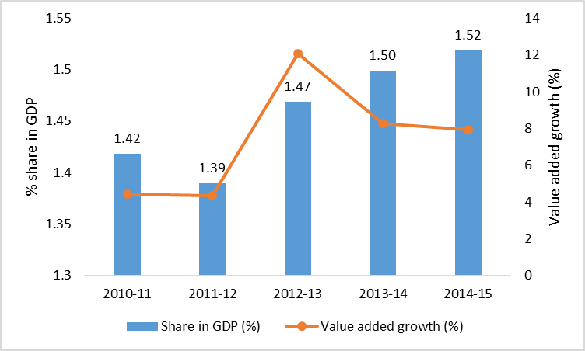
Data source: Bangladesh Bureau of Statistics

Despite the sizeable growth, the agro-processing sector’s contribution to the manufacturing value-added has been on a declining trend in recent years (Figure 16). The reason is primarily due to the fact that, in recent years, the manufacturing sector in Bangladesh has been increasingly concentrated around the readymade garments.

Figure 16: Food, beverages and tobacco (% of value added in manufacturing)
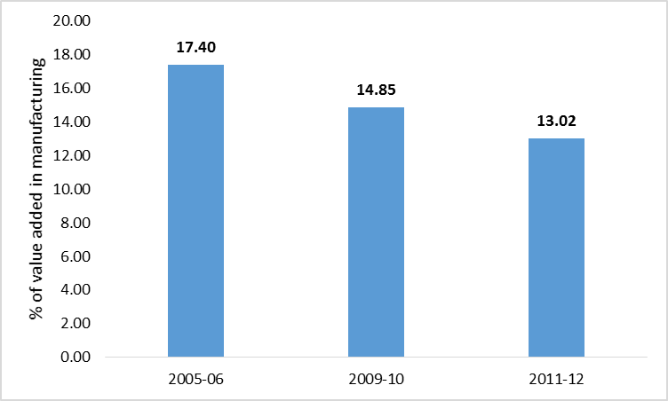
Data source: Bangladesh Bureau of Statistics

The sector has huge potentials in generating employment. This is reflected in Figure 17, which suggests that, the share of agro-processing sector in total employment in the country has been on the rise. In 2005-06, the share was 1.5% which increased to 2.5% in 2013.

Figure 17: Food, beverages and tobacco (% share in total employment)
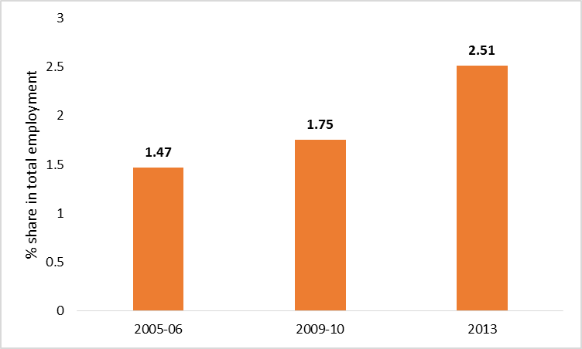
Data source: Bangladesh Bureau of Statistics

Interviews with the stakeholders indicate that, there are significant prospects of much larger exports of agro-processing products from Bangladesh than the current level of exports. Such views are also endorsed by some empirical studies in recent time, such as the ILO (2013) study and the ADB-ILO (2016) study. Figure 18 shows that, in recent years, exports from this sector has been little over US$ 1 billion and the growth in exports has slowed down. In terms of the share in total exports, in 2005-16, the sector contributed only around 3.2% (EPB, 2016).

Figure 18: Food, beverages and tobacco (exports in million US$)
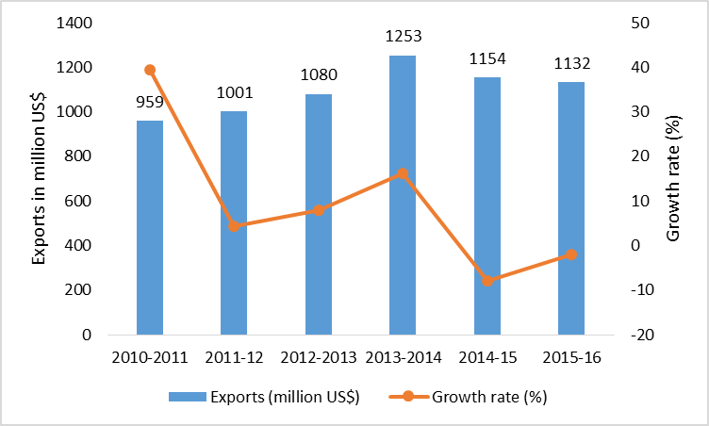
Data source: Export Promotion Bureau

Figure 19: Food, beverages and tobacco (composition of exports)
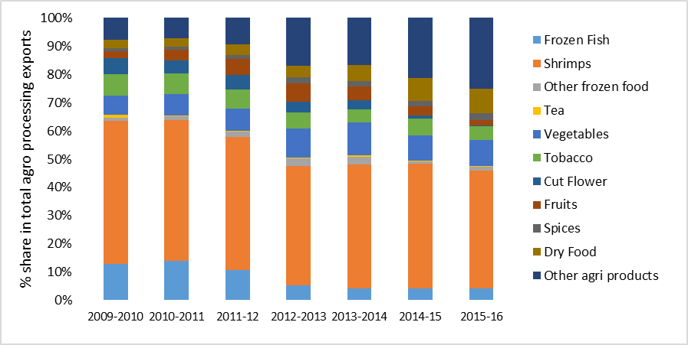
Data source: Export Promotion Bureau

The composition of Bangladesh’s agro-processing exports includes frozen fish, shrimps, other frozen food, tea, vegetables, tobacco, cut flower, fruits, spices, dry food, and other processed agricultural products (Figure 19). However, in terms of the share, the shrimp dominates. There is a growing share of other processed agricultural products and dry food. As mentioned before, the major export destinations are the EU, Middle East and the USA. However, it should be noted that, while Bangladeshi shrimp exporters have managed to position themselves in the main high-end markets, other agro-food exports are currently very concentrated on a number of regional markets, mainly targeting the ethnic food niches in countries with strong Bangladeshi diaspora, such as the United Arab Emirates, India, Saudi Arabia, and other Gulf countries (ILO, 2013).

Bangladesh is a country with low FDI orientation, which is reflected by the fact that, the country’s average FDI-GDP ratio during 2011-2015 was only 1.4% (Raihan and Ashraf, 2017). Raihan and Ashraf (2017) show that, in contrast, most of the Southeast Asian countries had FDI-GDP ratios well above 2% during the same period. For example, the average FDI-GDP ratios of Malaysia, Indonesia, Thailand, Vietnam were 3.65%, 2.38%, 2.07% and 5.42% respectively. Even the LDCs like Cambodia, Lao PDR and Myanmar had much higher FDI-GDP ratios, which were 8.98%, 5.43% and 3.15% respectively.

In the agro-processing sector, the FDI is still very low but on an increasing trend (Figure 20). While in 2010, the FDI was as low as US$17.2 million, by 2015 the amount increased to US$ 108.2 million.

Figure 20: Food products (FDI in million US$)
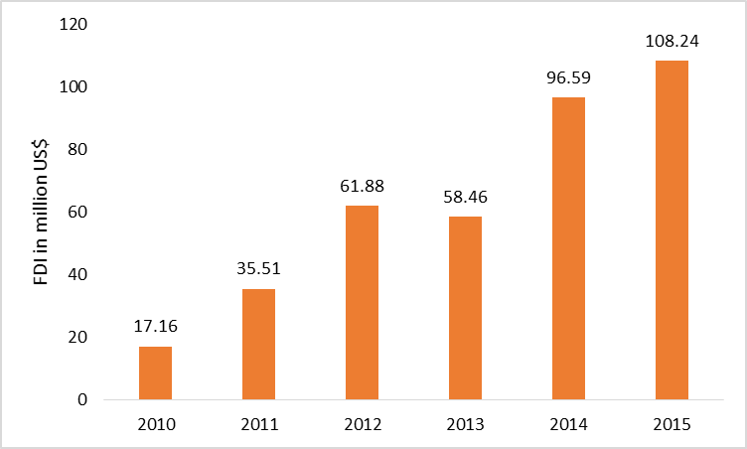
Data source: Bangladesh Bank

There are three major reasons for the good prospects of this sector for Bangladesh. First, the sector has high domestic value addition because of its large backward linkages. This helps exports from this sector to fulfil the rules of origin criteria in many of Bangladesh’s export destinations. Second, the sector has high potential for large-scale employment generation. Third, it can help industries with which it has backward and forward linkages to grow.

Despite these prospects, the sector suffers from six major constraints. First, there are tariff and non-tariff-related problems in many export destinations. Second, inadequate infrastructure – lack of cold storage facilities and a shortage of electricity – hinder progress in the sector. Third, there are issues at the different processing stages, ranging from the farm level to the packaging level. Fourth, small and medium sized enterprises (SMEs) face a lack of access to finance. Fifth, the sector suffers from a lack of skilled labour. Sixth, institutional inefficiency is a major issue. The capacity of Bangladesh Standards and Testing Institution (BSTI) and other standard agencies is far from the desired level, and because of this, many export destination countries do not accept certificates issued by them.

There are eight types of interventions that could remove the constraints facing the agro-processing sector. First, the Ministry of Industries (MOI) and the Ministry of Commerce (MOC), in collaboration with the private sector and international organisations, should instigate capacity-building programmes to enhance the domestic capacity of Bangladeshi exporters in meeting sanitary and phytosanitary (SPS) regulations in export destinations. Second, the Ministry of Road Transport and Bridges and the Ministry of Home Affairs should take the necessary measures to improve road traffic conditions and trucking facilities to reduce transport delays and their associated costs. Third, the Bangladesh Investment Development Authority (BIDA) should facilitate high-quality electricity connections to the sector. Fourth, Bangladesh Bank (BB) should provide financial incentives to investors to set up cold storage facilities. Fifth, BB should act to enable better access to financial services for SMEs, including taking the necessary steps to make the Entrepreneurs’ Equity Fund (EEF) effective. Sixth, MOI should take steps, in collaboration with the private sector and international organisations, to establish large training facilities to generate a skilled and semi-skilled workforce. Seventh, MOC and the National Board of Revenue (NBR) should ensure more supportive tax and tariff policies. Eighth, there is a need to improve the capacity of BSTI by increasing staffing levels, training and retention; ramping up investment in equipment and facilities; introducing a single-window depository and dissemination of all required documentation; setting up more testing labs; and building the required infrastructure.

6.1.2. Leather and Leather Goods

Leather is one of the oldest industries in Bangladesh. This is an agro-based by-product industry with locally available raw materials having a potential for high export and value-added growth over the coming years (Paul et al, 2013). About 40% of the supply of hides and skins comes from animals slaughtered during the annual Muslim festival of eid-ul adha. In addition, throughout the year, there is a substantial supply of hides and skins.

The Government of Bangladesh has identified the leather sector as one with considerable growth and investment potential. Bangladesh leather is widely known around the world for its high qualities of fine grain, uniform fibre structure, smooth feel and natural texture (Paul et al, 2013). Bangladesh's leather exports account for a mere 0.5% of the global leather and leather goods market worth around US$ 230 billion.

Hazaribag area of Dhaka turned into a location that now accommodates a large number of tannery units. There are reportedly around 220 tanneries in Bangladesh but, in fact, only 113 tanneries are in effective operation, out of these 20 units are reported to be fairly large (7 units very large), around 45 units are considered of medium size and around 48 units are considered small groups. These tanneries in Bangladesh produce 180 million square feet of hides and skins per year. In addition, there are about 30 modern shoe manufacturing plants engaged in the production of high-quality footwear, with over 2500 smaller footwear manufacturers also present in the sector. There are around 100 small-to-medium leather goods manufacturers, and a small number of niche larger manufacturers (Paul et al, 2013).

Despite significant prospects, the leather sector’s contribution to GDP declined in recent years (Figure 21). In 2010-11, the sector’s share in GDP was 0.36% which declined to 0.29% in 2014-15. The sector has been suffering from a declining growth in value-added since 2012-13, and in 2014-15 the growth rate turned out to be negative. This indicates that, it is not only the sector’s relative contribution to the GDP is declining, but also in absolute term, the sector is not performing well in recent years.

Figure 21: Leather and leather goods (% share in GDP)
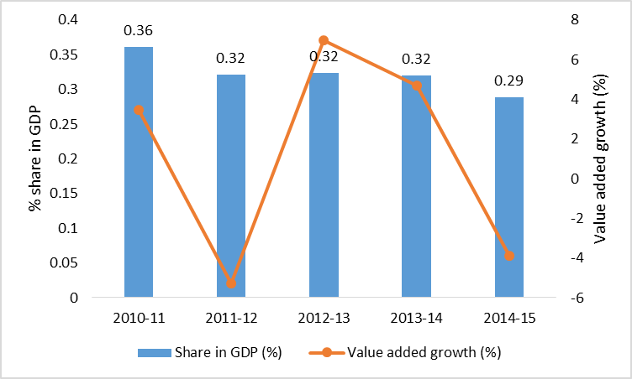
Data source: Bangladesh Bureau of Statistics

Figure 22: Leather and leather goods (% of value added in manufacturing)
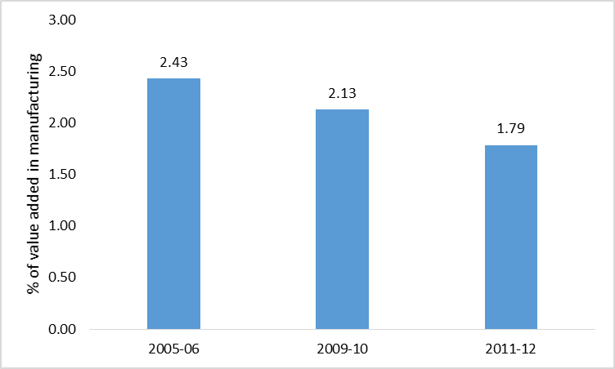
Data source: Bangladesh Bureau of Statistics

The leather sector’s contribution to the value-added in manufacturing is also on a declining trend (Figure 22). In 2005-06, such contribution was 2.4%, which declined to 1.8% in 2011-12. Part of the fall in such share is explained by the growing concentration of the manufacturing sector around the readymade garments and the rest is due to the sector’s declining performance.

The share of employment saw a significant fall from 0.22% in 2005-06 to 0.16% in 2013 (Figure 23). However, during 2009-10 and 2013 the number of employed people in the leather sector increased from 85,000 to 91,000.

Figure 23: Leather and leather goods (% share in total employment)
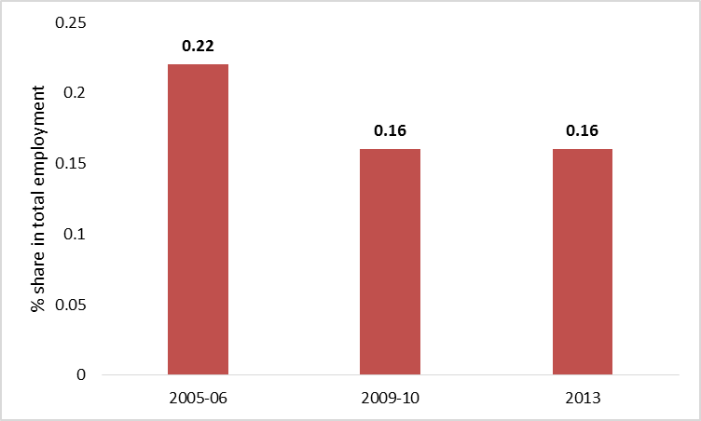
Data source: Bangladesh Bureau of Statistics

Figure 24: Leather and leather goods (exports in million US$)
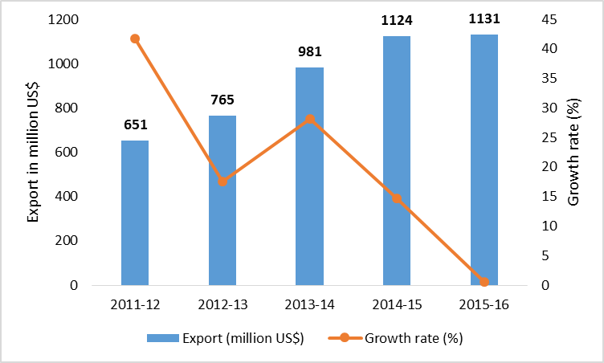
Data source: Export Promotion Bureau

About 95% of leather and leather products of Bangladesh are exported, mostly in the form of crushed leather, finished leather, leather garments, and footwear. The major export destinations are Germany, Italy, France, Netherlands, Spain, Russia, Brazil, Japan, China, Singapore and Taiwan (Paul et al, 2013). In 2011-12, the export was US$ 651 million, which increased to US$ 1.1 billion in 2015-16 (Figure 24). However, since 2013-14, the export from this sector had been experiencing a declining growth rate. The share of exports from the leather sector in the country’s total export in 2015-16 was around 3.5%.

Export data disaggregated by exports of leather, leather products and footwear presents some insightful findings. Figure 25 shows that, in recent years, the share of processed leather (crust and finished leather) in the total exports of leather has been declining while that of leather goods has been increasing. The share of footwear, however, with some fluctuations, has remained somehow stable. All these suggest some structural changes in the leather sector in recent years, where higher value-added products (leather goods and footwear) in contrast to lower value-added products (processed leather) have been accounting for the majority of the share of leather exports from Bangladesh.

Figure 25: Leather and leather goods (composition of exports)
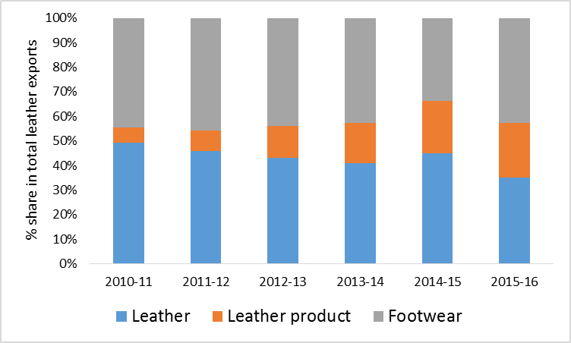
Data source: Export Promotion Bureau

Like in most of the manufacturing sectors FDI in the leather sector is very low. However, between 2010 and 2014, the FDI into the leather sector increased by almost three times: from only US$ 12.9 million to US$ 36.8 million (Figure 26). Regrettably, in 2015, the FDI inflow dropped to a meagre US$ 16.4 million. This suggests that though the sector has the potential of attracting larger FDI, there are certain constraints which hinder such prospects.

Figure 26: Leather and leather goods (FDI in million US$)
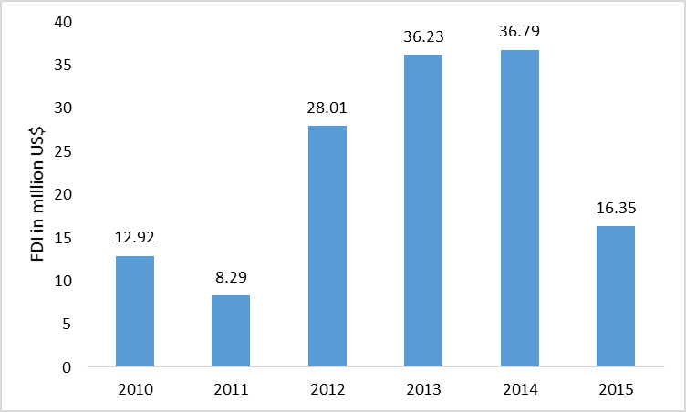
Data source: Bangladesh Bank

There are five major reasons for the bright prospects of the leather sector in Bangladesh. First, the sector has high domestic value addition, owing to the country’s large supply of raw hides and skins. Second, there are significant prospects for large-scale employment generation in the leather and leather goods sub-sectors. Third, the sector has the potential to help backward and forward linkage industries to grow. Fourth, the country has a good reputation for having a large supply of fine textured hides and skins. Fifth, there are bright investment opportunities in this sector, especially through foreign sources.

However, the sector suffers from five major challenges. First, progress on relocation of the tanneries to the Savar estate has been sluggish, which has constrained much of the potential of the sector. Second, there is a lack of skilled labour available for the leather goods and footwear industries. Third, there are important health and environmental concerns in this sector. Fourth, the sector does not enjoy access to duty-free imports of raw materials and machinery. Fifth, the sector suffers high costs of doing business, especially high land prices, weak infrastructure and the high cost of capital.

We can identify six policy issues that would help improve the situation in the leather sector. First, MOI must take appropriate measures to enable the quick and effective operationalisation of the tannery estate in Savar. Second, existing technical education and training facilities in the leather sector must be expanded to meet the growing demand for a large skilled workforce. There is scope for public–private partnership in this regard. Third, MOC and NBR should enable duty-free imports of eco-friendly machinery and raw materials, and different tax incentives, for factories that comply with health and environmental standards. Fourth, NBR should extend its bonded warehouse facilities to leather and all export-oriented firms. Fifth, BB should introduce a more flexible loan processing system and provide subsidised loans to entrepreneurs. Sixth, BIDA should facilitate electricity and gas connections for new investors on a priority basis.

6.1.3. Pharmaceuticals

Ahmed (2014) suggests that the pharmaceutical industry is one of the most potential sectors for industrial diversification in Bangladesh, as the country can be highly competitive and enjoy comparative advantages in both short and medium terms in this sector. Multinational companies (MNCs) dominated the pharmaceutical sector in the early post-independence period of Bangladesh. Eight leading MNCs enjoyed 75 per cent of the total domestic market, producing vitamins, enzymes and cough syrups locally, and importing other essential drugs from their sister-units located abroad. The National Drug Policies of 1982 and 2005 helped the formation and growth of a domestic pharmaceutical industry in the country. As a result, Bangladesh became a drug-exporting country by the late-1980s from a drug-importing nation earlier. The pharmaceutical industry in Bangladesh is now one of the largest capital-intensive white-collar industries, and has grown tremendously over the past few years. Bangladesh enjoys a comparative advantage in the sector due to its cheap labor and raw materials, favorable WTO legal regime as well as adequate supply of skilled manpower. Medicine sales in Bangladesh were worth US$ 0.60 billion in 2007, which nearly doubled to US$ 1.06 billion in 2011 and reached US$ 1.60 billion mark in 2014. The growth in 2011 alone was 24 per cent against the global growth of 8 per cent.

Figure 27: Export of Pharmaceuticals
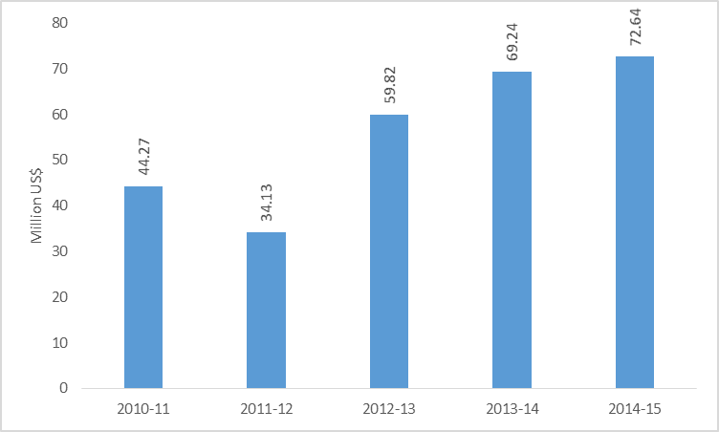
Source: EPB

Figure 27 suggests that through export of pharmaceuticals, Bangladesh earned US$ 72.64 million in 2014-15 which was US$ 44.27 million in 2010-11. Bangladesh is now almost self-sufficient in manufacturing pharmaceuticals. The imported drugs are mostly specialized pharmaceutical products like vaccines and anti-cancer drugs. The current ratio may tilt further in favor of domestic producers as big local firms are preparing to manufacture these drugs as well.

Ahmed (2014) also reported that the drug manufacturers hope to export drug items to 140 export destinations, climbing from the current 86, within the next few years, and have already made huge investments in new state-of-the-art manufacturing facilities. In fact, leading plants have increased their production capacity by 200 per cent to 300 per cent during the last few years. A number of companies have already obtained or are in the process of obtaining UKMHRA, EU, TGA and GCC certifications. The export prospects are very bright indeed, because of increased demand for high-quality generics throughout the world, and the inclusion of Doha declaration in WTO-TRIPS, which allows the LDCs not to opt for pharmaceutical product patents until 2016. Among the 50 LDCs, Bangladesh has one of the strongest bases for pharmaceutical manufacturing. Besides, there is a huge opportunity for Bangladeshi companies to go for contract manufacturing and compulsory licensing.

Ahmed (2014) highlighted a number of challenges for the expansion of pharmaceutical industry in Bangladesh. The major one is the expected expiry of WTO/TRIPS agreement in 2016, which provides patent exemption for pharmaceutical products in Bangladesh as a least developed country (LDC). Steps should be taken for extending this exemption for another 12-year term alongside preparations in the country for compliance with patent laws in case the exemption is not extended. Another challenge facing the local industry is absence of facility for bio-equivalence study, which is mandatory for drug exports to the regulated as well as some moderately regulated markets. Such tests are now done abroad at a quite high fee. Establishment of a full-fledged bio-equivalence laboratory in Bangladesh is, therefore, urgent in order to boost exports and improve the quality of products.

Ahmed (2014) also mentioned that Bangladesh pharmaceutical industry does not have any significant capability for research or sophisticated production of medicines. Pharmaceutical manufacturing generally consists of two steps. The first step – manufacturing of active pharmaceutical ingredients (APIs) is a highly sophisticated, technically demanding chemical and biochemical fermentation-cum-synthesis process. The second step is the drugs’ final formulation, which belongs to the manufacturing sector. Bangladesh is mainly engaged in the final formulation of branded generics from imported APIs. There is no research and development (R&D) activity and so the capacity for ‘reverse engineering’ of patented drugs is very limited. Pharmaceutical production has proved to be highly sensitive in Bangladesh as raw materials like API, packaging and materials are imported from outside (mainly China and India). Approximately 80 per cent of the APIs were imported in 2008 and 75-80 per cent of these were generic. At present, there are 21 companies manufacturing 41 APIs in Bangladesh (2011, IDLC). However, the producers mainly run the final chemical synthesis stage with API intermediaries, instead of the complete chemical synthesis (World Bank, 2016).

According to Ahmed (2014), there are currently 267 pharmaceutical companies in Bangladesh with the top 10 companies holding 67.6 per cent of the market share. With around 115,000 workers employed, it employs the highest number of white-collar workers in the country. Different factors within the pharmaceutical industry have prevented it from growing as expected. The industry is inherently a capital-intensive one and highly sanitized conditions are essential. Additional investments need to be made for the export market to guarantee quality and provide certification. The share of labor in total production cost is low, and this is even more so when the cost of APIs is included. Besides, the incentives created by policies have led to the private sector focus on import-substitution instead of enhancing ‘reverse engineering’ capacity to take advantage of the WTO/TRIPS waiver. Other factors that adversely affect exports include weak enforcement of quality regulations and strict foreign exchange controls. Lax enforcement of regulations has allowed local companies to fall below the standards necessary for the stringently regulated export markets. Strict foreign exchange controls deter firms from undertaking critical activities like receiving certifications from overseas regulatory authorities in order to increase exports (World Bank, 2016).

Ahmed (2014) reported that the government has also taken necessary steps to establish an Active Pharmaceutical Ingredients (API) Industrial Park at Gazaria, Munshiganj, which will boost the industry’s competitiveness as well as exports. A total of 42 industries would be set up under the project scheduled to be completed by 2015. The pharmaceutical sector has been among the high-priority ones in Bangladesh export policy since 2006. These sectors are entitled to income tax exemption for export earnings, export credit at reduced rates, assistance in marketing abroad through participation in export fairs etc. In addition, the government reduced or exempted duties on some capital machinery and raw materials imported for pharmaceutical production. The sector also enjoys a tax holiday and ‘duty drawback’ scheme. The Directorate General of Drug Administration (DGDA) under the Ministry of Health and Family Welfare is the drug regulatory authority in the country. But despite extensive rules, the pharmaceutical market remains under-regulated due to lack of capacity at DGDA. It is severely understaffed — against the backdrop of a rapidly growing pharmaceutical market, large numbers of registered products, and a huge population size. Enforcement measures suffer as a result. The drug-testing laboratories, including the two under DGDA, also have insufficient capacity. Even infrastructure support for the regulatory authority is not adequate. Its effectiveness is further complicated due to complexities of multiple administrative bodies and committees involved in the regulatory process. The industry does not have a bio-equivalence testing facility, which is mandatory for product registration in developed markets (World Bank, 2016). The government should undertake appropriate measures and initiatives for removing and rectifying these constraints in order to facilitate rapid growth of the pharmaceutical industry in Bangladesh.

6.1.4. Electronics

Electronics industry in Bangladesh is one of the fastest growing industries in the country with great potential. At present few of local and foreign trading or marketing company are importing spare parts and assembling electronic goods to meet demand. Such as LG Electronics, Singer, Walton etc. Walton is the largest local brand of electric company which is exporting electronic product in the world market; they also establish automobile industry to produce motor bike and other vehicles to export into the world. There large demandable products are TV, Fridge, LED bulb, Florescent bulb, Cell phone, A/C, woven etc, so foreign traders & company can open business in Bangladesh all the measures. Other popular Bangladeshi electronics brands include Marcel, Vicon, My One, LK and Swan.

Figure 28: Export of Electronics
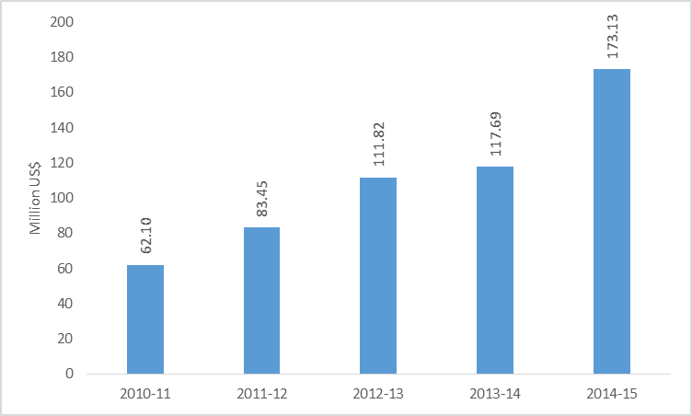
Source: EPB

The export of electronics saw some noticeable rises over the last five years (Figure 28). In 2010-11, the export was only US$ 62.1 million, which increased to US$ 173.1 million by 2014-15.

In Bangladesh, semiconductor-manufacturing industries can be easily established. It has a high demand locally as well as worldwide and can be turned into a high profit generating industry. Due to the rapidly growing rate of users, Bangladesh is soon going to become one of the largest cellular phone using countries of South Asia. This will also create a huge market for cellular technology. As the population of Bangladesh is growing, demand for electrical home appliances is growing with it. These factors show that Bangladesh is a perfect place to invest in electronics.

The sector is marked by some specific weaknesses. The most significant one is the lack of modern technological adaptation along with lack of adequate training and skill development. Others include lack of infrastructural facilities (especially inadequate supply of electricity), high transportation cost, lack of quality control facilities, high lead time for imports, high import duties for input machineries, lack of R&D facilities, and market access problems in a number of developed and developing countries.

6.1.5. Jute and Jute Diversified Products

With a growing environmental concern worldwide, demand for jute and jute goods are again reviving. Bangladesh stands second in jute production in the world followed by India. However, the once significant export items, i.e., aw jute and jute goods, have lost most of theirs markets. In recent years, increased export potentialities of jute diversified products, and thereby the initiatives undertaken both in public and private sector have generated new hopes for this sector. Jute diversified products of Bangladesh include geo-textiles, jute reinforced plastics, jute laminates, pulp and paper, decorative fabrics, carpets, and handicrafts.

As Figure 29 shows, Bangladesh’s export earnings from jute products had a fluctuating trend over the past five years. In 2010-11, the country exported US$ 904.7 million US$ of jute and jute goods which came down to US$ 727.8 million in 2014-15.

Figure 29: Export of Jute and Jute Goods
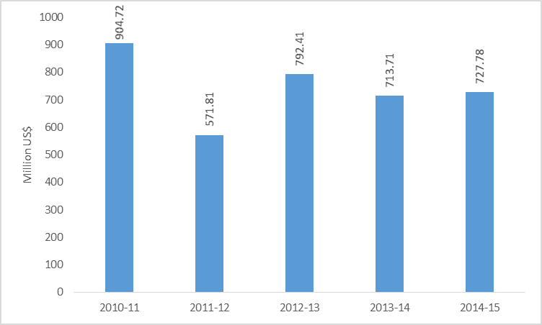
Data Source: EPB (various years)

Bangladeshi jute products are yet to exploit much of the potentials this sector has for exports expansion. Problems in export promotion activities include the lack of modern advanced technologies as well as the lack of international market needs assessment. There are also the lack of a wide product line, product development facilities, poor image of the products and limited research and developments in this line. The potentialities of jute and jute diversified products needs to be addressed properly with retention as well as extension of the existing market, improving packaging and informative campaign services, developing new application of traditional and non-traditional jute products, enhancing productive efficiency, addressing trade issues with sustainable development agenda being in front and creating a research and development network. Other than exports, domestic market should also be emphasized for ensuring balanced consumption and sales.

6.1.6. ICT

In recent years, Bangladesh has made major strides in laying the groundwork for a diverse and successful outsourcing market. In particular, the information technology (IT) services industry within Bangladesh has been growing, serving international clients and domestic clients in the banking and telecom sectors. Bangladesh’s emerging IT outsourcing players already have strong credentials, and the Bangladeshi freelancer community has supplemented IT exports. Bangladesh is consistently ranked among the top freelance work locations on employment websites like oDesk, eLance, and the like (ITC and KPMG 2012). Bangladesh is the 7th top country in terms of registered users of Upwork, which is the largest online marketplace for freelance jobs in the world (through a recent merger of eLance and Odesk). There are about 67 thousand registered users in Bangladesh.

The country offers a vast pool of young, trained, and English-speaking labor, which is available at costs almost 40% lower than in established destinations like India and the Philippines. Government authorities have demonstrated a determination to promote IT services industry in the country, including by providing cheaper bandwidth and alternate international cables, setting up technology parks, and providing tax holidays for export-oriented industries. The “Digital Bangladesh” initiative of the government is helping set up information and communication technology (ICT) infrastructure for enhanced connectivity, ICT-based citizen service delivery, and an ICT-based education system. There is evidence that many global players like Samsung, AMD, VizRT, and WorldBridge Global are setting up operations in Bangladesh (ITC and KPMG 2012). The country has positioned itself as a key outsourcing destination by enhancing delivery capability and skill availability, lowering costs of operations, making focused investments in telecom and IT infrastructure, and highlighting success stories.

The simulation exercises using a CGE model by Raihan and Cheong (2013) suggested that under different scenarios relating to IT export growth there would be positive impacts at the macro, sectoral, and household levels. A positive export shock in the IT sector would lead to a rise in employment not only in the IT sector, but also in all other sectors in the economy and indirect employment generation would be much higher than direct employment generation.

There are over 1500 registered software and IT Enabled Service (ITES) companies in Bangladesh among them over 1100 companies have the membership of Bangladesh Association of Software and Information Services (BASIS, 2016). Bangladesh exports software and IT enable services in more than 60 countries over the world and the number of exporting companies except freelancers is about 400. In terms of export destinations, USA dominates while European countries like UK, Denmark and Netherlands have emerged as major destinations during last few years. A number of companies regularly export in Australia, Japan, Malaysia, Singapore, UEA, Saudi Arabia and South Africa where the sizable Bangladeshi expatriate communities has played important role in creating attractive market demand for communication based IT service (BASIS, 2016).

Local market still constitutes the major part of business of the software and IT service industry. About 63% of BASIS member companies are focused only in local market. Over the last few years ICT sector of Bangladesh has been growing at a consistent rate of around 20 to 30 % (BASIS, 2016). The trend also shows that the market is maturing in terms of both client requirement and solution response from IT companies.

Government of Bangladesh has demonstrated the determination to promote ICT industry. In the Industrial Policy of 2016, ICT is placed as one of the most priority sectors. Few of governments’ initiatives such as cheaper bandwidth and cable line from India, establishing Technology parks and providing tax holidays for industries are taken to encourage this sector. The “Digital Bangladesh” initiative of the government is helping to setup ICT infrastructure for enhanced connectivity, ICT based citizen service delivery and ICT based education system.

There is no readily available data on the ICT sector’s contribution to the GDP. According to the Input-Output table of Bangladesh for the year 2012, ICT sector had a share of 0.01% of GDP (Khondker, 2016). This growth in IT-BPO exports has been accompanied by considerable employment growth in this industry. An estimated 20,000 or more skilled and semiskilled professionals are employed in the IT-ITeS sector. Another 35,000 IT-BPO professionals are employed in business enterprises, the government sector, and nongovernment organizations. Over 10,000 individuals are estimated to be engaged in freelance outsourcing jobs such as editing, proof reading, data entry, and web research. Freelance billings were worth over US$7 million in 2010, which placed Bangladesh seventh in freelance outsourcing earnings and Dhaka among the top five cities for such work (ITC and KPMG 2012).

The ICT sector in Bangladesh, though small in size, is seeing a growing amount of exports. From a very small amount of exports of US$ 35.4 million in 2009-10 the sector has increased its exports to US$ 125 million in 2013-14 (Figure 30). However, during 2011-12 and 2013-14, the growth rate of exports in this sector decelerated.

Figure 30: ICT sector (exports in million US$)
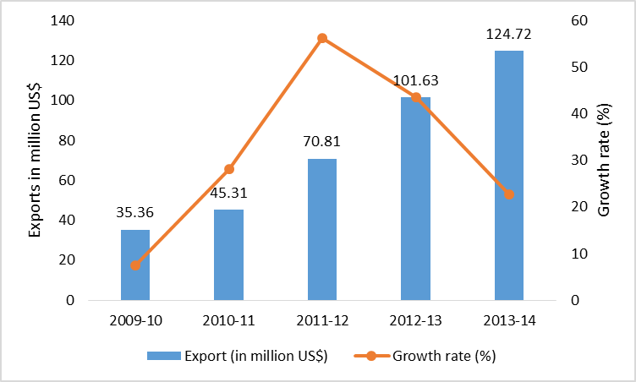
Data source: Export Promotion Bureau

The FDI in the ICT sector in Bangladesh started to increase since 2010 until 2013, from only US$ 4.4 million to US$ 29.7 million, but declined in 2014 and 2015 (Figure 31). The FDI in the ICT sector is still very low compared to the sector’s stated growth and export potentials.

Figure 31: ICT sector (FDI in million US$)
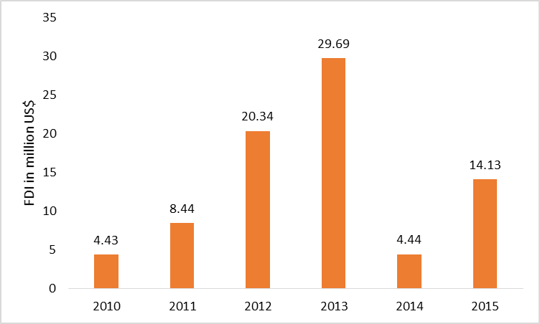
Data source: Bangladesh Bank

There are five major reasons for the bright prospects of the ICT sector in Bangladesh. First, Bangladesh has a significant advantage in terms of labour costs, as the wage rate for ICT professionals in the country is one of the lowest among ICT-exporting countries. Second, as per KPMG’s report on Bangladesh’s IT and ITES in 2012, the country has more than 7 million English-speaking residents – more than in its Latin American and East European competitors. Third, productivity of ICT workers is on rise. Fourth, the employment prospects in the sector are immense. Fifth, the government has taken several initiatives to kick-start the development of the sector.

However, the sector suffers from six major constraints. First, although Bangladesh has a cost advantage in the ICT sector, labour skills are not at the level required for greater expansion and high value-added exports. Second, physical infrastructural constraints, such as lack of a quality power supply and broadband connections, hinder the growth of the sector. Third, the sector also faces problems related to access to finance: banks do not want to provide loan facilities because of the high risks associated with the sector. Fourth, there is no unique reported figure on ICT exports/ICT production in Bangladesh, and freelancing and BPO service providers still face a great deal of regulation with regard to the payment gateway infrastructure. Fifth, political uncertainly has a negative impact on investment in the ICT sector. Sixth, absence of proper policies and lack of updated policies is hindering the growth momentum of the sector.

We suggest nine critical policy issues to address to develop the ICT sector. First, the Ministry of Information and Communication Technology (MICT), in collaboration with the private sector and international organisations, should expand the scale and scope of ICT training programmes. Second, MICT, in collaboration with the private sector, should work closely with universities to upgrade course curricula in line with the reality in the working world and to introduce e-commerce in teaching. Third, BIDA should facilitate an uninterrupted and quality electricity and low-cost broadband connection. Fourth, the Bangladesh Economic Zones Authority (BEZA) should implement special economic zones (SEZ), which would be instrumental in attracting foreign direct investment into the ICT sector. Fifth, BB should put in place provisions for better access to financial services and subsidised loans and make the EEF effective. Sixth, MICT, in collaboration with the Export Promotion Bureau and the Ministry of Foreign Affairs, should establish ICT export desks at Bangladesh’s embassies overseas. Seventh, the Ministry of Finance should establish provisions for export subsidies for ICT firms. Eighth, there is a need to generate political capital for the ICT sector through agreements among the country’s political elites. Ninth, NBR should facilitate supportive tax and tariff policies; for example, VAT and tax on ICT services, which is now at about 25%, should be lowered to 0%.

6.2. Supply-side Factors Constraining Effective Participation in the GVC

There are several supply side factors that may have contributed to constraining effective participation in the GVC for Bangladesh. These factors are directly associated with the domestic production and investment environment. Most prominent of these factors are: (1) access to finance, (2) weak physical infrastructure, (3) inefficient ports and high transport costs, (4) shortage of skilled workers, (5) technological bottlenecks, (6) lack of entrepreneurship and management skills, (7) lack of information, and (8) high costs of doing business.

6.2.1. Lack of investment funds and high interest rate

One of the most important problems affecting supply and export response is the access to finance. Finance is required to enable firms undertake productive investment in order to initiate and/or expand a business, to introduce new products and to market them. Availability of investment funds also facilitates acquiring better technology to promote competitiveness. Various survey and micro studies in Bangladesh have identified access to finance as the main problems facing the businesses including export activities. Entrepreneurs are expected to invest in projects where the potential benefits exceed the cost of investment. In Bangladesh investors face credit constraint and have to pay high interest rates on loans unrelated to their own performance. Since banks have to make provision for non-performing loans, the large share of such loans ultimately increases the cost of capital to entrepreneurs. Despite the measures taken by the government to improve the banking sector including strengthening debt recovery, non-performing loans have remained a cause for concern. The liberalization measures in the banking sector have increased the operation of the private banks; nevertheless, the competition in this sector is still weak.

The problem is even worse for small and medium scale enterprises (SMEs) including the export-oriented ones. Banks are shy to lend to SME activities, as they do not consider them as attractive and profitable undertakings. It has been found that in most cases banks and non-bank financial institutions require collateral in the form of land and buildings for advancing loans to their clients. SMEs are also regarded as high-risk borrowers because of their low capitalization, insufficient assets, and high mortality rates and consequently, they are not offered any attractive deals in terms of loans and interest rate. Furthermore, the loan application forms for investment financing from banks are long, tedious, and redundant. SMEs in the export sector also have the problem of access to working capital and there is no credit insurance policy for them.

6.2.2. Weak physical infrastructure

The state of physical infrastructure is weak in Bangladesh. Poor infrastructure requires firms to devote more resources to such tasks as procuring inputs and getting their products to market. All this can undermine the competitiveness of exporting enterprises. There are two dimensions of poor infrastructure – one is the unavailability of a certain service or utility (such as telephone, water, electricity, roads and highways, etc.) and the other is the unreliability of the services provided. In Bangladesh there are problems on both fronts. A large portion of rural areas do not have access to such facilities as electricity, water supply, and telecommunication, while in other areas where these services exist are unreliable.

6.2.3. Ports and transport costs

Ports and transport are serious problems facing Bangladeshi traders. Inefficiencies in ports aggravate the situation by eroding competitive advantage of the country further. It has also been found that ports in Bangladesh are plagued by labor problems, poor management, and lack of equipment. Inefficiency and excessive costs at ports are further exacerbated by poor customs services Apart from the delay in obtaining customs clearance, the payment of ‘extra’ money is required to complete the formalities and procedure.

Inland transportation also suffers from such problems as illegal toll collection, bad road communication, congestion at ferry-ghats, and frequent disruption in transportation due to political programs and labor unrest. Therefore, while geographical location puts Bangladesh at a disadvantaged position compared to many other competitors, inefficient and corrupt ports and inland transportation increase the cost of production substantially. Under this circumstance, many exporters find it extremely difficult to compete in the global market.

6.2.4. Shortage of skilled workers

Although Bangladesh is a labor abundant country, shortage of skilled workforce is perceived to be a major constraint for manufacturing production. This problem is particularly acute for medium scale export-oriented enterprises. Manufacturing goods now overwhelmingly dominate Bangladesh’s export basket, but a significant proportion of it comprises very low domestic value addition because of limited backward linkage. Increased backward integration and expansion of production in many other sectors will require skilled manpower. Therefore, supply capacity is preconditioned by availability of skilled workers. There is also empirical evidence which suggests that Bangladesh’s manufacturing production bases (hence exports) from low to high value-added items is unlikely to change substantially unless the general level of education and skill composition of the workforce rises.

Certain level of formal educational attainment, and job-specific training and experience are two essential components of skill formation. Therefore, both the quality of general education, and availability and suitability of vocational/technical education or on the job training are vital for skill development. Bangladesh has made good progress in terms of enrolment in primary and secondary schools, but the progress is not matched by the standard of education. While the improvement in the standard of education may require long-term planning and investment, to address the immediate need of the export industry it is most essential to arrange various short- to medium-term vocational and technical training programs/courses.

6.2.5. Technological bottlenecks

Technological up gradation, adoption of superior technology, and their effective use are important for improved productivity as well as competitiveness. Introducing new products in the world market and to make better quality products badly require using modern and up-to-date technology. Expenditures on R&D both at the national and at the firm level are very low in Bangladesh and the manufacturing sector is critically dependent on imported technology. Financial constraints do not allow most firms to modernize its technological capacity on a regular basis.

Although it is often argued that knowledge and technology travel freely, a great deal of information may be required to choose the ‘correct’ technology. Besides, investment in appropriate technology may not be sufficient to achieve international standards of productive efficiency. Overall, there is a need for technology policy, which amongst others will consider the issues of labor-intensive vis-à-vis capital-rich techniques of production, incentives for acquiring environment-friendly technology, support for firm level R&D activities, and access to information on technological advancement. The existing import regime in Bangladesh provides duty free import of machinery for export industry and other tariff preferences for spare parts, there is no explicit policy of encouraging superior or improved technology.

6.2.6. Lack of entrepreneurship and management skills

Entrepreneurship skill lies at the heart of business activities of the modern world. Today’s entrepreneurs must have management skills, should have access to up-to-date information, and must be capable enough to analyze events related to market opportunities, risks, and trends. Most managers and entrepreneurs often lack wider managerial skills that hinder their long-term success. Strategic planning, medium to long-term vision, marketing, commitment to quality, knowledge of quality systems, communicating in foreign languages, cash-flow organization, and information technology are a few critical elements of managerial skills required to meet challenges of the market economy, especially in the international market environment. In such a complex setting, since it is not possible for an individual to muster all of these qualities, firms make division of labor among their staff. A good entrepreneur recognizes the need for training of its staff and acts accordingly. However, due to many different reasons scope and opportunities for training for workers and managers even in the large firms are limited in Bangladesh. In fact, apart from learning by doing the practice of professional and formal training on a regular basis does not characterize the working environment in Bangladesh. Financial constraints along with information gap makes firms less aware of the benefits they would obtain from management training and few see training as a strategic tool. Besides, there is also a lack of facilities for such training.

6.2.7. Information

Lack of information is a major constraint to market development of Bangladesh’s exporting enterprises. Firms need all kinds of information: with regard to setting up a business, accessing finance, fulfilling government requirements, developing products, and finding markets. Trade information is more than ever an element of competitiveness due mainly to three reasons: (i) assessing market trends and characteristics, (ii) understanding the market and new market access conditions, and (iii) identifying new market opportunities and potential trading partners. The Internet has introduced a new way of doing business especially in the field of commercial operations – selling and buying, advertisement, servicing and training. The number of enterprises using Internet to market their products and services is rapidly increasing and more and more enterprises are becoming aware of the potential of this new technique. Internet has created unpredictable and unprecedented opportunities for exporting firms in the poor developing countries like Bangladesh as they can access information related to certain markets similar way as large enterprises in developed and relatively advanced developed countries do. It is now possible for export-oriented firms to engage international marketing which otherwise would have been unaffordable due to huge amount of resources required. The use of Internet at the private enterprise level is very low in Bangladesh and there is a serious lack of infrastructure in this regard. Amongst others, the dissemination of information is badly affected as result of little use of Internet.

6.2.8. Invisible costs of doing business

Business enterprises in Bangladesh are subject to invisible costs arising from widespread corruption and malpractices. These activities impose direct costs thus undermining the competitiveness of trading enterprises. Political activities like strikes and hartals also raise the costs of doing business. Corruption and hostile political situation together make the domestic environment business-unfriendly discouraging new investment in exporting activities both from local and foreign sources. Figure 21 puts Bangladesh into comparison with some of its competitor countries in terms of ranking in the Doing Business. In 2014, Bangladesh was ranked in the position at 173 out of the 189 countries.

7. Conclusion

It is important to note that strategies specified in the different policies in Bangladesh for economic and export diversification lack clear guidelines as regards implementation, and therefore, result in ineffectiveness of the strategies. A policy of supporting or undertaking a program itself cannot ensure achievement of objectives. Policy frameworks need effective institutions for successful implementation of the policies. In other words, it is institutions through which strategies are ultimately implemented. Besides, export policy usually encompasses a number of institutions or departments, and coordination of their tasks has important implications for all eligible exporting firms’ benefiting from incentives. Lack of coordination and integration in the various elements of policies has always been a major problem in Bangladesh. Since strategies remain too broad, it is difficult to analyze whether they ultimately work. It also becomes a hard task to identify the reasons for the ill-implementation of the strategies, and thus lessons to be learnt for similar future exercises.

In the case of export diversification, it has been a matter of serious concern that though there are significant incentives provided to the export sector in Bangladesh, there is formidable difficulty in actually accessing such incentives. Accessing many of those incentives was not easy and involved costs thus reduced the magnitude of support intended for exporters. It appeared that inefficient functioning of institutions dealing with the incentive programs and corrupt practices were the factors behind this tendency. Therefore, it is not the mere existence of provision for export promotional measures, but their effective well-implementation should be the main focus of policy.

Though the latest industrial policy identifies a number of high priority and priority sectors for economic diversification, there are several policy-induced and supply-side constraints that have constricted the development of these sectors. Some of these factors are sector-specific, whilst others are more general affecting the overall economy as a whole. Sector-specific problems can be identified from in-depth sectoral studies, some of which have been identified in this paper. There is a need for further research dealing with each of these sectors in a comprehensive manner. The general factors affecting the economic and export diversification can be identified quite easily: lack of investment fund and working capital, high interest rate, shortage of skilled workers, lack of entrepreneurial and managerial skills, poor physical infrastructure, inefficient ports along with high transport costs, weak institutions, poor law and order situation, invisible costs of doing business, etc. are the known supply-side impediments seriously obstructing economic activities. Therefore, it is important to address these policy-induced and supply-side constraints for stimulating supply responses from these sectors. One pragmatic way of dealing with such constraints is to consider a well-devised integrated approach. Under this approach, actions required at different levels can be brought together to make intervention schemes or support systems comprehensive. Such intervention schemes should be sector specific as well as economy-wide with a view to ensure effective diversification of the economy of Bangladesh.

Bangladesh’s achievement in economic growth over the last one decade has been quite robust. The country has recently been upgraded from low income country (LIC) to lower-middle income country (LMIC) as per World Bank’s classification. There is an aspiration of graduating from LDC status to middle income country by 2021 as per UN classification. The 7th five-year plan sets the target of 8 percent GDP growth rate by 2020. This requires a huge leap forward from the current level of 6 percent average growth rate. There is a need for increased domestic private investment and FDI targeting broader economic diversification and export diversification. Emphasis should be not only on raising the level of investment but also on the efficiency of investment. Importance should be attached to more on efficiency gains.

It is apparent that there has not been any major policy reform over the last two decades. The marginal benefits of the first generation reforms have diminished quite significantly. There is a need or a new paradigm of macro, trade and investment policies aiming at economic diversification. Tariff rates need to be further brought down and rationalized for economic diversification. The tax-GDP ratio is the lowest in this region and tax-incentive structure is imbalanced.

There is a need for rethinking industrial policy. Industrial policy is about incentive structure and effective designing of the incentive structure. There is a need for time-bound support to emerging dynamic sectors, support to pioneering firm for discovery cost, and integrating with the global value chain.

There is a need for reform of economic and political institutions for efficiency gains. Improving the bureaucracy quality, managing corruption and micro-level rent seeking activities, reducing the risk of contract modification or cancellation, reducing political uncertainties and establishing political stability, generating political capital for larger private sector investment and accelerated economic growth, are all part of the institutional reform.

Weak infrastructure is a big concern. However, in the case of electricity and gas, there is a problem of increased production vs. entitlement failure. Also, delayed implementation of the infrastructural projects increase cost. There is a need for efficient public investment in social and physical infrastructures, which can facilitate further private investment.

References

ADB and ILO (2016). “Bangladesh: Looking beyond garments. Employment Diagnostic Study”. Dhaka: Asian Development Bank (ADB) and International Labour Organization (ILO).

Ahmed, H.U. (2014). "Challenges pharmaceutical industry faces". The Daily Financial Express. http://www.thefinancialexpress-bd.com/2014/10/25/62771

BASIS (2016). “Bangladesh Software and IT Service Industry Recent Trends & Dynamics”. Bangladesh Association of Software and Information Services

Bhuyan, A. R. and M. A. Rashid (1993) Trade Regimes and Industrial Growth: A Case Study of Bangladesh. Dhaka: Bureau of Economic Research, Dhaka University, and San Francisco: International Centre for Economic Growth.

ESCAP (2016). Asia-Pacific Trade and Investment Report 2016. Bangkok

ILO (2013). "Bangladesh: Seeking Better Employment Conditions for Better Socioeconomic Outcomes", Studies on Growth with Equity, International Institute for Labour Studies, International Labour Organization, Geneva

IMF (2016). Regional economic outlook: Asia and Pacific, May 2016.

ITC and KPMG (2012). “Bangladesh Beckons: An Emerging Destination for IT-ITeS Outsourcing”, International Trade Centre, Geneva

Khondker, B.H. (2016) ‘Growth and distributional impacts of exogenous demand shock in selected activities in Bangladesh: Application of the Social Accounting Matrix Framework’, in S. Raihan (ed.) Structural change and dynamics of labor markets in Bangladesh. Dhaka: IDRC.

Mathai et al (2016). “China’s changing trade and the implications for the CLMV”. Working paper, IMF.

Nicita, A. and R. Peters (2013). "Non-Tariff Measures to Trade – Economic and Policy Issues for Developing countries." Prepared for the WTO workshop on "The Effects of NTMs on the Exports of Small Economies", Geneva, 23 October 2013

Paul, H.L., Antunes, A., Covington, A., Evans, P. and Phillips, P. (2013) “Bangladeshi leather industry: An overview of recent sustainable developments”, Journal of the Society of Leather Technologists and Chemists 97: 25–32.

Raihan, S. (2007) Dynamics of Trade Liberalisation in Bangladesh: Analyses of Policies and Practices. Dhaka: Pathak Samabesh.

Raihan, S. (Ed). (2016). Structural Change and Dynamics of Labor Markets in Bangladesh: Studies on Labor and Employment. Dhaka, SANEM Publications

Raihan, S. and Ashraf, F. (2017) “What factors matter in attracting FDI?”, Chapter 43 in Raihan, S. (ed.) Let’s think aloud, shall we? Dhaka: SANEM.

Razzaque, M. A. and S. Raihan (eds) (2007) Trade and Industrial Policy Environment in Bangladesh with Special Emphasis on Some Non-Traditional Export Sectors. Dhaka: Pathak Samabesh.

Sattar, Z. (2014) New Directions for Trade Policy. Unpublished

UNCTAD (2013). “Classification of Non-Tariff Measures.” United Nations Conference on Trade and Development. Geneva.

UNDP (2017). Report on the sustainable development of Chinese enterprises overseas.

World Bank (2004). “Trade Policies in South Asia”, Report No. 29949, Poverty Reduction and Economic Management Unit South Asia Region

World Bank (2016). “The Pharmaceutical Sector in Bangladesh. Attracting Investment in Bangladesh—Sectoral Analyses: A Diagnostic Trade Integration Study”. The World Bank

WTO (2000) Trade Policy Review: Bangladesh. Trade Policy Review Body. WT/TPR/S/68. Report by the WTO Secretariat. Geneva: World Trade Organization.

Zai and Morgan (2016). “Impact of the PRC’s growth slowdown on emerging Asia: A general equilibrium analysis”. Working paper 560, ADBI.

Annex 1: The Description of the GTAP Model

In the GTAP model each region has a single representative household, known as the regional household. The income of the regional household is generated through factor payments and tax revenues (including export and import taxes) net of subsidies. The regional household allocates expenditure to private household expenditure, government expenditure, and savings according to a Cobb–Douglas per capita utility function. Thus, each component of final demand maintains a constant share of total regional income.

The private household buys commodity bundles to maximize utility, subject to its expenditure constraint. In the GTAP model the constrained optimizing behavior of the private household is represented by a constant difference of elasticity (CDE) expenditure function. The private household spends its income on consumption of both domestic and imported commodities and pays taxes. The consumption bundles are constant elasticity of substitution (CES) aggregates of domestic and imported goods, where the imported goods are also CES aggregates of imports from different regions. Taxes paid by the private household include commodity taxes for domestically produced and imported goods and income tax net of subsidies.

The government also spends its income on domestic and imported commodities, and it collects taxes. Taxes consist of commodity taxes on domestically produced and imported commodities. Like the private household’s, government consumption is a CES composite of domestically produced and imported goods.

The GTAP model considers the demand for investment in a particular region as savings. In a multi-country setting, the model is closed by assuming that regional savings are homogenous and contribute to a global pool of savings. This global savings is then allocated among regions for investment in response to changes in the expected rates of return in different regions. If all other markets in the multi-regional model are in equilibrium, if all firms earn zero profits, and if all households are on their budget constraint, such a treatment of savings and investment will lead to a situation in which global investment must equal global savings, and Walras' Law will be satisfied.

In the GTAP model producers receive payments for selling consumption goods and intermediate inputs both in the domestic market and to the rest of the world. Under the zero profit assumption employed in the model, these revenues must be precisely exhausted by spending on domestic intermediate inputs, imported intermediate inputs, factor income, and taxes paid to the regional household (taxes on both domestic and imported intermediate inputs and production taxes net of subsidies).

The GTAP model postulates a nested production technology, with the assumption that every industry produces a single output, and constant returns to scale prevail in all markets. Industries have a Leontief production technology to produce their outputs. Industries maximize profits by choosing two broad categories of inputs – namely, a composite of factors (value added) and a composite of intermediate inputs. The factor composite is a CES function of labor, capital, land, and natural resources. The intermediate composite is a Leontief function of material inputs, which are in turn a CES composite of domestically produced goods and imports. Imports come from all regions.

The GTAP model employs the Armington assumption, which makes it possible to distinguish imports by their origin and explains intra-industry trade of similar products. Following the Armington approach, the import shares of different regions depend on relative prices and the substitution elasticity between domestic and imported commodities.

Annex 2: The Description of the Recursive Dynamic CGE Model

Much current debate focuses on the role of growth in alleviating poverty. However, the majority of CGE models used in poverty and inequality analysis are static in nature. The inability of this kind of model to account for growth effects makes them inadequate for long run analysis of the economic policies. They exclude accumulation effects and do not allow the study of the transition path of the economy where short run policy impacts are likely to be different from those of the long run. To overcome this limitation, we use a sequential dynamic CGE model. This kind of dynamics is not the result of intertemporal optimisation by economic agents. Instead, these agents have myopic behaviour. It is basically a series of static CGE models that are linked between periods by updating procedures for exogenous and endogenous variables. Capital stock is updated endogenously with a capital accumulation equation, whereas population (and total labour supply) is updated exogenously between periods. It is also possible to add updating mechanisms for other variables such as public expenditure, transfers, technological change or debt accumulation.

In each sector there is a representative firm, which earns capital income, pays dividends to households and foreigners and pays direct income taxes to the government. We adopt a nested structure for production. Sectoral output is a Leontief function of value added and total intermediate consumption. Value added is in turn represented by a CES function of capital and composite labour. The latter is also represented by a CES function of two labour categories: skilled labour and unskilled labour. Both labour categories are assumed to be fully mobile in the model. In the different production activities we assume that a representative firm remunerates factors of production and pays dividends to households.

Households earn their income from production factors: skilled and unskilled labour, agricultural and non-agricultural capital. They also receive dividends, intra-household transfers, government transfers and remittances and pay direct income tax to the government. Household savings are a fixed proportion of total disposal income. Household demand is represented by a linear expenditure system (LES) derived from the maximisation of a Stone–Geary utility function. The model includes nine household categories according to characteristics of the household head, as identified in the HES household survey. Five of these categories correspond to rural households and four are reserved for urban households. Minimal consumption levels are calibrated using guess-estimates of the income elasticity and the Frisch parameters.

We assume that foreign and domestic goods are imperfect substitutes. This geographical differentiation is introduced by the standard Armington assumption with a constant elasticity of substitution function (CES) between imports and domestic goods. On the supply side, producers make an optimal distribution of their production between exports and local sales according to a constant elasticity of transformation (CET) function. Furthermore, we assume a finite elasticity export demand function that expresses the limited power of the local producers on the world market. In order to increase their exports, local producers may decrease their free on board (FOB) prices.

The government receives direct tax revenue from households and firms and indirect tax revenue on domestic and imported goods. Its expenditure is allocated between the consumption of goods and services (including public wages) and transfers. The model accounts for indirect or direct tax compensation in the case of a tariff cut. Furthermore, general equilibrium is defined by the equality (in each period) between supply and demand of goods and factors and the investment-saving identity. The nominal exchange rate is the numéraire in each period.

Dynamic Module. In every period capital stock is updated with a capital accumulation equation. We assume that the stocks are measured at the beginning of the period and that the flows are measured at the end of the period. We use an investment demand function to determine how new investments will be distributed between the different sectors. This can also be done through a capital distribution function.2 Note that investment here is not by origin (product) but rather by sector of destination. The investment demand function we use here is similar to those proposed by Bourguignon et al. (1989), and Jung and Thorbecke (2003). The capital accumulation rate (ratio of investment to capital stock) is increasing with respect to the ratio of the rate of return to capital and its user cost. The latter is equal to the dual price of investment times the sum of the depreciation rate and the exogenous real interest rate. The elasticity of the accumulation rate with respect to the ratio of return to capital and its user cost is assumed to be equal to two. By introducing investment by destination, we respect the equality condition with total investment by origin in the SAM. Besides, investment by destination is used to calibrate the sectoral capital stock in base run.
Total labour supply is an endogenous variable, although it is assumed to simply increase at the exogenous population growth rate. Note that the minimal level of consumption in the LES function also increases (as do other nominal variables, like transfers) at the same rate. The exogenous dynamic updating of the model includes nominal variables (that are indexed), government savings and the current account balance. The equilibrium between total savings and total investment is reached by means of an adjustment variable introduced in the investment demand function. Moreover, the government budget equilibrium is met by a neutral tax adjustment.

The model is formulated as a static model that is solved sequentially over a 40 period time horizon. The model is homogenous in prices and calibrated in a way to generate "steady state" paths. In the baseline all the variables are increasing, in level, at the same rate and the prices remain constant. The homogeneity test, e.g. a shock on the numéraire the nominal exchange rate, with the “steady state” characteristics, generates the same shock on prices, and unchanged real values, along the counterfactual path. This method is used to facilitate welfare and poverty analysis since all prices remain constant along the business as usual (BaU) path.

Dr. Selim Raihan is Professor, Department of Economics, University of Dhaka, Bangladesh and Executive Director, South Asian Network on Economic Modeling (SANEM). Email: selim.raihan@econdu.ac.bd
See www.pwc.com
Full documentation of the GTAP model and the database can be found in Hertel (1997).
Share of domestic value added exported for China’s final demand is about 3 percent of GDP for Asia, compared to global average of about 1.5 percent. Of the 3 percent, about two-thirds is investment demand and rest consumption demand.
Based on a counterfactual scenario in which real investment growth in China is lowered by 3 percentage points in each year of 2016-2020.
The analysis uses two equations to consider effects operating both through onshoring and through exports to other markets on account of competition from Chinese exports.
As Raihan (2016) shows, in the case of the shares of different sub-sectors in the manufacturing GDP, during 1999-00 and 2011-12, the major gainer has been the textile and readymade garment sub-sector, which by 2011-12 increased its share of the manufacturing GDP to 37.8 percent from 28.4 percent in 1999-00. This suggests that over the years, in terms of sub-sectoral shares in value-addition, the manufacturing sector has become more and more concentrated around the textile and readymade sub-sector.
Cited from UNIDO Expert Team, Technical Report, United Nations Industrial Development Organization (UNIDO). TF/BGD/05/001, (2005)
Industrial Policy of 2016 by the Ministry of Industry, Government of Bangladesh
http://www.thedailystar.net/leather-sector-aims-for-5b-in-exports-54932
Bangladesh Tanners Association (BTA), Survey Report. 2010, Dhaka, Bangladesh
Data from the Labour Force Survey of the Bangladesh Bureau of Statistics.
Data source: Export Promotion Bureau
https://www.techinasia.com/this-bangladeshi-startup-wants-to-help-foster-the-freelance-community-in-south-asia
Savings enter into the static utility function as a proxy for future consumption.

