2012
The First Implementation Review of the Sixth Five Year Plan

General Economics Division
Planning Commission
Government of People’s Republic of Bangladesh

Contents
List of Tables iii
List of Figures iv
List of Boxes v
List of Annex Tables v
List of Annex Figures v
Executive Summary vi
Chapter 1: Sixth Plan Monitoring and Evaluation Framework 1
Objectives and Rationale 1
The Results Framework 1
Methodology and Approach 8
Scope of Sixth Plan Results Framework 10
Limitations of the Result Framework 12
Organization of the Report 13
Chapter 2: Implementation of the Sixth Plan Macroeconomic Framework 14
Introduction 14
Overview of Macroeconomy 14
External Environment 16
Real Sector Developments 22
Macroeconomic Stability 31
Monetary Developments 40
Poverty 42
Chapter 3: Implementation of the Sixth Plan’s Sectoral Programmes 49
Introduction 49
Human Resource Development 49
Water and Sanitation 55
Energy and Infrastructure 57
Gender Equality 61
Environmental Sustainability 62
Information Communications Technology (ICT) 65
Urban 66
Governance 67
Chapter 4: Strengthening Institutional Arrangements for Monitoring and Evaluation 69
Overview 69
Institutional Arrangements for M&E 69
Critical Role of Good and Timely Data 74
Coordination with Development Partners 75
Making Effective Use of M&E Findings 77
Conclusion 78

List of Tables
Table 1.1: Complementary Roles of Monitoring & Evaluation 2
Table 1.2: Accountability Cycle, Documents and Performance Indicators for M&E in South Africa 5
Table 1.3: RF Indicators for which Annual Data are Readily Available 11
Table 1.4: RF Indicators for which Planning Commission Needs Special Efforts 12
Table 2.1: Summary of Key Macroeconomic Targets 15
Table 2.2: Economic Outlook by Major Economies (%) 17
Table 2.3: Sectoral Growth Performances 22
Table 2.4: Saving and Investment, FY10 – FY12 25
Table 2.5: Revised Sectoral ADP Allocation FY2012 28
Table 2.6: Bangladesh Current Account Balance Situation 36
Table 2.7: Monetary Policy and Outcome (growth rates %) 41
Table 2.8: Headcount Poverty Rate (%) 42
Table 2.9: Gini Index of Per Capita Income 44
Table 2.10: SFYP Poverty Targets; Head Count Poverty under Different Elasticity Assumptions 47
Table 3.1: Water Supply- Target Coverage at the end of SFYP* 56
Table 3.2: Sanitation- Target Coverage at the end of SFYP 56
Table 3.3: Comparison of Infrastructure Quality, 2010-11 58
Table 3.4: RHD Physical Targets of the SFYP 59
Table 3.5: Bangladesh: New Electricity Production Plan (In MW) 61
Table 3.6: Power Sector Performance: FY09-FY12 61

List of Figures
Figure 2.1: Growth in Exports FY 2008-FY2012 18
Figure 2.2: Number of Persons Going Abroad 19
Figure 2.3: Foreign Direct Investment (Million USD) 20
Figure 2.4: Net Commitment of Foreign Assistance as Percent of GDP 21
Figure 2.5: Developments in Quantum Index of Manufacturing Production 23
Figure 2.6: Trend in Public Development Spending (% of GDP) 26
Figure 2.7: Actual ADP Spending in Relation to the Budget 26
Figure 2.8: Revised Budget and Actual Expenditure as Percentage of Budget 27
Figure 2.9: Recent RMG Export 30
Figure 2.10: Cumulative growth of Export Performance 30
Figure 2.11: Trends in LC Openings for Capital Machineries 31
Figure 2.12: Tax Performance 32
Figure 2.13: Composition of Deficit Financing, FY10-FY13B (% of GDP) 33
Figure 2.14: Disbursement/Commitment Ratio of ODA (%) 34
Figure 2.15: Foreign Aid Fragmentation in Bangladesh 35
Figure 2.16: Remittance Earning (in million USD) 37
Figure 2.17: Gross Foreign Reserves (Billion USD) 38
Figure 2.18: Net Capital Account Balance 38
Figure 2.19: Exchange Rate and REER Movements 39
Figure 2.20: Trends in Inflation 40
Figure 2.21: Monthly CPI Inflation Rate (%) 40
Figure 3.1: Primary School Completion Rate 50
Figure 3.2: % of Births Attended by Skilled Personnel 54
Figure 3.3: Under 5 Mortality (per 1000 live births) 55

List of Boxes
Box 4.1: India Statistical Strengthening Project 76

List of Annex Tables
Table A1.1: Monitoring and Evaluation Framework for the Sixth Five Year Plan of GoB 79
Table A2.1: Trends in Sectoral Share of GDP in South Asian Countries 84
Table A2.2: Trends in Sectoral Growth Rates in Selected South Asian Economies 84
Table A2.3: Trends in Export and Imports in Selected South Asian Countries 87
Table A2.4: Trends in Current Account Balance in Selected South Asian Countries 87
Table A2.5: Trends in Poverty in Selected South Asian Countries (percent of population) 89
Table A3.1 : Dickey Fuller test for unit roots 90
Table A3.2: Employment projection and less employment under different growth scenarios 92

List of Annex Figures
Figure A2.1: Average Annual GDP Growth Rates in Selected South Asian Countries 83
Figure A2.2: Trends in Investment in Selected South Asian Countries 85
Figure A2.3: Trends in Saving in Selected South Asian countries 86
Figure A2.4: Trends in Trade-to-GDP Ratio in Selected South Asian Countries 86
Figure A2.5: Trends in Tax-to-GDP Ratio in Selected South Asian Countries 88
Figure A2.6: Trends in Fiscal Deficit in selected South Asian Countries 89
Figure A3.1: Regression Results 91

Executive Summary
Background
The Sixth Five Year Plan (2011-2015) seeks to accelerate growth and reduce poverty. With the completion of the second year of the Plan, the Government believes it is important to evaluate the implementation progress with a view to understanding how well the Plan is being implemented, what policies are working, what are the emerging constraints, and what needs to be done to make mid-course corrections.
Recognizing the importance of a result based monitoring and implementation (M&E) system, the Government placed top priority to extend the existing structure of M&E to one that tracks results. The Sixth Five Year Plan defines this priority in concrete terms by outlining the actions required to move towards a results-based M&E.
The Results Framework
For M&E purposes the Sixth Plan provides a results framework (RF) that contains 35 measurable indicators under 9 broad themes. The 9 themes of the RF can be categorized as falling under two broad groups: macroeconomic performance and sectoral performance. The macroeconomic category deals with objectives and indicators concerning the overall economy and includes performance on GDP growth, investment, exports, macroeconomic stability and poverty reduction. This maps to the first theme of the RF. The remaining 8 themes concerning human development, water and sanitation, energy and infrastructure, gender, information communications technology, environment, urban and governance all relate to sectoral performance.
The Sixth Plan constitutes the first attempt in the history of Bangladesh planning to develop and implement an RF. It is therefore understandable that there are large gaps in terms of quantitative indicators, data, capacity and accountability. The RF in the Plan document is indicative and is not fully-fleshed in the sense that in many areas it is not fully representative of the targets and outcomes of Sixth Plan. This is particularly true of the sectoral targets. In some instances the baseline data are outdated or not specified. Some sectors, such as governance and public administration, are particularly not well specified in the RF. So, assessment of performance in these areas is qualitative. Given these limitations, this first M&E endeavour should be seen as essentially a hands-on-learning exercise that could be use as a pilot to move forward with future M&E work.
Another important point to note upfront is that an M&E effort is not intended to serve as a score-card for government performance. It is a learning tool that helps the government to make sound and realistic economic planning and policy management. The main objective of the M&E is to help the government understand areas where policies and programs have not gone well for a variety of reasons including external environment factor (e.g. the European Debt Crisis), unanticipated internal political developments, domestic economic shocks and implementation constraints. Based on this analysis, it is expected that the government will take corrective policy actions as appropriate.
Assessment Results
The Macroeconomy: While the Sixth Plan set fairly realistic macroeconomic targets supported by a well-rounded and consistent macroeconomic framework, the outcomes for the first two years of the Plan suggest a mixed record of performance. The GDP growth was on target in FY11 but is expected to be somewhat lower than planned in FY12. The current account and fiscal balances are broadly on target, but there is substantial shortfall in the targets for the investment rate, growth of exports and the inflation rate. At 6.3% the GDP growth in FY12 is healthy and exceeds the performance in most developing countries. But it is below the Plan target of 7%. A bigger concern is the inflation rate. Instead of being contained and reduced as targeted in the Sixth Plan, the average inflation rate continued to rise in FY11 and peaked in FY12. Slower GDP growth and higher inflation relative to the Plan targets, unless tackled forcefully, will likely have adverse implications for employment and poverty reduction targets of the Sixth Plan.

In an open economy, the external developments can have positive or unanticipated negative implications for development efforts. The export performance in FY 11 benefitted from the recovery of world demand from the global financial crisis. But the export performance in FY12 was adversely affected by the European debt crisis. On the financing side, the positive outcome on the remittance front has helped counter the adverse effects of slowdown in growth of exports in FY12.

Agricultural sector growth was strong in FY11 (5%) but slumped to 2.5% in FY12, which is substantially below target (4.5%). Manufacturing growth also accelerated in FY11 (9.3%) supported by a surge in exports (40%) that was fueled by exports of ready-made garments (RMG). The Euro-debt crisis hurt RMG exports in FY12 that in turn slowed exports (6% compared with target of 14.5%). The sharp slowdown in growth of exports tended to pull down the growth of manufacturing sector. Fortunately, vibrant growth in domestic demand-based manufacturing including small scale enterprises largely offset this. As a result, the manufacturing growth remained on track (9.5% as compared with target of 9.6% Plan target).

For the future, the world demand is expected to recover that will support a faster expansion of exports. Similarly, with policies to help diversification, the agriculture sector growth is likely to recover. However, from the longer-term perspective, the main concern for the sustainability of the Sixth Plan growth target is the substantial shortfall in the rate of investment in both FY11 (24.7% as compared with the target of 25.9%) and FY12 (24.9% as compared with the target of 26.8%). This shortfall constrained the ability to strengthen the supply of infrastructure services, especially power. Unless the challenges of infrastructure and the expansion of the overall investment rate needed to finance the higher GDP growth are tackled upfront, there is a substantial risk that the Sixth Plan GDP growth targets may not be achievable.

A major unanticipated factor underlying the shortfall in the investment rate is the emergence of a resource constraint. In recent years Bangladesh was fortunate in experiencing a rapidly expanding national saving. This made it possible to finance a growing domestic investment even in the absence of a buoyant foreign direct investment and dwindling official assistance. The financing environment has changed rapidly over the past 2 years. Compared to a saving rate of 28.1% in FY10, it has declined dramatically in the first two years of the Plan, sliding to 25.7% in FY11 and further falling to 25.2% in FY12. This dramatic change in the saving outcome is a major negative development that requires urgent attention.

Both public and private savings effort declined. The projected increases in public saving during the first two years of the Plan did not materialize as growing energy and food subsidies increased public consumption. As well, the projected financing of public investments from foreign sources, both official and through PPP channels, did not materialize to the extent projected in the FY11 and FY12 budgets. In the private sector, strong growth in private consumption in FY11 and FY12 lowered private savings. For the economy as a whole, the macroeconomic balances saw a sharp swing in FY11 and FY12 as both public and private consumption soared, savings rate fell and investment rate stagnated. Commensurate increases in foreign saving required to offset the decline in national saving were not available.

In the foreign account, despite satisfactory trend in export growth in recent years, the trade deficit has been widening due to persistently high imports of fuel, food and capital goods. The trade gap widened from US$ 4.7 billion in FY09 to $7.3 billion in FY11. This widened further in FY12 to $8.5 billion in FY12. Along with the gap on the services and other income accounts, the total financing gap on the trade and services account would widen from $$7.7 billion in FY09 to $13.3 billion in FY12. Bangladesh is fortunate to be able to finance these gaps in the current account by the large influx of remittance income, supplemented by some additional private transfers and official grants. These inflows, particularly from remittances, were large enough to finance such gaps and still allow a surplus in the current account. The outlook for remittance is one positive external development in FY12. The improved prospect for migrant workers is translated in growing remittance inflows. Monthly flows now exceed a billion dollars. For FY12, total remittances reached $12.8 billion (11.6 percent of GDP). Nevertheless, despite this positive outlook for remittances, the widening gaps in trade and services account of the balance of payments are becoming a source of concern. While these gaps are still lower than the total inflow of remittances, the current account surplus is narrowing sharply. This is a huge swing in the macroeconomic environment, with the current account moving from a large surplus of 3.4% of GDP in FY10 to a surplus of 0.3% of GDP in FY12. While this is still a positive development and more generally a current account deficit is a normal result for a low income developing country like Bangladesh, the main problem is the lack of adequate foreign funding in the capital account. To achieve the growth rate targeted in the Sixth Plan Bangladesh needs to mobilize substantial higher inflows of official aid and foreign direct investment as an important element of financing required investments during the Sixth Plan.

The fiscal stance in FY11 and FY12 were moderately expansionary with overall deficit contained at or below 5% of GDP as projected in the Sixth Plan. Revenue performance has been good and in line with the Sixth Plan targets. On the spending front, a rapid growth in fuel subsidies created major fiscal problems in both fiscal years. The budget deficit targets were maintained by cutting development spending. On the financing front, foreign aid disbursement has been slowing down. The declining trend in external financing has intensified reliance on domestic borrowing to finance the budget deficit. A particularly worrisome development was the increase in net borrowing from banking sources, which jumped to 2.6 percent of GDP in FY11 from (-) 0.3 percent of GDP in FY10. It further increased to 2.8% of GDP in FY12.

Bangladesh has been facing growing inflationary pressures. The rate of inflation has crept up steadily since July 2009. On a yearly average basis the inflation rate increased from 7.3% in FY10 to 8.5% in FY11 and surged to 10.6% in FY12. Increase in the inflation rate was initially driven by high food prices, but non-food prices have been soaring in recent months. Inflation in Bangladesh can be explained through both supply and demand side factors. Soaring international commodity prices were the main source of food inflation. Meanwhile, an expansionary monetary policy during FY10 and FY11 boosted domestic demand, creating upward pressure on prices.

During FY10 and FY11 Bangladesh Bank’s monetary targets were exceeded in practice primarily due to growth in credit to public and private sector. In FY11, monetary growth was high partly because of the monetization of the fiscal deficit through government borrowing from Bangladesh Bank. The stock of government borrowing from Bangladesh Bank at end-June, 2011 was 43.6 percent higher than that at end-June, 2010. The FY12 monetary policy statement (MPS) for the first half aimed to restrain domestic credit growth by selectively containing the growth of credit for wasteful, unproductive and speculative uses. The MPS also sought to ensure adequate credit flows for all productive pursuits in manufacturing, agriculture, trade and other services. However, achieving this balance required coordinated fiscal policy management that keeps borrowing from Bangladesh Bank to a minimal level. In the event, this has proven difficult owing to larger-than-budgeted energy subsidies. Controlling inflation, therefore, has been a major challenge during the first two years of the Sixth Plan. The good news however is that efforts since the second half of FY12 to tighten domestic credit and money supply have yielded positive results. Inflation rate has been falling in the second half of FY12. Building on the success of the MPS of the second-half of FY12, the MPS for the first half of FY13 aims to consolidate the gains made in the second half of FY12. If this progress is sustained, there will be a further decline in inflation.
Poverty and Inequality: The SFYP targeted a substantial reduction in poverty from 32.5% in FY10 to 22.9% in FY15. This target was underpinned by an average GDP growth rate of 7.3% for the plan period and the assumption that there will be no further worsening of income distribution. The shortfall in GDP growth in FY12 is a source of concern for poverty reduction.
The assumption of no worsening of income/consumption distribution is a predicated on proper implementation of all the Sixth Plan programs related to the poor and vulnerable population including higher funding for social security programs. The target to increase social security spending to 2% of GDP in FY11 was not achieved and the prospect for increasing this spending to 3% of GDP by FY15 is challenging. Additionally, available M&E of a number of social protection spending suggest a mixed record of achievement. Similarly, while the FY11 and FY12 budgets have emphasized spending on education, health, and rural infrastructure, the levels of spending are below those needed for sustained improvement in these services. The other key development that could seriously hurt income/consumption distribution is inflation. There is considerable empirical evidence that inflation hurts the poor relatively more than the rich. So, higher inflation since 2009 is of serious concern. .

Sectoral Programmes: Unlike the evaluation of the macroeconomy, the analysis of sectoral results is constrained by the lack of relevant data for FY12. So, only preliminary and qualitative conclusions can be drawn based on historical trends and data for FY11. Even for FY11, there is no data for a number of sectoral programs. Available evidence suggests that the RF targets for education, water, forestry and ICT are on track, but targets for health, gender, energy, infrastructure, environment, sanitation, urban and governance need attention.

At a general level, the shortfalls in implementation of the public investment program in FY11 and FY12 noted above have contributed to difficulties in achieving the physical targets of most sectoral program. In particular, many of the large public investment programs in energy and infrastructure did not happen owing to foreign financing constraint. Procurement problems primarily created difficulties. Shortage of domestic funding also created problems in health, education, sanitation, urban, transport and social protection.

Regarding sectoral policy reforms, progress appears to have been mixed. Progress was made in adjusting energy prices, deregulating the telecommunications sector, and attracting private investment in ICT, health and education. The agriculture sector support policies are also broadly on track, although they remain focused on food production and may need to be revised to support agricultural diversification. But a large shortfall in the PPP target for energy and infrastructure investment happened owing to weak progress in implementing the policy framework for PPP. Similarly, the progress on coal policy and new investments in gas sector were inadequate. There is also a substantial unmet policy agenda in environmental management. Fiscal and pricing policies for environmental management are conspicuously absent from policy discussions and discourse. Availability of funding for waste management, urban slums upgrading, lake water treatment and river dredging is also a substantial challenge.

Institutional reforms are key to achieving many of the sectoral targets, especially in urban, environment, transport. Available information suggests that progress was made in strengthening the power sector institutions and in strengthening the delivery of public education. But progress with reforming the urban sector and in the area of governance was limited. The urban sector has serious governance and institutional problems that were identified in depth in the Sixth Plan along with suggestions for reforms. It does not appear that the institutional and policy reform agenda has received much attention from the Government so far.
The governance challenge for Bangladesh is complicated and complex. It primarily concerns quality of institutions and public administration. On the institutional side progress has been made in establishing parliamentary oversight bodies, separating the judiciary from administration, and improving the electoral process. However, progress in establishing strong local governments has been mixed. While local government elections have been conducted, these institutions are weak and do not have financial autonomy. Regarding public administration, the government has adopted an ambitious program for merit based recruitment and performance based promotions. Nevertheless, the capacity of administration and quality of civil service remains fragile.
Implications for Policy Reforms

It is obvious that the poverty reduction targets for the Sixth Plan face serious downside risks that require careful monitoring and policy actions. Corrective policy measures to increase the investment rate focused on infrastructure, strengthening agricultural diversification, sharply reducing the rate of inflation and improving the level and quality of social safety net spending are of particular significance for securing the poverty reduction goals of the Sixth Plan.

On the growth front, the highest priority is to increase the investment rate. The financing constraint could be addressed by reducing energy subsidies, strengthening income taxes ( eliminating the exemptions on capital gains, introducing a broad-based property tax system), attracting foreign private investment and mobilizing more resources from development partners. The PPP initiative for infrastructure financing could be revitalized by creating PPP Wing/Division under Planning Commission, staffed by trained and relevant officials. Public investment programs should be protected from budgetary cutbacks and implementation capacity strengthened by providing necessary training and preparing career planning to the related government officials. Stronger partnership with development partners in project development and implementation will also help.

Exports could be boosted by reducing trade protection, reducing trade logistic costs by improving transport and port services. The potential for agricultural exports including exports of foodgrain may also be explored. Bangladesh has already made some headway in exporting food-products. The lessons of that experience might be reviewed for policy support. Agricultural export, including foodgrain, is possibly the best strategy for supporting production and income for farmers in the current business environment. The other area where Bangladesh may have export potential concerns exports of services. The highly positive services exports experience of India provides a good example of how this might be promoted in Bangladesh.

The social sector programmes need more attention. The priority given to health, education and social protection is appropriate but budgetary resources allocated to these programmes is lower than needed to achieve the poverty reduction targets of the Sixth Plan. A part of the additional resources mobilized by cutting energy subsidies and increasing income taxes might be reallocated to these programmes. In the area of social protection, corrective policy actions to improve program design, reduce the multiplicity of programs, and improve targeting are also needed. In environmental management attention could be given to fiscal and pricing policy aspects. In energy resolving the primary fuel shortage requires urgent policy attention.

Institutional reforms to strengthen the urban management, local governments and public administration need to be bolstered. The strategies and policies for these reforms are well identified in the Sixth Plan. The implementation of these strategies and policies require urgent attention.

Institutional Framework for M&E

The M&E framework should be best seen as a dynamic process. Given data and capacity limitations, the M&E process will evolve and mature over time. International experience with good practice M&E will be helpful in starting the process on the right track, but these experiences will have to be tailored to the Bangladesh context and the underlying constraints.

An effective M&E strategy calls for a combination of institutions, quantitative targets and benchmark, data and political commitment. In Bangladesh, the Government has provided political support and interest in developing an effective results-based M&E as articulated in the Sixth Plan. This is an encouraging beginning and needs to be cashed in with a well articulated strategy for M&E. The assignment of the Planning Commission as the focal point for M&E strategy is a welcome development. Simultaneously with the adoption of the medium-term budgetary framework (MTBF) as the main instrument for coordination with national planning and fiscal management, the role of M&E at the line ministry level also gains significance. While the Planning Commission should rightly focus on developing a nation-wide M&E framework in coordination with the Ministry of Finance and the line ministries, its own M&E focus ought to be on high level outcomes related to the implementation of the national plans and major policies. Specific project level M&E ought to be the responsibility of the line ministries.

The line Ministries constitutes the main agencies who implement government policies and programs. They play the key role in developing and implementing projects. As such, they are a critical player in revamping the M&E framework. On the other hand, performance evaluation is assigned primarily to IMED. However, the IMED presently does only financial and physical monitoring of ongoing projects. They do not undertake evaluation or any results-based M&E of projects. At the program level, there is no M&E effort at all, except reviews done by donor agencies in the context of program-based financing. Overall, the M&E gap is yawning and will require concerted effort over a long period of time.

At the project level, M&E coordination is assigned to IMED. To enable IMED do proper results-based M&E a thorough review of the present functions, accountabilities and capacities of IMED is necessary. Based on a proper diagnostics, the IMED role will have to be redefined. Along with this redefined role, the capacity of IMED will have to be developed with proper staffing, technology and other resources. This is clearly a long-term effort. Yet, the IMED reform program will need to identify intermediate incremental steps to move forward with its proper implementation.

The macro-level M&E is assigned to the General Economics Division (GED) of the Planning Commission. It is now necessary to strengthen its capacity. The effort again will be long-term, but it is possible to start in a phased manner. GED already has developed some capacity in the context of this first Implementation Review. This could be used as a starting point to scale up the effort. As a first step, GED could be assigned responsibility for doing the mid-term review of the Sixth Plan in year 2013, followed by a full Sixth Plan M&E in 2016. To make this possible, some minimum institutional rearrangements will be needed. For example the work program of the present macroeconomic monitoring unit of GED could be redefined to make Sixth Plan related M&Es as a key part of its accountability. To deliver this accountability, GED will require technical assistance that could be funded through donor support. Over time, the capacity of GED will need to be built up with proper staffing, skills and technology

In addition to reforming the coordinating units in the Planning Commission, the M&E capabilities of the line ministries themselves will need to be strengthened. This responsibility could be assigned to the planning wings of the line ministries. These wings may need to be strengthened with trained officials and technology to prepare project performance reports and results data. They in turn will coordinate with the responsible unit of the Planning Commission (i.e. IMED and GED as relevant). IMED/GED will provide beforehand the agreed M&E results framework to each line ministry so that each ministry knows its commitments and the benchmark against which performance will be evaluated. The M&E framework will be some combination of quantitative benchmarks and targets as well as illustrative qualitative assessment. Such assessment will initially be provided by the line ministries based on constraints, financial resources and other factors that underlie the delivery of results. An iterative process might be necessary to get the required information for doing proper M&E.

The quality and relevance of a results-based M&E are critically dependent on the timeliness and quality of data. At the national level, the Bangladesh Bureau of Statistics (BBS) is the primary data institution in Bangladesh. The BBS role has slowly evolved and over time it has developed substantial experience and competence in providing a range of data at a national, district, and sectoral basis. In particular, the BBS has developed commendable competence in conducting Household Income and Expenditure Surveys (HIES) and doing poverty and income distribution estimates based on these surveys.

Despite the progress, the data effort needed to do proper results-based M&E at the sectoral or program level is quite weak. This is well illustrated by the limitations of this first implementation review. While major macroeconomic data on an annual cycle is relatively easily available, sectoral data relating to outcomes in social sector is only available with considerable gap and on a 3-5 year cycle. The data base to measure the performance of public institutions and governance hardly exists. These are serious limitations to the conduct of proper M&E of sectoral and national programs and will need to be addressed on an urgent basis. Strengthening of the BBS is probably the topmost priority for instituting a results-based M&E.

A related area where database is weak and serious effort is needed concerns data at the district level. BBS provides some data at the district level, but this is not adequate. National accounts and budget data at the district level is weak and not up-to-date. The quality of data at the national level, which is supposed to represent an aggregation of district level data, can be cross-checked and improved through a proper reconciliation of district and national level data. The M&E effort can also be extended to district level with the availability of this database.
The M&E tools are evolving and practices are taking new shapes. The staff involved in M&E needs continuous support in the form of training and capacity building. Without appropriately trained officials it will become increasingly difficult to run a results-based M&E system. Not least is the need to develop appropriate incentive mechanisms for compliance with the M&E system. Lack of incentives implies lack of morale and less productivity, which in turn will lead to poor M&E.

Chapter 1: Sixth Plan Monitoring and Evaluation Framework

Objectives and Rationale
The Vision 2021 and the associated Perspective Plan 2010-2021 have set solid development targets for Bangladesh by the end of 2021. Those targets if achieved will transform Bangladesh to the first stages of a middle income economy from a low income country. Along with higher per capita income, Vision 2021 lays down a development scenario where citizens will have a higher standard of living, will be better educated, will face better social justice, will have a more equitable socio-economic environment, and the sustainability of development will be ensured through better protection from climate change and natural disasters.
The implementation of Vision 2021 will be done through two medium term development plans, with the first spanning FY11-15. The Sixth Five Year Plan (2011-2015) envisages to accelerating growth and reducing poverty. The Government recognizes that in a market economy like Bangladesh where the bulk of the economy is privately owned and managed, the role of planning is essentially indicative in nature. A key focus of the plans is therefore on strategies, policies and institutions to help guide the private sector in helping Bangladesh achieving the goals set in underlying policies and programs.
The Government understands that an effective monitoring and evaluation (M&E) system is crucial to monitor the implementation of both long-term as well as short term plans and associated programs. Without an effective M&E structure, resources might be spent in an inefficient manner and could be disbursed to projects that are not consistent with the overall development priorities of the country. The existing M&E structure of Bangladesh is focused on tracking spending of projects/programs; it does not offer a results-based analysis that would ensure the best utilization of scarce resources. In recognition of this shortcoming, the Government has placed top priority to extend the existing structure of M&E to one that tracks results. The Sixth Five Year Plan defines this priority in concrete terms by outlining the actions that are planned to move towards a results-based M&E Planning Commission 2011).

The Results Framework
Monitoring and evaluation systems can be classified into two groups: (i) traditional implementation-focused M&E systems and (ii) results-based M&E systems. The former tries to answer certain questions like whether the project mobilized required inputs or whether the project delivered intended outputs etc. The implementation approach focuses on monitoring and assessing whether a project, program, or policy has been executed successfully or not. However, this approach does not provide policymakers or stakeholders with a proper understanding of the success or failure of that project, program, or policy.
On the other hand, results-based M&E systems are designed to address the questions like, what are the goals of the organization, whether they are being achieved, in which way the achievement can be proven etc. The key elements of results monitoring are: (i) baseline data for describing the problem/situation before the intervention has taken place, (ii) appropriate indicators reflecting outcomes, (iii) data on outputs and the knowledge of the ways they contribute towards achievement of outcomes. Monitoring and Evaluation are both essential to analyze the outcome of intervention being reviewed.
Table 1.1 shows the complementary roles of Monitoring and Evaluation in a results based environment. They are basically two legs of any effective results framework.
Table 1.1: Complementary Roles of Monitoring & Evaluation
Monitoring | Evaluation
Focuses on primary objectives pertaining to the program | Analyzes the root causes of success or failure of the predicted and actual outcomes
Channels associated activities and resources to objectives | Stresses the causality of objectives and results
Sets appropriate performance indicators and targets | Mechanizes the process of implementation
Systematically collects data on the indicators to reflect on the desired outcomes | Provides experimental explorations with unintended results
Communicates the management and stakeholders associated with the problem | Provides with lessons, insights, feedbacks and recommendations; along with potentialities and improvement of the program
Source: Khandker, S. R., Koolwal, G. B. and Samad, H. A. (2010). Handbook on Impact Evaluation: Quantitative Methods and Practice. The World Bank: Washington DC.

Procedural Steps towards a Results-based M&E System

The results-based M&E seeks to measure and analyze the impact of an intervention both at the micro level (a project or policy) and at the macro level (public investment program or the national development plan). Although there is no hard and fast rule for the best practice results-based M&E, the following steps outline the common framework of a results-based M&E:
- Conducting a readiness assessment to understand why a result based M&E is required.
- Selecting the outcomes to monitor and evaluate for determining the success and failure of a program.
- Selecting key indicators to monitor outcomes.
- Keeping track of the factors which would directly or indirectly affect monitoring.
- Analyzing the current trends, possibilities and previewing the status quo with the baseline data on the indicators.
- Capturing the inter-linkage of goals, outcomes, targets and strategies based on quality and diversity of the related inputs.
- Carefully selecting a pragmatic evaluation procedure to correlate the planned and actual trends of performance.
- Analyzing the results of evaluation procedure and reporting findings to the stakeholders.
- Sustaining the M&E system within the organization while internalizing the tested methods of M&E into the existing structure of management.

M&E System at Micro-Macro level and Approach for the Macro level

As mentioned above, in the context of monitoring and evaluation two basic branches exist –
- First branch deals with the assessment of individual projects/programs/intervention and the other is concerned with economy wide/sector wide programs incorporating several projects/programs/interventions. The effectiveness of monitoring and evaluation of micro projects are primarily concerned with the accuracy of sample selection and the efficiency of the application of appropriate methodology.
- The target of the macro M&Es are to monitor and evaluate the implementation of all development projects as well as to conduct evaluation of strategic plans to ensure their proper implementation. It therefore helps the policy makers to evaluate existing policies and to design future policies and strategies.
The M&E framework at the micro level is very different from the macro level, especially because the “with and without experiments” to measure “impact” can be conducted quite readily for micro M&Es while these are rarely possible at the macro level. Also, given the complexities of the macro outcomes, the methodology for M&E is much more pragmatic and simplified than the methodology for micro evaluation where data requirements and estimation techniques can be sophisticated. Since most the elements of the SFYP fall under the purview of the macro level, the focus is on the various aspects of macro level M&E system.
International Experience of Macro Level M&E

The application of a results framework for macro level monitoring and evaluation is a new phenomenon and hence widespread international experiences are not available. The review of the experience of five available countries/agencies are summarised here.
China’s M&E of the 11th Five-Year Plan: The 11th Five Year Plan of China was based on “five balances” or guiding principles aiming at high economic growth which is consistent with environmental and natural resource constraints. For evaluating the plan, an indicator matrix with 22 indicators was used where each of the indicators contained baseline and target. In terms of target, six of the indicators target economic growth and structure and 16 emphasized on issues related to environment, resources and social development. Eight of the 22 indicators were termed as obligatory, e.g. reduction of energy consumption per unit of GDP, total cultivated land maintained, reduction of emission volume of major pollutants and the government expressed its commitment towards meeting those. For the remaining 14 indicators, the Chinese government agreed to create a congenial environment for attaining the target levels.
The M&E framework was organized around three tiers where the 1st tier was the matrix of 22 indicators with 14 “benchmarks” and 8 “targets”. The 2nd tier involved 51 indicators including the 22 indicators of the 1st tier and is organized along the concept of “five balances.”There were 99 indicators in the 3rd tier and it included all of the indicators of the 2nd tier along with those of the Five Year Plan. Furthermore, for monitoring the urban-rural balances, the approach was to identify two goals and three sets of input indicators for each of the goals.
South Africa Framework for Monitoring and Evaluation: South Africa is another good example of a developing country that has moved with a well articulated M&E framework to evaluate the performance of the public sector. In 2007 the South African Presidency in collaboration with the Treasury and the Department of Statistics produced the “Policy Framework for the Government-wide Monitoring and Evaluation System” (GWM&E). This policy requires that all government institutions must adopt and M&E strategy or framework. M&E framework adopts a results-based framework based on four pillars:
- Definition of strategic goals;
- Specification of specific outputs that contribute to the strategic goals;
- Alignment of programs, processes and resources to the strategic goals; and
- Monitoring and evaluation of performance, integrating lessons learnt into future planning, and improved accountability for results.

The results-based M&E framework is based on the model of hierarchy that relates inputs to outputs and outputs to outcomes and ultimately impacts. In line with standard M&E theory, the framework requires that all inputs, outputs and results must be identified in measurable and verifiable form in an annual planning cycle. Accordingly, the M&E framework adopts a monitoring matrix as a standard tool for implementing the M&E. All government departments are required to prepare this monitoring matrix in a standard template, although the definition of measureable inputs, outputs and outcomes are specific to the nature of the government institution. The M&E accountability cycle, performance and documentation varies by the nature of function being evaluated. This is indicated in Table 1.2 below.
Table 1.2: Accountability Cycle, Documents and Performance Indicators for M&E in South Africa
Accountability Cycle | Accountability documents | Performance indicators
Policy Development | - Policy documents  - Explanatory memos | - Identify baseline information underlying the policy  - Set out desired effect of policy
Strategic Planning | - 5 year strategic plans | - Specify high level performance indicators
Operational planning and budgeting | - Annual performance plans and budgets  - Performance agreements | - Set measurable objectives, performance indicators, and performance targets
Implementation and in-year reporting | - Monthly budget reports  - Quarterly performance reports | - Indicates available resources  - Allocates responsibilities  - Report progress with implementation of plans and budgets
End-year reporting | - Annual reports | - Report on performance against plans and budgets
Source: M&E Evaluation Framework Report, Monitoring and Evaluation Unit, Department of Economic Development, Government of South Africa.

Evaluation of Sudan’s Five Year Plan (National Council of Strategic Planning, Sudan, 2006): The Sudanese government emphasized on the responsible role of the ministries and states and each ministry and state will submit quarterly and annual reports of progress. In this connection each ministry will produce at least one evaluation report describing the performance of its strategic plan. Besides, the government of Sudan believes that consultation with the stakeholders is crucial in evaluation process. Each of the ministries will need to answer some question as part of the evaluation process, including (i) relevance of the performance of the Plan in terms of the goals of the ministry; (ii) whether the interventions are efficient; (iii) whether the results are sustainable; (iv) whether the services, programs and projects are effective in meeting the goals of the strategic plan; (v) whether the interventions of the plan were able to generate positive impact etc. In addition, the ministries should address both process evaluation and impact evaluation while completing the projects.

Zambia’s M&E Framework (Ministry of Finance and National Planning, 2006): It is done at two levels: (i) tracking progress in implementing stability-oriented policies and (ii) tracking progress in implementation of growth-promoting and pro-poor policies and structural reforms. For evaluating the 1st type of progress monitoring performance of some key indicators such as (i) government domestic borrowing; (ii) growth of money supply; (iii) budget deficit; (iv) arrears; (v) clearance of domestic areas and (vi) domestic debt is used. The 2nd type of evaluation is done while evaluating the performance of a variety of public expenditure management indicators and the progress in implementing key structural reform programs. The structural reform is monitored in public service reform program, private sector development, financial sector development, public expenditure management and financial accountability.
United Nations Development Assistance Framework (UNDAF) for Uganda: UNDAF is a results-based planning and monitoring structure that collects data, analyze it and evaluates the targets. It also monitors whether the assumptions made at the design stage of planning are realistic and whether the risks identified are valid. For Uganda, this framework outlined baseline and target values of the indicators where the indicators are chosen from the National Development Plan as well as from UN specific indicators. The MDG indicators have also been included for evaluation. The UNDAF proposed three broad outcome areas: (i) governance and human rights; (ii) sustainable livelihoods; and (iii) quality social services. Within this framework, 6 special areas were identified: (i) Northern Uganda, which needs special attention in terms of human development indicators; (iii) gender discrimination; (iii) human rights, especially for the vulnerable groups; (iv) population; (v) environment; (vi) HIV/AIDS. The evaluation is conducted within an UNDAF calendar which outlines the time frame of relevant evaluations.
Lessons of Experience with Macro Level M&E
- The above review of macro M&Es in a number of countries show the wide variations in the coverage as well as and focus. In Sudan, Zambia and Uganda the database and national institutional capacities are limited and the approach to M&E is accordingly designed to track basic performance indicators. On the other hand in China and South Africa, the M&E framework is much more elaborate and ambitious reflecting the availability of richer national capacities as well as better data bases. Arguably, the political will to measure government performance is still stronger in these countries.
- The review also suggests that this is still an evolving practice in developing countries. The search for accountability for use of foreign assistance by donor countries has led to considerable progress in instilling the need for macro-level M&E framework in receiving countries. Progress has also been made in developing M&E framework including adoption of commonly agreed high-level performance targets (MDGs). The implementation of M&E framework with acceptable quality is still a challenge. Performance across countries is uneven.
- A whole host of factors has been constraining the adoption of result framework for M&E in developing countries. They include lack of data, institutional capacity and political will. The institution of a solid M&E framework requires strong political will that the government is willing to evaluate its performance and share this information publicly. This is not easily obtained and is often the binding constraint for instituting a results-based M&E. Data constrains requires the development of the strong and independent national statistical institute, which is a long-term challenge for most developing countries. Similarly, building capacities in the ministries of planning, finance and other government bodies for developing and implementing M&E is a long term challenge.
- In view of the above political and institutional constraints, a pragmatic approach to macro-level M&E is needed. In particular the M&E adopted should be consistent with available data bases and institutional capacities. The framework could be modified in accordance to the gradual expansion of the above capacities,

Current Practice of Macro Level M&E in Bangladesh

At present macro level M&E in Bangladesh is concerned primarily with tracking spending. Current practice in Bangladesh falls under the purview of the traditional implementation-focused M&E systems. Implementation Monitoring and Evaluation Division (IMED) of GOB is responsible for tracking the public sector development programs. IMED primarily monitors and evaluates the development projects for efficient implementation. Monitoring primarily oversees the implementation process, identifies the challenges in terms of quality, time and costs and provides recommendations for improvement.

IMED is involved at various stages of the project cycle- project preparation (pre-project), project completion and also post-project impact evaluation. In the pre-project phase, IMED’s role is to suggest for improvement and modification whereas in the implementation phase, IMED monitors progress to ensure timely implementation and to maintain quality. In the post implementation phase, terminal evaluation reports are prepared by IMED on all projects, containing an analysis of the performance of project with suggestions for improvement. It also evaluates selected projects for assessing their impacts on certain indicators and the findings are used in future project design and implementation. The main consideration of IMED's M&E activities is identification of implementation problems and their timely resolution and all the reports prepared by IMED contain implementation problems and suggestions for improvement. These are discussed in review meetings held at the Ministry, the NEC and the ECNEC.

As for impact evaluation, the Evaluation Wing of IMED carries out the evaluation of individual projects. Under this evaluation procedure, they carry out evaluation of already completed projects each financial year. The choice of those projects is made out of a list of proposed projects submitted by each of the ministries at the end of each fiscal year. After thorough review process about ten to twelve projects are selected for evaluation. This evaluation is done either through: (i) out sourcing-under which the task of evaluation is conducted by a research firm and the selection of that firm is done through open advertisement and call for proposal; (ii) in house evaluation-under this system the evaluation Wing appoints consultants and the evaluation is carried out by them. Under both of the procedures, a Technical Evaluation Team of IMED monitors the methodology, technical aspects, survey method or as a whole the procedure of the research. The final evaluation is placed in front of the Technical Evaluation Team as well as a Steering Committee. The result of the evaluation is finally disseminated for comments and suggestions.

In summary, in most of the cases the evaluation study conducted by the IMED or its Evaluation Wing is focused on tracking expenditure. The attention to results is very limited. The M&E effort is also concentrated at the project level. Economy wide and sectoral programme reviews are almost non-existent.

Methodology and Approach
As reviewed above, the establishment of a results-based M&E involves several steps. The political commitment and the ownership of the government is a major step forward. Several other actions have also been taken to help move towards a results-based M&E framework. These include the institution of the MTBF, the initiation of the Digital Bangladesh program, and the strengthening of the Bangladesh Bureau of Statistics (BBS).

In developing an effective results-based M&E for the Sixth Plan the Government intends to take the following steps: i) undertaking readiness assessment; ii) agreeing on outcomes to monitor; iii) selecting indicators to monitor; iv) establishing baseline data on indicators; v) monitoring for results; vi) emphasizing the role of evaluation; vii) reporting the findings; ix) using the findings; and x) sustaining the M&E system within organization.

Actions for M&E

The Sixth Plan strategy to institute a results-based M&E involves the following actions:

- Assign overall responsibility for instituting a results-based M&E to the Commission. The General Economics Division (GED) in collaboration with the IMED will take the lead responsibility. Technical assistance from a multi-donor Trust Fund is already available for this purpose.
- The capacity of the GED and IMED will be strengthened with better staffing, technology, training and technical assistance. In particular, a strong GED is essential to enable it to guide the M&E working groups, coordinate their activities and carryout the analytical work.
- Good practice results-based M&E from international experiences will be reviewed and adapted to the specific context of Bangladesh.
- Good data is essential for an effective results-based M&E. The capacity of the BBS will be further strengthened to generate required data for M&E. This could entail special-purpose surveys and other outcome-oriented data base.
- Strong results-based M&E will require collaboration with the line ministries, research institutions, and civil society. GED will be assigned this responsibility.
- Proper review and dissemination of M&E results is essential to make this a useful tool for policy making. The findings of M&E will be reviewed through workshops and training programs. The dissemination effort will include sending the reports to the cabinet, the Parliamentary committees, various ministries and also published as reports and posted on the website of the Planning Commission for general public review.
Approach to M&E
At the macro level the Government of Bangladesh has agreed to develop a results framework to monitor the implementation of the Five Year Plan as a first step to introduce results based management approach across all levels. A Results Framework will assist the Government in monitoring its own progress towards the targets set in the Plan. It can go a long way in refocusing existing bureaucratic practices on achieving results, moving away from a process-centered mentality. Internationally, countries have also used the results framework as a tool to mobilize external resources around their core development priorities. Two features of a Results Framework are critical to its strength as a performance measurement tool:
- Big picture perspective: A Results Framework identifies a set of measurable indicators to monitor progress towards a limited set of development outcomes. It provides a snapshot of the main macro-level results that the Five Year Plan seeks to achieve. The strength of the tool lies in its capacity to identify a core set of development outcomes that if adequately monitored suffice to judge the level of progress in implementing the strategy. The indicators included in the results framework are only a minor set of the indicators monitored by the broader M&E system to be established for the Plan.
- Frequent reviews with key stakeholders: Because of the limited size of indicators that it includes, the Results Framework can be reviewed and adjusted annually. Annual reviews serve to assess yearly progress towards the main development outcomes identified in the Plan and to take corrective measures if needed. They also play an important role in providing information to citizens and key stakeholders. In line with the principles of results based management described above, frequent monitoring of results is the single most important step towards achieving better results.
Institutional Arrangements
The implementation arrangements for the Results Framework involve the following actions:
- Assign overall responsibility to develop the Results Framework for the Five Year Plan to GED and the Economic Relations Division (ERD). As agreed in the Joint Cooperation Strategy (JCS) signed in June 2010 between the Government of Bangladesh and development partners, the latter will assist the Government in developing the results framework.
- Assign overall responsibility to monitor the Results framework to GED, in line with its general responsibilities to institute a results based M&E. GED will act as the clearinghouse for the data and will ensure that adequate roles are assigned to line ministries and other relevant agencies. An existing initiative to create a network of M&E officers across line ministries will form the basis of a monitoring network for the results framework.

Scope of Sixth Plan Results Framework
The matrix of results framework (RF) for the Sixth Plan is shown in Annex 1. The framework is concerned with the goals and objectives of MDG, Vision 2021, Perspective Plan as well as the Sixth Five Year Plan. The RF contains 35 measurable indicators under 9 broad groups. Accordingly some 9 areas of performance have been identified for M&E purposes. These are:
(i) Income and Poverty;
(ii) Human Resource Development;
(iii) Water & Sanitation;
(iv) Energy and Infrastructure;
(v) Gender Equity;
(vi) Environmental Sustainability;
(vii) Information Communications Technology (ICT);
(viii) Urban Development; and
(ix) Governance.
The RF identifies the outcomes, the indicators against which performance are evaluated, the baseline values and end-plan targets. For this first implementation review, this RF will be used as the reference point. The analysis monitors performance for each of the 9 monitoring areas and evaluate this performance on the basis of policies and actions taken by the government. To the extent possible, the analysis separates out external factors and constraints over which the government had no control, both positive and negative, and links the results to the government policies and their implementation.
In addition, the analysis provides a broad overview of the Sixth Plan performance focusing on the big picture in terms of growth, macroeconomic stability, employment, investment, exports and social development. Related developments in the global economy are also reviewed and some broad comparisons of how Bangladesh is faring in reference to its regional comparators are provided.
The 35 indicators in the RF were aimed at focusing on some big ticket items in each of the sectors. The sectoral chapters in the Sixth Plan have much more detailed sectoral performance targets and indicators. The review also refers to those indicators and associated strategies and policies to provide a richer and more qualitative assessment of progress. This is especially helpful in view of the fact that in many cases updated data on many of the 35 indicators are not available owing to the time lag with which these indicators are generated.
Even with the limited scope of the RF, the data requirements are large. Some 35 quantitative indicators with baseline values have been identified in the RF. Of these data for only 9 indicators are readily available on an annual cycle (Table 1.3). This leaves some 26 indicators where special effort is needed to get the required data and the ministerial review underlying the outcomes. These are indicated in Table 1.4. In the absence of this data, qualitative assessment of progress and the likelihood the associated targets will be met at the end of the plan are discussed. The review emphasizes the critical need for upgrading the statistical foundations for establishing a proper RF moving forward.
Table 1.3: RF Indicators for which Annual Data are Readily Available
Indicators | Indicator No of RF
1. Tax Revenue as % of GDP | 1
2. Average annual CPI inflation rate | 2
3. Annual amount of remittances | 3
4. Private investment as % of GDP | 4
5. Total export as % of GDP | 5
6. Government spending on social protection | 6
7. Rate of growth of agricultural GDP | 8
8. Per capita consumption of electricity | 19
9. Access to electricity | 20
Source: SFYP Result Framework
For the next review it is highly recommended that two essential inputs are prepared as background input to the review. First detailed sectoral RF reviews should be done for at least 4 key sub-sectors: health, education, energy and transport. These absorb over 75% of the Annual Development Program (ADP) and it is imperative that some minimum RF based analysis is done for these sectors. Second, a proper survey of stake-holders involving private sector and NGOs will be helpful to get rich qualitative data on how well the sixth plan is being implemented.

Table 1.4: RF Indicators for which Planning Commission Needs Special Efforts
Indicators | Indicator No of RF
1. Poverty headcount (CBN basis) | 7
2.Average growth of wages in Kg of rice | 9
3.Prevalence of underweight in children under five years of age | 10
4. Grade V completion rate, by gender | 11
5.Net enrolment rate in secondary education, by gender | 12
6. Percent (% )of births attended by skilled health personnel | 13
7.Percent (% )of people using modern contraceptives in HPNSDP low performing areas, by gender | 14
8. Percent (% ) of population using improved drinking water sources (urban/rural) | 15
9. Percent (%) of population using improved sanitary facilities (urban/rural) | 16
10 Percent (%) of road network in “Good to Fair” condition | 17
11. Kms of railway in usable condition | 18
12. Percent (% ) of women employed in the formal sector | 21
13. Hectare of forest coverage | 22
14. Km of waterways navigable year round | 23
15. Number of usable cyclone shelters | 24
16. No. of rural communities with disaster resilient habitats and community assets | 25
17 Percent (% )of people with phone | 26
18. Percent (% ) of people with broadband connection | 27
19. Percent (%) of City Corporations’ expenditure raised autonomously | 28
20. Percent (%) of urban population with regular employment | 29
21. Number of ministry oversight hearings held by the Parliament | 30
22. Percentage (%) difference between actual primary expenditure and budgeted primary expenditure in real terms | 31
23. Percent (%) of contracts awarded
within the initial bid validity period for key agencies (RHD, LGED, BWDB, REB) | 32
24. Percent (%) of Local Government institutions’ share of public expenditures | 33
25. Number of Case backlogs in the formal justice system (lower and upper judiciary) | 34
26. Number of UPR agreed Human Right principles institutionalized in national policy frameworks | 35
Source: SFYP Result Framework

Limitations of the Result Framework
An effective M&E strategy calls for a combination of institutional, data and minimum political commitment. In Bangladesh, the Government has provided political support and interest in developing an effective results-based M&E as articulated in the Sixth Plan. However, the lack of data and broad-based awareness of the importance of a results-based M&E remain major challenges. Data generation for the huge set of indicators and their useful analysis is a formidable task. Since RF attempts to synthesize complex development process into quantifiable indicators, his process may not fully capture achievement and progress as well (Toffolon-Weisis, Bertrand, & Terrell, 1999).
The Sixth Plan provides the first attempt in the history of Bangladesh planning to develop and implement an RF. It is therefore understandable that there are huge gaps in terms of quantitative indicators, data, capacity and accountability. The RF in the plan document is indicative in the sense that in many areas it is not fully representative of the targets and outcomes of Sixth Plan. This is particularly true of the sectoral targets. In some instances the baseline data are outdated or not specified. Some sectors, such as governance and public administration, are particularly not well specified in the RF. So, assessment of performance in these areas will essentially be qualitative. Given these limitations, this first exercise should be seen in that overall context as a hands-on-learning exercise that could be use as a pilot to move forward with future M&E.

Organization of the Report
Following this introductory chapter, chapters 2 and 3 provide the analysis of the RF. The 9 themes of the RF can be categorized as falling under two broad categories: macroeconomic performance and sectoral performance. The macroeconomic performance deals with objectives and indicators concerning the overall economy and includes performance on GDP growth, investment, exports, macroeconomic stability and poverty reduction. This maps to the first theme of the RF. The remaining 8 themes concerning human development, water and sanitation, energy and infrastructure, gender, information communications technology, environment, urban and governance all relate to sectoral performance. Chapter 2 provides the analysis of the implementation of macroeconomic framework of the Sixth Plan while Chapter 3 reviews the implementation of the sectoral programs. Since implementation arrangements are critical for a proper results based framework, Chapter 4 provides a brief review of the present implementation arrangements and what can be done to strengthen these arrangements based on the experience of this first implementation review. Finally, the Report contains three annexes. The first Annex provides a summary of the RF. The second Annex contains comparison of Bangladesh’s macroeconomic performance with other major countries of the South Asia Region. The third Annex shows the relationship between GDP growth and employment for Bangladesh Sixth Plan.

Chapter 2: Implementation of the Sixth Plan Macroeconomic Framework

Introduction
At the macroeconomic level the RF identified two major targets:
- To achieve an average GDP growth rate of 7.3% over the plan period.
- To lower the headcount poverty rate from 31.5% in 2010 to 22.9% by 2015
To achieve the growth rate the Sixth Plan recognized the importance of ensuring a sound macroeconomic system. The RF includes a number of indicators to measure this:
- To increase tax revenue as a percent of GDP to 10% in FY11 and 12.4% in year FY15.
- To contain annual inflation to 8% in FY11 and 6% in year FY15.
- To increase annual flow of remittance to USD 11.54 billion in FY11 and USD 17.83 billion in FY15.
- To increase private investment as percent of GDP to 19.5% in FY11 and 25% by FY15.
- To increase the export to GDP ratio to 20.3% in FY11 and 23.9% by FY15.

These indicators of the RF are a subset of the broader macroeconomic framework of the Sixth Plan. It is therefore important to look at the implementation of the entire macroeconomic framework to appreciate better the progress made and identify the areas of concern.

Overview of Macroeconomy

The SFYP targets an average GDP growth rate of 7.3 percent for the plan period. The associated yearly time path entails accelerating real GDP growth from 6.1 percent in FY10 (base year) to 8 percent in FY15. To achieve this growth, investment rate is targeted to rise from 24.4 percent in FY10 to 32.5 percent in FY2015 (end year of the SFYP). The key macroeconomic targets and indicators of the Sixth Plan are presented in Table 2.1.

Savings rate is projected to rise gradually during the SFYP from 28.1 percent in FY10 to 32.1 percent in FY15. A growth rate of 14-15% per year in exports has been set over these years. To support GDP growth, exports and investment, the Sixth Plan anticipates a steady increase in the growth of imports to around 14-15% per year. Some scope for fiscal expansion is also allowed in the Sixth Plan, although the fiscal deficit target is set prudently not to exceed 5 percent of GDP. The Sixth Plan recognized the need to stabilize the macro economy and curb inflationary
Table 2.1: Summary of Key Macroeconomic Targets
 | Benchmark FY10 | FY11^{P} | FY12E | SFYP Target
 |  |  |  | FY12 | FY13 | FY14 | FY15
Real GDP Growth Rate | 6.1 | 6.7 | 6.3 | 7.0 | 7.2 | 7.6 | 8
Investment Rate (% of GDP) | 24.4 | 24.7 | 24.9 | 26.8 | 29.6 | 31.0 | 32.5
Savings Rate (% of GDP) | 28.1 | 25.7 | 25.2 | 26.7 | 29.4 | 30.7 | 32.1
Export Growth | 4.2 | 38 | 6.0 | 14.5 | 14.5 | 14.5 | 15
Import Growth | 5.4 | 45 | 7.0 | 14 | 14 | 14.5 | 14.5
Current Account Balance (% of GDP) | 3.7 | 1.0 | 0.3 | -0.1 | -0.2 | -0.3 | -0.4
Fiscal Balance (excluding grants) (% of GDP) | -3.7 | -4.4 | -5.1 | -5 | -5 | -5 | -5
Inflation (average) | 7.3 | 8.8 | 10.6 | 7 | 7 | 6.5 | 6
Source: SFYP and GED estimates
P= provisional; E=estimated

pressure. Accordingly, inflation was targeted to slow down steadily from 7.3 percent rate in FY10 to 6 percent in FY15. Although the current account balance in the benchmark year was in surplus, the SFYP recognized that such large surpluses are not sustainable or necessary. Higher growth would entail rising imports as well as foreign financing of investment. As such, the Sixth Plan targeted a slowly rising current account deficit that is aligned to available foreign financing.

While the Sixth Plan set fairly realistic macroeconomic targets supported by a well-rounded and consistent macroeconomic framework, the outcomes for the first two years of the Plan suggest a mixed record of performance. The GDP growth was on target in FY11 but is expected to slow down somewhat in FY12. The current account and fiscal balances are broadly on target, but there is substantial shortfall on account of the targets for exports, the investment rate and the inflation rate. At 6.3% the GDP growth in FY12 is healthy and exceeds the performance in most developing countries. Nevertheless, it falls of the target of 7 percent GDP growth in the Sixth Plan. A bigger concern is the high inflation rate. Instead of being contained and reduced as targeted in the Sixth Plan, the inflation rate continued to rise in FY2011 and peaked at 10.6% in FY2012. Slower growth and higher inflation relative to the Plan targets will likely have adverse implications for employment and poverty reduction.

The dynamics underlying the outcome of the implementation of the Sixth Plan macroeconomic framework in the first two years of the Plan, the external environment that Bangladesh faces and the risks and opportunities it presents to the macro-framework, and what could be done to restore the macro-framework to the Sixth Plan time path are discussed in greater details in the rest of this chapter.

External Environment
Developments in financial and real sectors in foreign economies could affect the Bangladeshi economy through two channels: (i) financial channels; and (ii) real side channels. The financial sectors of many of the developing economies including Bangladesh are insulated from the financial sectors of the developed economies and the impacts on the domestic economies via this channel have been found to be smaller. In contrast to the financial sector, the Bangladesh economy is highly integrated with the global economy with respect to major indicators such as (i) international trade in goods and services; (ii) movements of workers and flow of foreign remittances; (iii) flow of foreign direct investment; and (iv) foreign aid flow.

While the direct effects of the global financial crisis in developing countries were small, the spill-over effects of the financial crisis slowed their economic growth and employment, leading to decline in trade, remittances, foreign direct investment and foreign aid and grants. The adverse implications of these developments for developing economies were substantial. The global financial crisis is now being followed by the European debt crisis creating concerns about their adverse impacts on Bangladesh economy.

Effects of the Ongoing European Debt Crisis

During the global crisis, Gross Domestic Product of the Euro Zone declined by 4.3 percent (Table 2.2). Recent projections suggest that due to European debt crisis the Euro area may enter into a recession or no-growth phase. However, some of the large economies (e.g. Germany, France and UK) may continue to experience positive growth while for some hard-hit economies (e.g. Greece, Italy and Spain) the loss of output could be much more severe. On the whole, the Euro Zone economy is projected to decline by 0.1% in 2012. United States of America which also experienced a 3.5% decline in income in 2009 is projected to grow at a rate of around 2% in 2012. Another important point to note is that world trade volume in goods and services is also projected to be around 4% in 2012, while in 2009 the world trade volume fell by 11%. These developments suggest that the impact of the EU debt crisis would likely be less severe than the global financial crisis of 2008-09.

Table 2.2: Economic Outlook by Major Economies (%)
 | Actual Data |  |  |  | Projections (April-12) |  | OECD Projections
 | 2008 | 2009 | 2010 | 2011 | 2012 | 2013 | 2012 | 2013
World Output | 2.8 | -0.7 | 5.1 | 3.9 | 3.5 | 4.1
Advanced Economies | 0.2 | -3.7 | 3.2 | 1.6 | 1.6 | 1.9
United States | 0 | -3.5 | 3 | 1.7 | 1.4 | 2.0 | 2.4 | 2.6
Euro Area | 0.5 | -4.3 | 1.9 | 1.4 | -0.3 | 0.9 | -0.1 | 0.9
Germany | 0.8 | -5.1 | 3.6 | 3.1 | 0.6 | 1.5 | 1.2 | 2.0
France | -1.1 | -4.4 | 1.4 | 1.7 | 0.5 | 1.0 | 0.6 | 1.2
United Kingdom | -0.2 | -2.6 | 2.1 | 0.7 | 0.8 | 2.0 | 0.5 | 1.9
Emerging and Developing Economies | 6.0 | 2.8 | 7.5 | 6.2 | 5.7 | 6.0
Developing Asia | 7.7 | 7.2 | 9.7 | 7.8 | 7.3 | 7.9
China | 9.6 | 9.2 | 10.4 | 9.2 | 8.2 | 8.8
India | 6.4 | 6.8 | 10.6 | 7.2 | 6.9 | 7.3
World Trade Volume (Goods & Services) | 2.9 | -10.7 | 12.9 | 5.8 | 4.0 | 5.6 | 3.7 | 6.1
Source: IMF World Economic Outlook April, 2012. OECD Economic Outlook May 2012.

Financial market: The banking sector, which dominates the financial system in Bangladesh, is still healthy and not much linked and exposed to the global economy. Hence, we do not expect a negative impact on the performance of the banking sector in Bangladesh due to the European debt crisis. Analogously, due to the minimal exposure of the Bangladesh capital market to foreign portfolio investment, it is expected that the external shock will not have any impact on the capital market this time also. Bangladesh capital market has its own problems and domestic economic and political issues will continue to dominate market performance/developments.

Exports: Bangladesh’s export performance during the global recession was better than the global decline in export value. While global trade in value terms declined by more than 30% at its bottom the decline for Bangladesh was limited to 11.7% at its worst (FY10). As shown in figure 1, the fall in the growth rate of exports in Bangladesh started in the first quarter of 2008, coinciding with the global export decline. However, global trade collapsed much faster than the exports of Bangladesh. In line with the deleterious experience of the previous episode (i.e. global financial crisis), this time also there are signs of a significant slowdown in global and Bangladesh exports. Growth of Bangladesh exports which was more than 30% between March 2011 and August 2011 fell substantially to about 5% onward September 2011. The declining trend in exports continued for the rest of FY 12, becoming negative on a month-on-month basis throughout the March-June 2012 periods. As a result, overall exports growth slumped to only 6% for FY12.

Figure 2.1: Growth in Exports FY 2008-FY2012
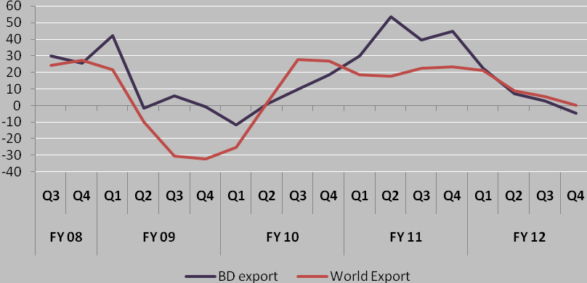
Source: Bangladesh Bank and IMF

While there is an apprehension that a prolonged European debt crisis may further hinder Bangladeshi exports to Europe, there are some mitigating factors that will likely protect exports from sliding further in FY13.

- The US economy is expected to pick up some momentum; hence the expectation is that export orders from US would continue to rise.
- As illustrated in various global projections (Table 2.2), while some EU economies will enter into a recession (e.g. Greece, Italy, Spain etc.), for the EU region as whole the depth of this recession will be less severe. Moreover, three large economies of EU region-Germany, France and UK which together accounted for about 88% of total EU zone export from Bangladesh are projected to grow at a modest positive rate of around 0.5 percent;
- Beginning of 2011, Bangladesh has received the benefit of the change in the rules of origin (ROO). The positive impact of that should be felt in the coming months.
- Some of the global apparel suppliers are diverting textile orders from China due to rise in labour cost in China. It is expected that export order from China would continue to divert to Bangladesh leading to a salutary impact on Bangladesh export growth.

Labour migration and remittances: The recent migration trend is shown in figure 2.2. The major destination of Bangladeshi migrant workers is oil exporting Middle East comprising of Saudi Arabia, Kuwait, UAE, Bahrain and Oman. Despite opening of some new destinations onward 2001, the Middle East still accounts for about 78% of Bangladeshi migrant workers. Slow down of development activities in the Middle East likely to have a strong influence on labour migration and remittance in Bangladesh.
Figure 2.2: Number of Persons Going Abroad
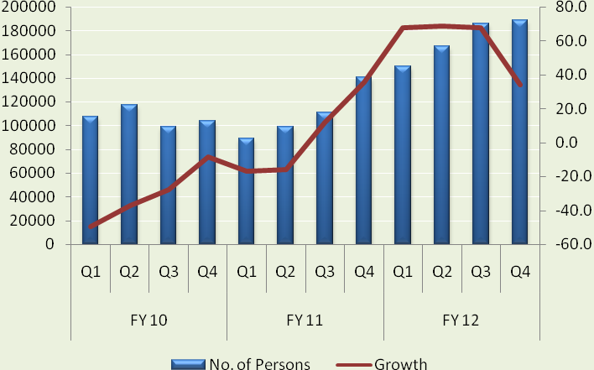
Source: Bangladesh Bank

During the global financial crisis of FY09, number of migrant workers leaving for abroad declined sharply. The decline continued for some time through end 2010. The main reason for the sharp decline of Bangladeshi migration workers during the financial crisis was the slowdown of economic activities in the oil exporting Middle East due to the sharp drop in the price of crude oil from the all time peak of $131/per barrel (i.e. in 2008) to only $41/per barrel. With the gradual recovery of Middle East led by the rise in crude oil price, the declining trend for Bangladeshi workers has reversed. We are observing a strong pick up in this number since Q1, 2011. In Q3 of FY12 the number of workers going abroad increased by 68% over the corresponding quarter previous year. This upward trend is expected to continue in the coming months because of the following factors:

(a) As mentioned above, much of the Bangladeshi workers migrate to the oil exporting Gulf countries, where economic activity and employment is driven by crude oil price. Crude oil prices which dropped to only $41/barrel from an all time peak of $131 in 2009 are still above $104 during the European Debt crisis and are likely to hover around $100 level in the coming months. Thus, on the basis of the projected price of the crude oil it is expected that the economic activities as well as labour demand in Middle East would remain unaffected during this new episode of European Debt Crisis.

(b) Furthermore, in the midst of the ongoing political upheaval in the Arab countries, all oil exporting Gulf countries have increased government spending significantly leading to growing demand for labour.

(c) Recently some new markets are also opening up for Bangladeshi workers in that region including Iraq, Lebanon and Libya. The reconstruction efforts in these countries will likely increase the demand for migrant workers including from Bangladesh.

These factors suggest that the adverse effects of the Euro debt crisis on the flow of remittances will not be significant and will likely be countered by positive migration outlook in the in the Middle East. Latest data suggest that remittance income increased further in FY12, reaching $12.8 billion which is an all time record high for Bangladesh.

Foreign direct investment: Inflow of foreign direct investment (FDI) has historically been low in Bangladesh. Data from Bangladesh Bank suggests that the inflow of FDI virtually remained stuck between $600 million and $900 million between FY05-FY11 suggesting that foreign investors do not find Bangladesh as an attractive destination for their investments (figure 2.3). There was a small improvement in FY12, approaching the $1.0 billion mark.

Figure 2.3: Foreign Direct Investment (Million USD)
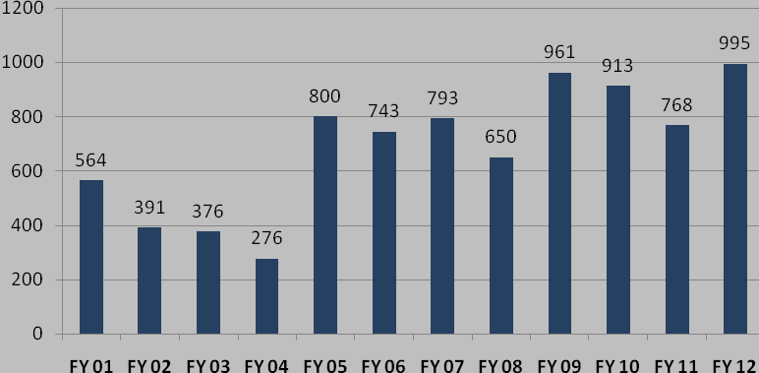
Source: Bangladesh Bank

During the same period average annual inflow of FDI in Vietnam, Pakistan, India and China were respectively $4.2 billion, $2.5 billion, $18 billion and $75 billion. On the basis of these opposing trends in FDI flows, it may be argued that inflow of FDI in Bangladesh is not related to global financial and economic condition. This argument is further validated by the fact that highest FDI inflow in Bangladesh is recorded for FY12, the year the Euro debt crisis happened. So, the pattern of FDI flow to Bangladesh is expected to remain unaffected by European debt crisis and is driven instead by domestic market conditions.

Foreign Aid: In spite of its status as a member of the least developed country group, Bangladesh’s dependence on foreign assistance (ODA) has declined very significantly since independence. The country was heavily dependent on aid during the first two decades of independence during which ODA comprised between 5 -7% of GDP. Since then, ODA as a share of GDP has declined rapidly, falling to around 3% of GDP. The role of official aid further declined over the past 12 years with new net commitments approaching 2-3% of GDP (figure 2.4). Net ODA commitments as percent of GDP to Bangladesh have been falling even before the advent of the global economic crisis and are not related to the global crisis.

Although we do not expect a shortfall in external financing from multilateral sources because of the crisis, there are concerns whether the major economies impacted by growing fiscal and debt problems would be able to fulfill their existing and new commitments under various bilateral and multilateral/global initiatives. It remains to be seen whether the rich nations would be able to fulfill their commitments under the global warming initiative and other framework. Furthermore, traditionally in an open market economy, a global or regional crisis tends to dry up market based financing. Thus it could be difficult for Bangladesh to access the international capital market by issuing sovereign bonds or borrowing from foreign financial institutions.

Figure 2.4: Net Commitment of Foreign Assistance as Percent of GDP
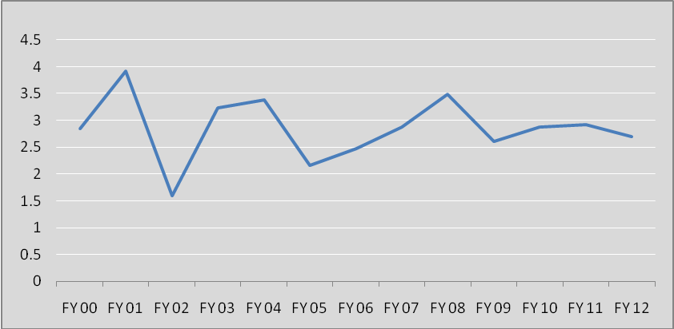
Source: External Relations Division, Ministry of Finance

In summary, the external outlook remains challenging for Bangladesh. While food and fuel prices have stabilized, demand for Bangladeshi exports are down. The export performance in FY 11 benefitted from the recovery of world demand from the global financial crisis. But the export performance in FY12 is adversely affected by the European debt crisis. The positive external environment benefitted exports and GDP growth in the first year of the Sixth Plan, but negative developments in FY12 have adversely affected exports and GDP growth in the second year of the Sixth Plan (FY12). On the financing side, the positive outcome on the remittance front has helped counter the adverse effects of slowdown in growth of exports.

Real Sector Developments
Growth Outcome

FY11 GDP growth outturn: The GDP growth is estimated at 6.7 percent for FY11, which is in line with the Sixth Plan projected growth path. Agriculture and services sector activities continued to follow the benchmark year’s growth rate performance while an impressive surge was achieved in industrial sector growth (Table 2.3).

Table 2.3: Sectoral Growth Performances
Components | FY10 |  | FY11^{P} |  | FY12^{Target} |  | FY12E
Components | Share | Growth | Share | Growth | Share | Growth | Share | Growth
Agriculture | 18.6 | 5.2 | 18.4 | 5.0 | 17.7 | 4.5 | 17.5 | 2.53
Industry | 28.5 | 6.5 | 28.6 | 8.2 | 29.4 | 9.6 | 28.5 | 9.47
Services | 53.0 | 6.5 | 53.0 | 6.6 | 52.9 | 6.8 | 53.9 | 6.06
Real GDP | 100.0 | 6.1 | 100.0 | 6.7 | 100.0 | 7.0 | 100.0 | 6.32
Source: Bangladesh Bureau of Statistics and GED estimate

Agricultural sector achieved 5 percent annual growth in the last two fiscal years (FY10 and FY11) reflecting the government’s continuous effort to boost the performance of this sector. Government has taken various support initiatives including better distribution of seeds, fertilizer, and other necessary inputs which have contributed to these positive results. Uninterrupted electricity supply for irrigation at a subsidized rate and higher prices of farm produce including government procurement prices also contributed to agricultural growth.

Strong rebound in export-oriented manufacturing and better performance of domestic market based industries supported higher growth in industrial sector in FY11. Though growth in small scale industries declined, owing to power shortage and high raw material prices, an impressive growth in large and medium scale manufacturing supported by a huge 40% growth in exports, especially ready-made garments (RMG) provided the impetus. Thus, the quantum index of medium and large-scale manufacturing increased by 16.4 percent during FY2011 (figure 2.5). As a result the growth of manufacturing sector increased to 9.5% in FY2011, as compared with 6.5% in FY10.

Supported by vibrant agriculture and manufacturing, the services sector flourished, registering a healthy growth of 6.7% per year. All service components- transport, trade, financial sector, government and private services- contributed to this, responding to demand fed by rising incomes from agriculture, manufacturing and remittances.

GDP growth outturn in FY12: The outlook for GDP growth for the current fiscal year is that it will remain strong but will fall short of the Sixth Plan target of 7%. While the long-term
Figure 2.5: Developments in Quantum Index of Manufacturing Production
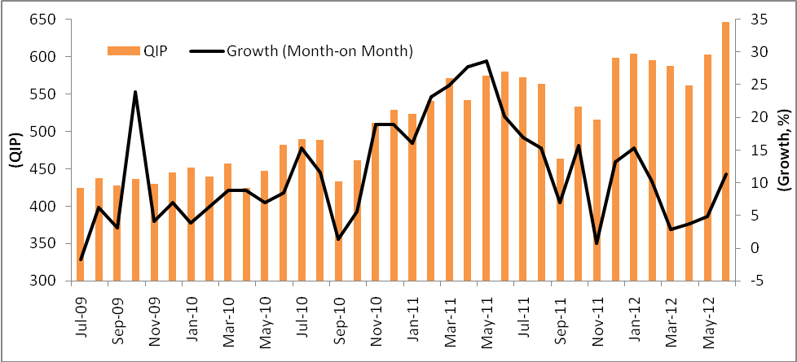
Source: Bangladesh Bureau of Statistics

prospects for agriculture remains solid, agricultural growth in FY12 has fallen substantially short of the Sixth Plan target. The growth of value-added from crop production, which is dominated by rice, has slowed down owing to sharply falling rice prices in real terms that has lowered farm incentives. Furthermore, progress towards diversification appears limited as reflected in sharply rising prices of livestock and fishery products suggesting that supply constraints remain strong. On the whole the estimated growth of the agricultural sector in FY12 (2.5%) is much below the Sixth Plan target (4.5%). For the future, inadequate crop diversification and lower productivity are two major challenges of this sector that must be addressed to sustain a 4% plus growth as envisaged in the Sixth Plan. Sustaining a 5% real growth in agriculture on the basis of food crops for domestic market alone with demand growing at around only 2% per year is not a viable proposition. The options for food exports and diversification to other higher value-added farm production (fish, meat, fruits, vegetables, processed food, etc) must be explored to sustain agriculture GDP growth at 4% plus.

Regarding manufacturing, the slowdown for RMG exports in Europe owing to the ongoing Debt Crisis hurt Bangladeshi exports and value-added in manufacturing. This slowdown is also observed from the data on quantum of manufacturing production for the first nine months of the fiscal year (figure 2.5). The average growth of Manufacturing QIP during the first nine months of FY12 was 10.8% which is considerably lower than that of 15.1% during the last fiscal year. This adverse effect of the external sector on manufacturing production, however, was offset for the full year by a stronger performance of small enterprises and a pickup in manufacturing production based on domestic demand. So, the overall manufacturing sector growth remained strong at 9.4% in FY12, which is close to the 9.8% target for FY12 in the Sixth Plan. Additionally, the strong performance of construction sector and increase in power production has boosted industrial sector performance. On the whole, in FY12 the industrial sector is expected to grow by 9.5%, which is close to the Sixth Plan target of 9.6%.

Supported by strong inflows of remittances and the growth in industrial production, the services growth, which is demand driven, grew at a healthy pace of 6.1%, although lower than the 6.8% projected in the Sixth Plan.

These sectoral growth outturns imply a total GDP growth of 6.3% in FY12, which is a solid performance in the international context but slower than targeted in the Sixth Plan. The shortfall in growth over the target in FY12 is largely the result of the unexpected slowdown in the growth of the agriculture sector, although the Euro-Debt crisis also affected the growth of exports. Agricultural sector growth, which is substantially below target, will likely recover with policies to help diversification. However, from the longer-term perspective, the bigger concern for the sustainability of the Sixth Plan growth target is the substantial shortfall on the investment front. It is well recognized that the inadequacy of infrastructure, particularly power, has emerged as a binding constraint to the expansion of economic activities, especially manufacturing. Unless the challenges of infrastructure and the expansion of the investment rate needed to finance the higher GDP growth are tackled upfront, there is a substantial risk that the Sixth Plan growth targets will not be achievable.

Saving-Investment Balances

Capital accumulation along with increase in average labor productivity is the mainstay of long run economic growth. Bangladesh is lagging behind in capital accumulation since investment as a percentage of GDP remains stagnant over the past few years (Table 2.4). To achieve the target of 8 percent real GDP growth, a boost in investment rate is essential. Increasing investment to desired level appears to be a formidable challenge and requires major effort to improve the investment climate, especially to attract more direct foreign investment. Reviews of the investment climate suggest that there is scope for improving the investment climate by strengthening the availability of power and transport services, by simplifying land acquisition and registration and by reducing the corporate tax rate.

A new challenge that was unanticipated during the Sixth Plan is the emergence of a resource constraint. In recent years Bangladesh has been fortunate in rapidly expanding national saving. This made it possible to finance a growing domestic investment even in the absence of foreign direct investment and dwindling official assistance. The financing environment for investment has been changing rapidly over the past 2 years. Compared to an estimated saving rate of 28.1% in FY10, the saving rate declined dramatically in the first two years of the Plan, falling to 25.7% in FY11 and further sliding to 25.2% in FY12. This is a major negative development that requires urgent attention.

Table 2.4: Saving and Investment, FY10 – FY12
 | FY10 | FY11 | FY12^{P} | FY12E
 | (In Percent of GDP)
Investment Rate | 24.4 | 24.7 | 26.8 | 24.9
of which:
Public Investment | 4.1 | 4.5 | 6.6 | 5.0
Private Investment | 20.3 | 20.2 | 20.2 | 19.9
Incremental capital output ratio(ICOR) | 3.7 | 3.8 | 3.8 | 3.9
Financed by:
National Savings Rate | 28.1 | 25.7 | 26.7 | 25.2
Public Saving | 0.5 | 0.1 | 1.6 | 0.1
Private Saving | 27.6 | 25.6 | 25.1 | 25.1
Foreign Saving | (-)3.7 | -(1.0) | 0.1 | (-) 0.3
Source: Sixth Five Year Plan, 2012 and GED estimates 2012
P=planned; E=estimated

The decline in the savings rate has happened in both the private and public sector. In the private sector buoyant demand, accommodating monetary policy, low real interest rates and acceleration of housing prices that build up windfall untaxed wealth pushed the growth of private consumption. In the public sector the projected increases in public saving during the first two years of the Plan did not materialize as growing energy and food subsidies increased public consumption. The financing constraint hit public investment pretty badly. In addition to domestic financing shortfalls owing to soaring subsidy bill, the financing of public investments from foreign sources, both official and through PPP channels, did not materialize to the extent projected in the FY11 and FY12 budgets.

A range of policies could be taken to offset this pattern including higher public saving through cutback in subsidies and increase in tax revenues, and through greater mobilization of private financial savings by offering more attractive real rate of return. Importantly, the Government needs to focus serious attention to mobilizing direct foreign investment, reactivating the PPP infrastructure financing initiative, greater mobilization of official assistance and faster use of available foreign aid portfolio.

Implementation of the Annual Development Programme (ADP)

Between FY01 and FY08, the size of the ADP declined by half in relation to GDP (figure 2.6). The long-term decline in ADP spending is attributable to two factors. First, the Government’s limited administrative capacity in implementing the ADP projects even when resources are made available. Second, limited availability of public sector domestic resources, coupled with declining foreign financing for projects, also constrained the size of the ADP in the budget.

Figure 2.6: Trend in Public Development Spending (% of GDP)
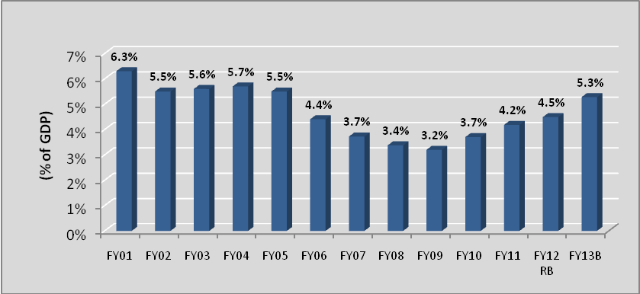
Source: Implementation Monitoring and Evaluation Division (IMED), Ministry of Planning

Some progress was made in arresting this declining trend of ADP and a slow recovery in ADP as a percent of GDP happened since the FY09 national budget. This has been the result of both an increase in the allocation for ADP in the budgets and an improvement in ADP implementation relative to ADP allocation (figure 2.7).

Figure 2.7: Actual ADP Spending in Relation to the Budget
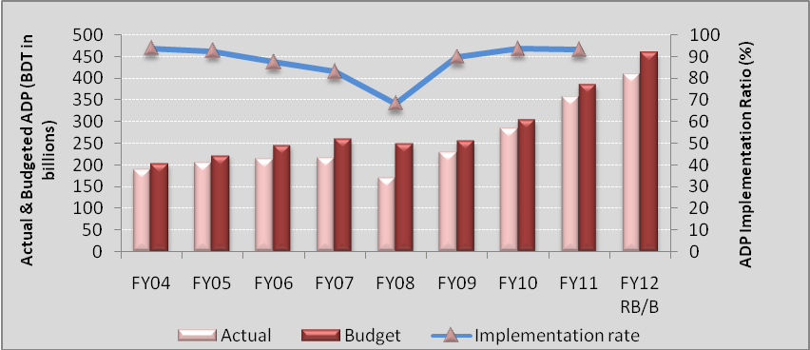 Source: Implementation Monitoring and Evaluation Division (IMED), Ministry of Planning

Nevertheless, implementation problems remain serious and re-emerged in FY12. Some key factors have contributed to the unsatisfactory implementation of ADP include: (i) lengthy procurement procedure; (ii) inadequate capacity of implementing agencies, (iii) land procurement problems and (iv) lack of proper monitoring of the agencies implementing the ADP.

An additional factor has been the inability to provide the approved ADP funding due to excessive spending on current expenditures like subsidies. This is illustrated in figure 2.8. The allocation of ADP in budget has been curtailed in the revised budget on a regular basis and the actual implementation is even lower (figure 2.8). On the other hand revised revenue expenditure tends to increase from actual allocation in almost every year. This pattern of government spending demonstrates an anti public investment bias which requires necessary attention.

Figure 2.8: Revised Budget and Actual Expenditure as Percentage of Budget
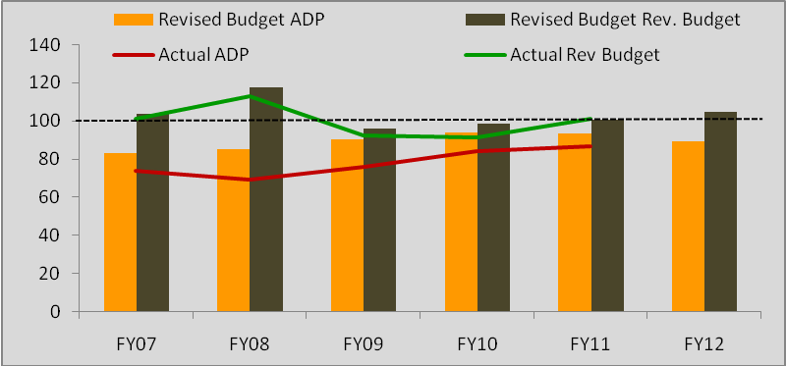
Source: Ministry of Finance

In line with the SFYP public investment projection, the size of ADP for FY12 was set Taka 460 billion envisaging an increase of almost 28 percent of the actual ADP implemented in the last fiscal year (i.e. Taka 358 billion in FY11). Implementing such a large ADP, although necessary to reduce the much needed infrastructure gap of the country, has turn out to be a major challenge for this year’s budget. Since considerable progresses could not be attained in the areas of rationalization of public procurement policies; efficiency of the government agencies and close monitoring of performance of agencies only 85% of the projected ADP may be realized. According to the latest revision, the revised FY12 ADP size is estimated at around Taka 410 billion. Furthermore, recent estimates of resource allocation patterns under the revised annual development programme by Planning Commission shows considerable deviation from the public investment allocation patterns envisaged under the SFYP (Table 2.5). Non fulfillment of projected ADP along with lower allocations would lead to further widening of infrastructure and energy gaps and thereby undermine the growth potential of the country.

Table 2.5: Revised Sectoral ADP Allocation FY2012
(Billion Taka Unless Otherwise Specified)
SFYP Sectors | Revised ADP | SFYP Public Investment | Difference | % Change
Agriculture, Water Resources & Rural Development (+ Environment and Disaster Management) | 89.9 | 66.0 | 23.9 | 27
Manufacturing | 9.7 | 8.1 | 1.6 | 16
Energy | 79.5 | 85.8 | -6.4 | -8
Transport Sector | 70.7 | 76.9 | -6.2 | -9
Urban Sector | 42.0 | 100.8 | -58.9 | -140
Knowledge Economy | 2.3 | 5.2 | -2.9 | -130
Education, Religious Affairs, Sports and Culture, and Labor and Manpower | 51.1 | 71.6 | -20.5 | -40
Health Sector | 33.9 | 45.0 | -11.1 | -33
Social Protection | 3.3 | 5.0 | -1.7 | -53
Environment and Disaster Management | 0.0 | 0.0 | 0.0
Public Administration and others | 9.8 | 42.1 | -32.2 | -328
Total | 392.0 | 506.4 | -114.4 | -29
Source: GED, Planning Commission.

Note: (i) Environment and Disaster Management has been grouped with Agriculture and Water Resources. (ii) RADP allocations do not include block allocations by Honorable Planning Minister. (iii) Estimated SFYP public investment composed of ADP as well as investment usually undertaken by ministries and hence size of public investment is larger than the ADP size.

Public Private Partnership (PPP) – Unrealized Potential

Continued shortfall in implementing the ADP during the last decade has resulted in large gaps in both physical and social infrastructure, seriously limiting Bangladesh’s economic growth prospects over the medium and long run. Although the public funding of public infrastructure investment through annual development programs worked during 1970s and 1980s, when the domestic resource base was small and the country was largely dependent on foreign multilateral and bilateral assistance to carry out its public sector investment program, it is increasingly apparent that it is no longer an adequate mechanism to cope with the needs of an economy aspiring to grow at an annual rate of 8 percent or more. Thus, generation of power, access to better roads, and improved sanitary and sewerage systems calls for immediate attention. A tried and tested approach for infrastructure development in China, and one that is being increasingly pursued in India, is that of public private partnerships (PPP).
However, despite the good intentions of the Government the PPP mechanism largely remained ineffective due to various reasons. More specifically, although, the Government allocated funds in FY2010 - FY2012 budgets and established a PPP cell in Board of Investment (BOI) to operationalize the PPP initiative, little progress has been achieved so far due to several implementation challenges. These include pricing and financing aspects, regulatory and legal frameworks, competitiveness in the bidding process and a careful match between assets, liabilities and cash flow. Additionally, lack of leadership and technical staff has constrained progress. The government review of the financial and economic viability of PPP projects is crucial because success depends largely on costing and pricing issues, as well as generation of the revenue stream. The legal framework must lay down obligations of the government to private sector partners, keep provisions for cost recovery and address issues of compensation and redress mechanisms. Imminent actions are required to establish a comprehensive policy and regulatory framework to ensure competitive and transparent bidding, sharing of risks and rewards and dispute settlement mechanisms.

A well functioning PPP cell with a broad mandate is usually considered the right mechanism to offer resolution to the above mentioned challenges. It is argued that the relocation of PPP cell as an autonomous body would allow it to draw a cross sectoral pool of expertise to supplement capacities in the line agencies that contract for PPPs. More specifically, most countries engaged in a broad-based PPP program have felt the need to develop a cross sectoral pool of expertise in a dedicated PPP unit to supplement capacities in the line agencies that contract for PPPs. These fulfill different roles depending on the needs of the situation. In some cases their role is limited to disseminating information on PPPs and providing broad guidance on good practices. In others they have an active role in helping line agencies and ministries successfully contract for PPPs, and in yet others they play a role in approving PPPs developed by other government agencies.

Foreign Trade: Export Performance and Import Growth

In an increasingly open economy, developments on the external front have a substantial bearing on the growth outturn. Exports from Bangladesh are highly concentrated both in terms of products and destinations since RMG exports to E.U. and U.S.A. are the current mainstay. For example, RMG exports amounted to 76% of total export earnings in FY12. Within RMG, Some 80% earnings came from USA and Europe. Such undiversified export basket always carries sustainability risks and the recent EU debt crisis can, therefore, be a major concern. As noted earlier, the RMG exports have been hurt by the EU debt crisis. The recent pattern of RMG exports is shown in figure 2.9. RMG exports boomed in FY11 but have slowed down considerably in FY12. The rapid decline in the growth of RMG exports in FY12 considerably lowered the growth of total exports. For FY12 as a whole, exports are now estimated to have grown by only 6% as compared with the Sixth Plan target of 14.5%, which is a substantial shortfall (Fig.2.10).
Figure 2.9: Recent RMG Export
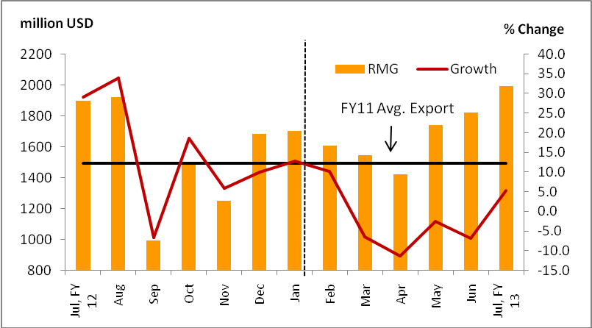
Source: Export Promotion Bureau (EPB)

Figure 2.10: Cumulative growth of Export Performance
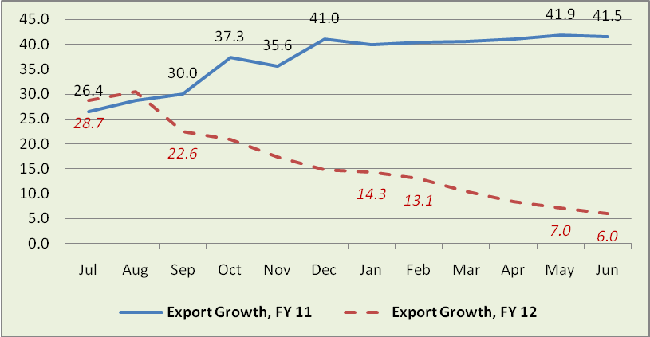
Source: Bangladesh Bank

The slowdown in export earnings has put pressure on the balance of payments, partly offset by growing remittances. Nevertheless, the continuing pressure on foreign exchange reserve has led Bangladesh Bank to tighten import payment policies. As a consequence LC opening for capital machineries has been falling during the first half of FY12 (figure 2.11). This decline in import of capital goods if sustained will likely result in lower investment and GDP growth rates in the future.

Figure 2.11: Trends in LC Openings for Capital Machineries
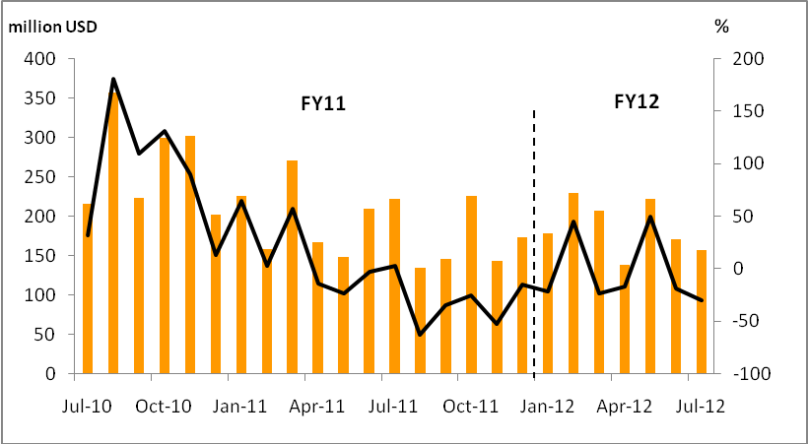
Source: Bangladesh Bank

Macroeconomic Stability

Fiscal Outturn, Deficits, and Financing

The fiscal stance in FY11 was moderately expansionary with overall deficit (including grants) estimated at 4.4 percent of GDP. This deficit was below the budget target of 5 percent but higher than the budget deficit in FY10 (3.7% of GDP). Revenue performance was good, exceeding the budget estimates and registering an impressive 27.8 percent growth (figures 2.12 a, b). As a result the tax to GDP ratio reached the double digit mark in FY11 for the first time in Bangladesh.

On the spending front, increase in subsidies to agriculture, power, fuel, foods and exports contributed to a surge in non-development expenditures. Subsides and current transfers including grants and pensions increased as well, amounting to 3.7 percent of GDP in FY11. However, despite increasing pressure of current spending, total public expenditures in FY11 remained below the budgetary target due to underutilization of Annual Development Program (ADP) allocations.

Figure 2.12: Tax Performance
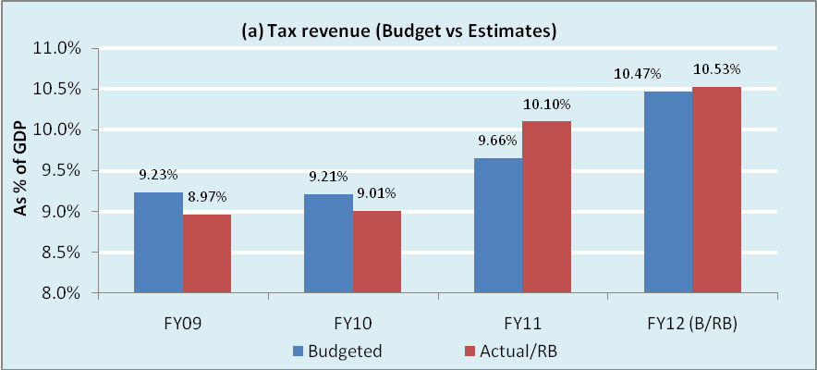
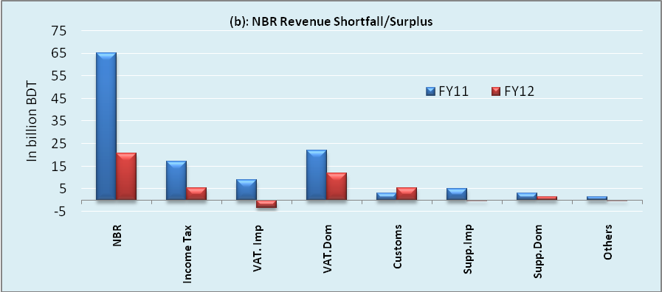
Source: Ministry of Finance and GED estimates.

On the financing front, foreign aid disbursement has been slowing down. The declining trend in external financing over the last few years has intensified reliance domestic borrowing to finance the budget deficit. A particularly worrisome development was the increase in net borrowing from banking sources, which jumped to 2.6 percent of GDP in FY11 from (-) 0.3 percent of GDP in FY10 (figure 2.13).

Figure 2.13: Composition of Deficit Financing, FY10-FY13B (% of GDP)
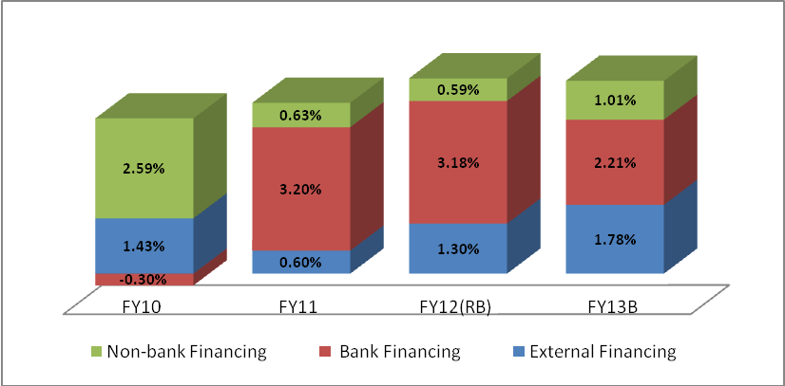
Source: Ministry of Finance, Bangladesh and GED estimates

The progress with improved tax performance was maintained in FY12. As a result, Sixth Plan tax target of 10.4% of GDP for FY12 was achieved. But continued pressure on account of food, fuel and electricity subsidies coupled with the shortfall in the availability of foreign funding relative to the plan target challenged fiscal policy management in FY12. In the first four months of FY12 the Government borrowed TK 150 billion from the domestic banking system, which is 80 percent of the target for the entire fiscal year. Since then the borrowing rate declined somewhat. For FY12 as a whole, the bank financing is estimated at 3.2% of GDP, which is substantially higher than the 2% of GDP target in the FY12 national budget. ADP implementation has also been slow and a combination of capacity and financing constraints has reduced the ability to implement the planned ADP expenditure in FY12.

On the whole, while the tax target for FY12 has been achieved, the public investment target for FY12 has been missed. The fiscal deficit is contained at around the stated target of 5% of GDP, but much of the deficit financing has come from borrowings from the Bangladesh Bank with adverse consequences for the growth of credit to the private sector.

ODA – Persistent Story of Mismatch between Commitment and Disbursement

Along with declining ODA trend as percent of GDP, another disturbing feature in the aid architecture of Bangladesh has been the consistently wide gap between disbursements and commitments/planned spending of Development Partners. In only six of the 18 years under consideration have disbursements exceeded planned spending (Figure 2.14). Since FY2003, disbursements as a share of commitments have consistently been well below 100 percent. Such prolonged under- disbursement of committed aid is indicative of several issues which have been a deterrent to higher disbursement of planned assistance. The pipeline of foreign aid has increased to a record high level of about $12.4 billion.
Figure 2.14: Disbursement/Commitment Ratio of ODA (%)
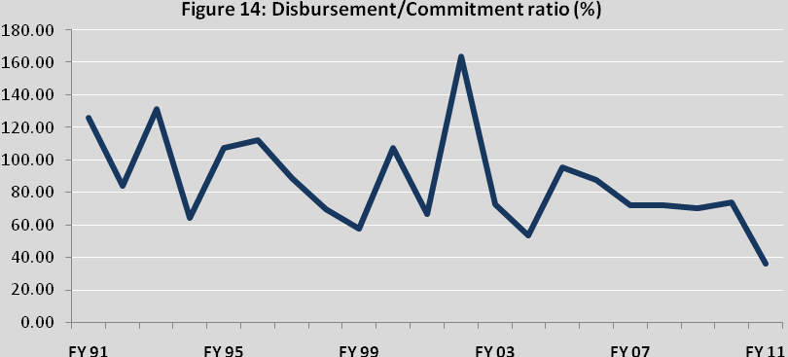 Source: Data from External Relations Division (ERD), Ministry of Finance

The explanations of the observed mismatch are to be found in the discussion on aid effectiveness that has now taken centre stage. According to an independent Evaluation Group Survey carried out in mid 2008, Development Partners are critical of the way in which aid is spent in Bangladesh and consider governance and quality of country systems as main impediments to realizing development potential (Development Partners 2009). This is corroborated by an Operations Evaluation Department Survey also carried out at the same time which pins the blame squarely on government related problems such as “…delays, policies or decisions delaying or obstructing the projects, difficult government systems and procedures, lack of coordination with other agencies, and lack of (qualified) government staff” (Development Partners 2009, p.5). Weaknesses also emanate from the development partner (DP) side. Delays caused by DPs, difficult forms, procedures and paperwork and enforcement of the donor agenda also contribute to lower disbursement of ODA than planned.

In spite of reduced reliance on aid, Bangladesh has participated in all initiatives to enhance aid effectiveness and has endorsed the joint commitments contained in the Paris Declaration (PD) of 2005. The PD “…stipulates that new partnership relationships and ways of working between developed countries and partner countries are essential if development results are to be assured, aid well spent and aid volumes maintained” (DAC 2010, p.2). Since then the government has taken significant steps to promote all the Paris Principles – ownership, alignment, harmonization, managing for results and mutual accountability. In fact, the 2008 DAC evaluation of the PD assessed the country’s progress against these 5 principles of the PD. Although, the evaluation report (NRP 2008) noted some improvements in above five areas, there is room for improvement as there still remain discrepancies between aid disbursement recorded by the GoB and by individual DPs.

Furthermore, the value and effectiveness of foreign assistance is also frequently undermined by a high degree of aid fragmentation. The ODA environment is becoming ever more complex due to the growing importance and role of non-DAC emerging Development Partners. These pose challenges to harmonizing and aligning aid, increasing transaction costs for both Development Partners and recipients and creating duplication in delivery that is wasteful. Increasing fragmentation in sectors could also lead to rising competition between DPs which could lead to increasing focus on results of own projects rather than on broader national priorities, posing coordination challenges (Nadoll and Hussain 2008).

The Hirschman-Herfindahl (HH) index is frequently used to measure aid fragmentation. It reflects both the number of Development Partners as well as their relative shares. The higher the index, the less fragmented is the aid environment in the country. Figure 2.15 reports the HH index over time both by economic sector and donor. The evidence suggests that implementation of the PD has led to improvement in the use of aid and has promoted better coordination and as

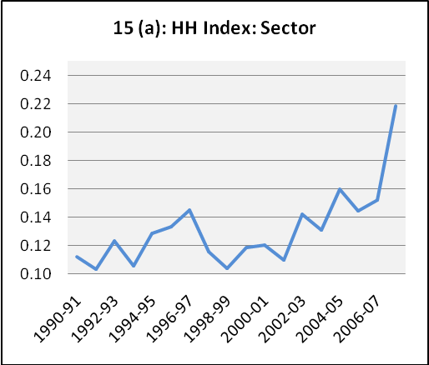
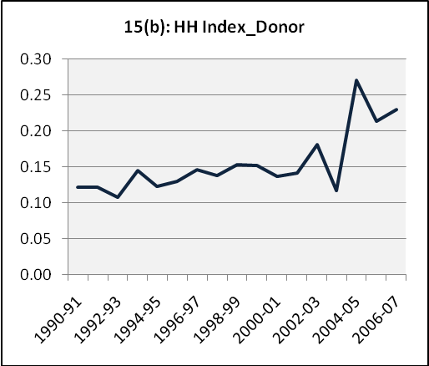
Figure 2.15: Foreign Aid Fragmentation in Bangladesh
Source: Based on ERD data

the Primary Education Development Programme II, aid harmonization and effectiveness has been enhanced, although some challenges still remain. Donor harmonization, for instance could be boosted further as 20 percent of procurements are still done following different rules, as could monitoring and reporting (NRP 2008)

The evidence suggests that implementation of the PD has led to improvement in the use of aid and has promoted better coordination and partnerships amongst Development Partners. Through the sectoral approach to aid delivery such as the Primary Education Development Programme II, aid harmonization and effectiveness has been enhanced, although some challenges still remain. Donor harmonization, for instance could be boosted further as 20 percent of procurements are still done following different rules, as could monitoring and reporting (NRP 2008).

Balance of Payments and Exchange Rate Developments

Despite satisfactory trend in export growth in recent years, trade deficit has been widening due to persistently high imports of fuel, food and capital goods (Table 2.6). The trade gap widened from US$ 4.7 billion in FY09 to $7.3 billion in FY11. This is estimated to have widened further in FY12 to $8.5 billion. Along with the gap on the services and other income accounts, the total financing gap on the trade and services account has widened from $$7.7 billion in FY09 to $13.2 billion in FY12.

Table 2.6: Bangladesh Current Account Balance Situation
 | FY09 | FY10 | FY11 | FY12^{P}
Components
Trade balance | -4708 | -5149 | -7318 | -8472
Export f.o.b.(including EPZ) | 15583 | 16237 | 23009 | 23992
Import f.o.b (including EPZ) | -20291 | -21387 | -30326 | 32464
Services | -1621 | -1240 | -2399 | -3279
Income | -1361 | -1484 | -1354 | -1508
Current transfers | 10226 | 11610 | 12068 | 13699
Official transfers | 72 | 122 | 120 | 105
Private transfers | 10154 | 11488 | 11948 | 13594
Of which : Workers' remittances | 9689 | 10987 | 11536 | 12843
Current Account Balance | 2536 | 3737 | 998 | 440
Source: Bangladesh Bank; P=provisional

Fortunately for Bangladesh, these widening financing gaps in the current account are financed by the large influx of remittance income. Remittance inflows, other private transfers and official grants are still large enough to finance such gaps and allow a surplus in the current account. As we saw earlier, the outlook for remittance is one positive external development in FY12. The improved prospect for migrant workers is translated in growing remittance inflows. Monthly flows now exceed a billion dollars (figure 2.16). For FY12, total remittance reached $12.8 billion, which is an all time high for Bangladesh. Thus the remittance target of the Sixth Plan ($ 17.8 billion in FY15) is on track and will likely be achieved.

Figure 2.16: Remittance Earning (in million USD)
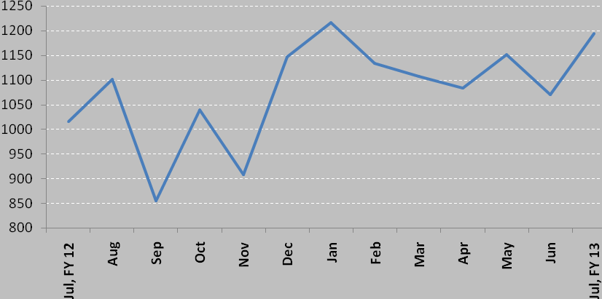
Source: Bangladesh Bank.

Nevertheless, despite this positive outlook for remittances, the widening gaps in trade and services account of the balance of payments are becoming a source of concern. While these gaps are still lower total inflow of remittances, the current account surplus is narrowing sharply. This is a huge swing in the macroeconomic environment, with the current account moving from a large surplus of 3.4% of GDP in FY10 to a surplus of 0.3% of GDP in FY12. While this is still a positive development and more generally a current account deficit is a normal result for a low income developing country like Bangladesh, the main problem is the lack of adequate foreign funding in the capital account. To achieve the GDP growth targets of the Sixth Plan, Bangladesh needs to mobilize substantial higher inflows of official aid and foreign direct investment as an important element of financing required investments during the Sixth Plan.

Gross International Reserves: Bangladesh experienced very favorable balance of payments situation in past several years that allowed large surpluses in the current account and which in turn supported a rapid built up of foreign reserves. Thus foreign reserves grew from a low of $1.0 billion in FY2001 to $10 billion in FY10. The reserve level hovered around this $10.0 billion mark since then (figure 2.17). The reserves, however, came under pressure in FY12, mainly owing to negative balance in the capital account (figure 2.18). Unlike other developing countries, Bangladesh has been experiencing a mostly negative capital account balance over the past 4 years (FY08-FY12) owing to declining net official aid and stagnant FDI. There have also been excessive private capital outflows in FY11 and FY12 due to a variety of factors including outward remittances. For FY12, it is estimated that the capital account was roughly in balance that allowed Bangladesh to preserve its small current account surplus. However, reserves remained unchanged at $10.4 billion owing to valuation adjustments.

Figure 2.17: Gross Foreign Reserves (Billion USD)
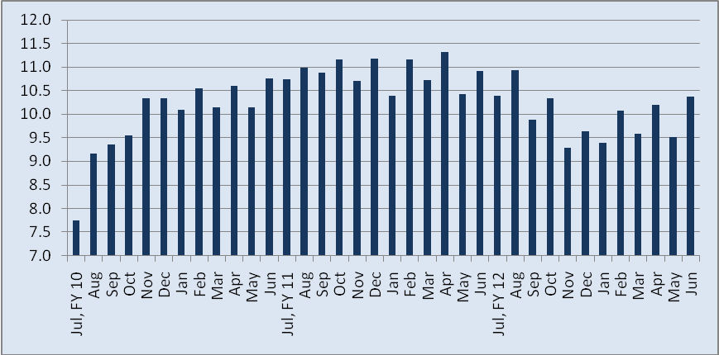
Source: Monthly major economic indicators, Bangladesh Bank

Figure 2.18: Net Capital Account Balance
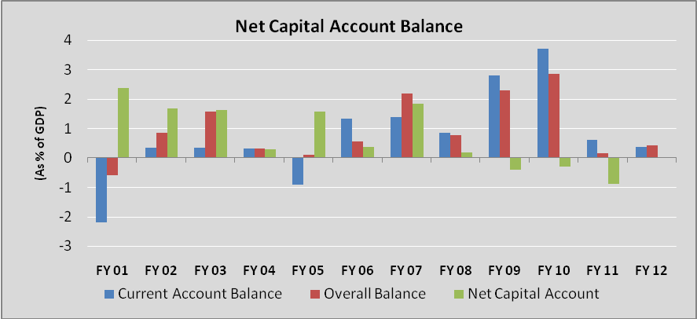
Source: Bangladesh Bank

Exchange Rate

As a result of large current account surpluses Bangladesh was able to build up reserves and also protect the exchange rate from losing value. Between July 2006 and July 2010 the nominal exchange rate remained virtually constant at around taka 70/US $. However, since the inflation rate in Bangladesh was higher than in major trading partner countries, the Taka appreciated in real terms (figure 2.19). The Taka came under pressure since early 2011 as the deficits in surplus in the current account shrunk and the deficit in the capital account overtook. Initially the

Figure 2.19: Exchange Rate and REER Movements
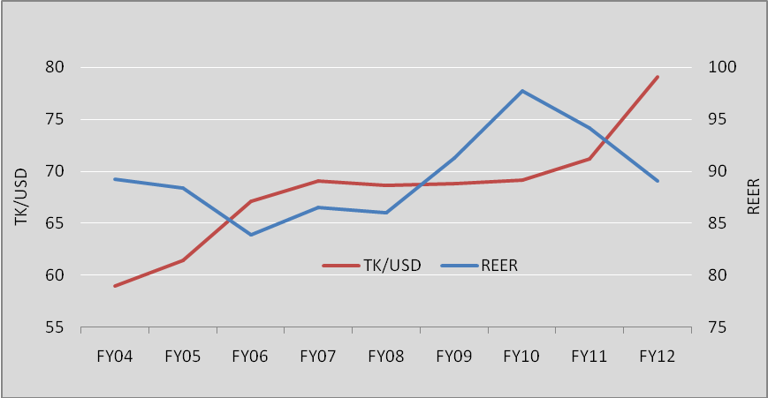
Source: Monthly Economic Trends, Bangladesh Bank; Economic Review, Ministry of Finance.

Bangladesh Bank was able to protect the exchange rate for a while and instead take the pressure on reserves. Between April 2011 and November 2011, Bangladesh Bank lost as much as 2 billion dollars of foreign reserves. Faced with this unsustainable pressure on the reserves, the Bangladesh Bank let the exchange rate depreciate. The nominal exchange rate (defined as Taka per one US Dollar) climbed from around Taka 70.2/US$ in September 2010 to Taka 84.4/US$ in January 2012 and then it has stabilized around Taka 81.8/US$ since February 2012. On the whole, the Taka depreciated by 20% over the 16 months of September 2010 to January 2012 as compared to zero depreciation over the entire 4 years from July 2006 to July 2010.
One positive outcome of the exchange rate depreciation is that the large appreciation of the real effective exchange rate between FY06 and FY10 was arrested and partially corrected. Depending upon the future trends in exports and imports some further correction of the real exchange rate might become necessary. However, this does not necessarily require a large depreciation of the exchange rate. A better policy would be to reduce inflation through prudent monetary and fiscal policies that allows the inflation rate in Bangladesh to be better aligned to global inflation.

Monetary Developments
Inflation: Bangladesh has been facing growing inflationary pressures since FY01. The average yearly rate of inflation climbed from a low of 2% in FY01 to a peak of 10.6% in FY12 (figure 2.20).

Figure 2.20: Trends in Inflation
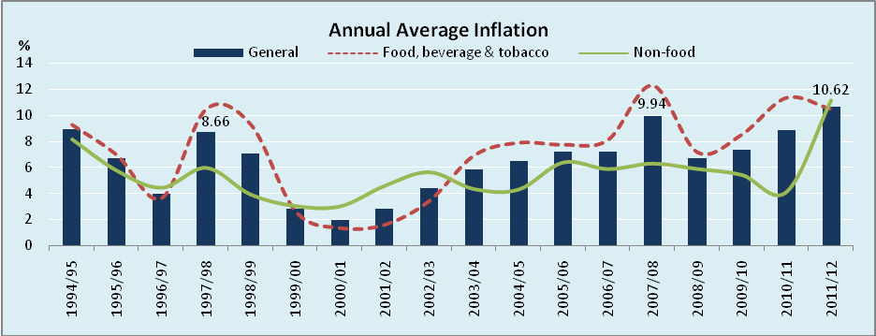
Source: Bangladesh Bureau of Statistics

Looking at the more recent experience, the rate of inflation on a point-to-point basis crept up steadily since July 2009, rising from a low of 2.3% in June 2009 to a peak of 12% in September 2011. The inflation rate declined slowly after that and stood at 8.6 % in June 2012 (Figure 2.21). Increase in the overall CPI was initially driven by high food prices, but non-food prices have been soaring in recent month. Increases in food prices reached a peak at 14.4 percent in April

Figure 2.21: Monthly CPI Inflation Rate (%)
Source: Bangladesh Bureau of Statistics

2011, but declined after that, falling to 8.0 percent in June 2012. Non-food prices fell during the first half of FY11 reaching a low of 3.3 percent in December, but then increased rapidly climbing 14.0 percent in March 2012. It then declined to 12% in June 2012.

Inflation in Bangladesh can be explained through both supply and demand side factors. Soaring international commodity prices was the main source of food inflation. Meanwhile an accommodating monetary policy boosted domestic demand, creating serious upward pressure on non-food prices. Larger-than-planned budgetary borrowings in FY11 and FY12 also contributed to monetary expansion and inflation.

Despite the intention to restrain monetary growth, during FY10 and FY11 Bangladesh Bank’s monetary targets were exceeded in practice due to growth in credit to public and private sector (Table 2.7). In FY11, monetary growth was high also because of the monetization of the fiscal deficit through government borrowing from Bangladesh Bank. The stock of government borrowing from BB at end-June, 2011 was 43.6 percent higher than that at end-June, 2010.

Table 2.7: Monetary Policy and Outcome (growth rates %)
Monetary Components: | FY10 |  | FY11 |  | FY12
Monetary Components: | Target | Actual | Target | Actual | Target
Net Foreign Assets | 27.9 | 41.3 | -1.5 | 5.2 | -1.6
Net Domestic Assets | 13.1 | 18.8 | 20.0 | 25.0 | 22.1
Domestic Credit | 15.6 | 17.6 | 18.8 | 27.4 | 20.0
Public sector | 11.9 | -5.2 | 29.2 | 33.6 | 28.1
Private sector | 16.7 | 24.2 | 16.5 | 25.8 | 18.0
Broad money | 15.5 | 22.4 | 16.0 | 21.3 | 18.5
Reserve money | 7.0 | 18.1 | 15.0 | 21.1 | 16.0
 | Macroeconomic Outcomes
Inflation(CPI) | 6.5 | 7.3 | 6.3 | 8.8 | 7.5
Real GDP growth | 5.5 | 6.1 | 6.7 | 6.7 | 7.0
Nominal GDP growth | 12.0 | 12.9 | 13.0 | 13.4 | 14.5
Source: Based on BBS and BB data

The FY12 monetary policy statement (MPS) for the first half aimed to restrain domestic credit growth by selectively containing the growth of credit for wasteful, unproductive and speculative uses. The MPS also sought to ensure adequate credit flows for all productive pursuits in manufacturing, agriculture, trade and other services. However, achieving this balance required coordinated fiscal policy management that keeps borrowing from Bangladesh Bank to a minimal level. In the event, this has proven difficult owing to larger-than-budgeted energy subsidies.

Controlling inflation has, therefore, been a major challenge in the first two years of the Sixth Plan. The good news however is that efforts since the second half of FY12 to tighten domestic credit and money supply has yielded positive results. Building on the success of the implementation of the MPS for the second half of FY12, the MPS for the first half of FY13 aims to continue and build on the progress made in the second half of FY12. In summary, the estimated average inflation rate for FY12 is 10.6%, much higher than the Sixth Plan target of 7.5%. For the future, monetary and fiscal policies need to be coordinated so that the Treasury borrowing from Bangladesh Bank is restrained and the monetary growth rate is consistent with the Sixth Plan’s inflation target. Proper implementation of the MPS for FY13 is of critical importance for achieving lower inflation.

Poverty
The RF identified a number of indicators for monitoring performance on the poverty reduction goal. These are:
- Lower the national head-count ratio to 29.7% in FY11 and 22.5% in FY15.
- Increase government spending on social protection (excluding pensions) to 2% of GDP in FY11 and 3% in FY15
- Achieve a 5% growth rate of agricultural GDP in FY11 and maintain a 4.3% growth rate in FY15.
- Achieve an average growth of wages in terms of rice equivalent by at least 0.5% higher than real GDP growth.
Past progress with poverty: Bangladesh has made commendable progress with respect to eradication of poverty and hunger where the percent of population living below the poverty line went down from more than 80 percent in early 1970s to 31.5 percent in 2010 (Table 2.8). However, Bangladesh still face the reality that 46.8 million of its population live in poverty
Table 2.8: Headcount Poverty Rate (%)
Year | Rural | Urban | National
1973-74 | 82.9 | 81.4
1981-82 | 73.8 | 66.0
1991-92 | 61.2 | 44.9 | 58.8
1995-96 | 55.2 | 29.4 | 51.0
2000 | 52.3 | 35.2 | 48.9
2005 | 43.8 | 28.4 | 40.0
2010 | 35.2 | 21.3 | 31.5
Source: Different HES, HIES
Sustained growth rate of around 6% per annum, along with increased protection of the vulnerable community with social safety net programs, the country has progressed well in terms of attaining its target of 22.5% poverty headcount ratio in 2015. According to MDG Progress Report 2011 of the Planning Commission, inclusive pattern of growth, gradual transformation in sectoral composition of GDP, sustained improvement in various human development indices-all have contributed towards this fight against poverty. The poverty reduction in Bangladesh can be attributed to the following combination of factors that add up to a story of significant social and economic transformation:
- The decline in poverty in Bangladesh stems in large part from strong, decade-long economic growth. The economy’s expansion during the 1990s – on average annual real GDP increase of almost 5 percent – meant a rise in real per capita GDP of 36 percent or twice the average rate of other low-and middle-income countries during the same decade. This impressive performance was fueled by large jump in real GDP in the expanding industrial sector where the output of export-oriented ready-made garment (RMG) enterprises grew by double-digit increments.
- The economic transformation is closely related to rapid GDP growth and the urbanization process in recent times – manifested in rising returns to human and physical assets, rising labor productivity and wages, the shift from low return agricultural labor to non-farm employment and growth in export industries.
- Increasing flow of remittances.
- The growth of micro-finance
- Equally important are some of the forces that have emerged from social transformations occurring over time. A fall in the number of dependents in a household, linked to past reductions in fertility, has been an important contributor in raising per capita incomes.
- Increases in labor force participation and educational attainment, particularly among women, have contributed as well.

The poverty and inequality challenge in the Sixth Plan: Despite the progress in alleviation of poverty, Bangladesh still has a larger proportion of people living below the poverty line. In 2010 there was still 17.6 percent of the total population (26 million people) in extreme poverty. Locating these poor and targeting policies and programs to lift them from the poverty trap is a real challenge and requires concerted efforts.
The other dimension of poverty is the spatial distribution of poor beyond the urban-rural divide. This concerns the distribution of poverty by districts and divisions. Despite recent progress, there is still an East-West divide in the distribution of poverty, with a significantly higher poverty incidence in the Western Divisions of Rajshahi, Khulna and Barisal as compared with the Eastern Divisions of Dhaka, Sylhet and Chittagong.
In addition to the structural causes of poverty, recurring community-wide shocks have a significant accumulated impact. Some of these are seasonal, while others are more unpredictable, like the major floods and tropical cyclone. There is some evidence to suggest that severe and repeated community-wide shocks contribute to poverty traps in certain areas of the country. By (at least partly) mitigating the impact of the shocks, a well-functioning safety net system would ensure that the considerable gains Bangladesh has achieved through rapid economic and social transformation are not eroded.
There is considerable concern in Bangladesh about the growing income inequality. Results show that the distribution of income is much more unequal than the distribution of consumption. Income inequality as measured by the gini coefficient for the distribution of income has risen substantially during the 1980s and the 1990s. More recent data shows a further increase in the income gini coefficient from 0.451 in 2000 to 0.458 in 2010 due to an increase in rural income inequality (Table 2.9). Thus, the rural income gini coefficient increased from 0.393 in 2000 to 0.431 in 2010. The urban income gini coefficient remained unchanged at 0.497 during 2000 and 2005 but declined to 0.452 in 2010.

Table 2.9: Gini Index of Per Capita Income
 | 2000 | 2005 | 2010
National | 0.451 | 0.467 | 0.458
Urban | 0.497 | 0.497 | 0.452
Rural | 0.393 | 0.428 | 0.431
Source: Bangladesh Bureau of Statistics Different HIES.
Measures of expenditure inequality, which is a more reliable measure of inequality in view of the weakness of income data in HIES, shows a similar picture of rising inequality in the 1990s. Expenditure inequality rose considerably during 1990s, particularly in urban areas. The HES data suggest that inequality in the distribution of private per capita expenditures, as measured by the gini coefficient, increased from 0.259 in 1991-92 to 0.306 in 2000. Unlike in the 1990s, the expenditure inequality for the country showed no change between 2000 and 2005. The urban expenditure gini fell somewhat while the rural expenditure gini increased slightly, offsetting the impact on the national expenditure gini. Overall, since 1995-96, the changes in national and urban/rural expenditure ginis for are too small to be statistically significant, which indicates that changes in the distribution of expenditure (relative to the mean of the distribution) has remained stable for the last decade in Bangladesh.
Nevertheless, the growing income inequality is of major concern to the Government. The SFYP has made attempts to address the income inequality problem through a range of measures including creating better access to high productivity, high income jobs; improving farm productivity and incomes; sharpening the focus on equity aspects of public spending on education, health, family planning; nutrition and water supply; reducing the regional disparity of growth; and improving the access of the poor to means of production (fertilizer, seeds, water, electricity and rural roads); and by improving the access of the poor to institutional finance.
These aspects of the poverty profile suggest that growth strategy alone will not be able to fully solve the poverty problem in Bangladesh. While growth acceleration and job creation will be the primary foundation for the poverty strategy, this will need to be complemented by a well designed specific and targeted interventions that go to the bottom of the various factors contributing to the rural-urban poverty divide, the regional variations in poverty, and the large concentration of ultra-poor and seek to remove those constraints.
The Sixth Plan strategy for reducing poverty and income inequality: In this context, the SFYP emphasized productive employment being the most potent means of reducing poverty, which requires strategies and actions on the demand side of the labor market (driven primarily by economic growth) as well as strategies and policies on the supply side (labor force growth and quality). The strategies mentioned in the SFYP in this regard are:
- Acceleration of economic growth and employment
- Benefiting from higher labor force growth (the demographic dividend) and ensuring labor quality
- Ensuring food security
- Managing the spatial dimensions of growth
- Reducing income inequality
- Ensuring social protection for the under-privileged population
- Ensuring gender parity
- Sustaining growth and protecting the poor from the adverse effects of environmental degradation and climate change
In order to ensure participation of poor in growth process, the SFYP recognizes that amongst others, the government should ensure access to financial services for the poor. It will also take necessary steps for protecting the poor from the adverse effects of environmental degradation and climate change. With a view to create overseas employment and foster growth, efforts have been made in the Sixth Plan to promote migration, especially from lagging districts of the northern and north-western regions of the country. Two major interventions will be undertaken - skill development through training programs and financing of migration. Rural non-firm activities (RNFA) will be continued to be considered as an important means for poverty reduction, especially for the poor. In this context, future strategies will focus on two broad areas: (i) improving the rural investment climate; and (ii) supporting institutional framework including strengthening local governments.
Finally, the SFYP recognizes that the diverse underlying causes of poverty in Bangladesh include vulnerability, social exclusion, and lack of assets and productive employment. The extreme vulnerable poor can potentially lift themselves out of poverty with appropriate short to medium-term support. The Social Protection Programs address basic needs of the poor and vulnerable people, namely food, shelter, education and health.
Assessment of progress in FY11 and FY12: A major constraint to assessing progress quantitatively on a yearly basis is the lack of relevant data. The HIES that serves as the basis for evaluating progress in poverty and income distribution is only available on a 5-year cycle and with an additional one year lag for data processing and analysis. Interim shorter-term surveys as in India is not done in Bangladesh. This is a major data problem that needs to be addressed expeditiously in order to mainstream results-based M&E. In the absence of quantitative evidence, some qualitative assessment can be made using past trends, growth outcomes and other determinants of poverty and inequality.
Although the determinants of poverty reduction are not straight forward, it is widely accepted that persistent and high growth is the most crucial ingredient. As reported in the poverty analysis of the Sixth Plan, based on the poverty data from 2000 to 2010, growth elasticity of poverty is estimated to be 0.76. However, while considering recent higher rate of poverty reduction statistics of 2005-2010, the growth elasticity of poverty of 0.89. It is important to note that this higher poverty elasticity to growth is associated with a slight improvement in income distribution and a stable pattern on consumption distribution. A worsening of consumption distribution will lower the elasticity.
The SFYP targeted an average growth rate of 7.3% for the plan period. If this growth path is sustained, the poverty profile under the assumption of no worsening of income/consumption distribution is shown in Table 10. It is obvious that the growth path in the Sixth Plan and the assumption of no worsening in the distribution of income/consumption are key factors for achieving the Sixth Plan target for poverty re
The experience so far suggests that the GDP growth rate in FY11 was on target; however, the rate of growth in FY12 is below target. The quality of growth in terms of agriculture performance (5.0% in FY 11 and 2.5% estimated for FY12) and manufacturing (average estimated growth of 9.5% during FY11 and 9.4% in FY12) suggests that earnings prospects in agriculture and overall employment prospects have improved, although the lower than-targeted growth in agriculture in FY12 is a matter of concern. Higher growth in agriculture in the context of a flexible agricultural labor market has favourable implications for real wages. Research suggests that labor market in agriculture works flexibly and employment and real wages have grown in response to higher labor productivity. So even though the growth in a real wage indicator in the RF has not been realized, it is reasonable to conclude that agricultural wages have continued to grow in real terms and is contributing to poverty reduction.
Table 2.10: SFYP Poverty Targets; Head Count Poverty under Different Elasticity Assumptions
Income and Poverty | 2009-10 | 2010-11 | 2011-12 | 2012-13 | 2013-14 | 2014-15
Per Capita Income (Taka/Person) | 46732 | 52034 | 58212 | 65217 | 73292 | 82482
Per Capita Income ($/Person) | 674 | 726 | 785 | 848 | 920 | 1001
Growth in PCY (%) | 9.6 | 11.3 | 11.9 | 12.0 | 12.4 | 12.5
Per Capita Consumption (BDT/Person) | 39116 | 42852 | 47301 | 52463 | 58208 | 64569
Growth in PCC (%) | 9.5 | 9.6 | 10.4 | 10.9 | 10.9 | 10.9
Real PCY (Taka/Person) | 24283 | 25588 | 26992 | 28578 | 30420 | 32505
Growth Rates in Real PCY (%) | 2.8 | 5.4 | 5.5 | 5.9 | 6.4 | 6.9
Head Count Poverty (Poverty Elasticity = 0.76, between 2000 and 2010) | 31.5 | 30.1 | 28.8 | 27.4 | 25.9 | 24.5
Head Count Poverty (Poverty Elasticity= 0.89, between 2005 and 2010) | 31.5 | 29.7 | 27.9 | 26.1 | 24.3 | 22.5
Source: Sixth Plan Projections
On the whole, the GDP growth and employment aspects of poverty reduction strategy of the Sixth Plan require careful monitoring and policy responses. The outlook for agriculture remains favourable but policy actions are needed to diversify agricultural production and explore opportunities for exports. The inability to achieve the investment targets is a serious setback for the GDP growth path of the Sixth Plan and associated expansion of the manufacturing sector. Unless corrective actions are taken immediately, there is a serious risk that the average growth of 7.3% and the associated yearly path that takes growth rate to 8% in the terminal year of the Plan will not be realized. This in turn is going to hurt employment prospects and will make it difficult to achieve the poverty reduction target of an HCR of 22.5% by FY15 (See Annex 3 for the relationship between GDP growth and employment).
The assumption of no worsening of income/consumption distribution is a predicated on proper implementation of all the Sixth Plan programs related to the poor and vulnerable population including higher funding for social security programs. The target to increase social security spending to 2% of GDP in FY11 was not achieved and the prospect for increasing this spending to 3% of GDP by FY15 is challenging. Additionally, available M&E of a number of social protection spending suggest a mixed record of achievement. Corrective policy actions to improve program design, reduce the multiplicity of programs, and improve targeting are needed. Similarly, while the FY11 and FY12 budgets have emphasized spending on education, health, and rural infrastructure, the levels of spending are below the levels needed for sustained improvement in these services. So, stronger efforts are needed to further improve expenditure priorities by cutting energy subsidies and increasing greater allocation to social protection, human development and rural infrastructure.

The other key development that could seriously hurt income/consumption distribution is inflation. There is considerable empirical evidence that inflation hurts the poor relatively more than the rich. So, higher inflation since 2009 is of serious concern. While the Government has taken steps to keep staple food prices under control, continued double digit inflation is not good for poverty reduction and must be reduced with concerted policy efforts as discussed earlier.

In summary, the poverty reduction targets for the Sixth Plan face serious downside risks that require careful monitoring and policy actions. The growth momentum needs to be restored to achieve the Sixth Plan GDP growth rates. Corrective policy measures to increase the investment rate focused on infrastructure, strengthening agricultural diversification, sharply reducing the rate of inflation and improving the level and quality of social safety net spending are of particular significance for securing the poverty reduction goals of the Sixth Plan

Chapter 3: Implementation of the Sixth Plan’s Sectoral Programmes

Introduction
To make the M&E exercise manageable, the RF picked up 8 sectoral themes: human resource development; water and sanitation; infrastructure and energy; gender; environmental sustainability; information communications technology; urban development and governance. In this chapter we look at the implementation progress in these areas based on the indicators of the RF. It is important to note that data are a major constraint in evaluating sectoral progress in a quantitative framework. Due to paucity of information, the RF itself was not able to fully quantify many of the baseline indicators. Hence the analysis in many cases needs to be qualitative.

Human Resource Development
Education
Bangladesh has made significant progress, especially with respect to increasing access to education and attaining gender equity, both at primary and secondary levels. Net primary enrollment rates rose from 60.5 percent in 1991 to 91.9 percent in 2008, while at the secondary level enrollment rates have risen to 41 percent in 2005 from 28 percent. Gender parity in access to primary and secondary education has also been achieved. These achievements are particularly spectacular when compared to countries in the South Asian region and other countries at similar levels of per-capita income.
The SFYP recognizes that it is not only coverage or parity or quantitative issues, but also quality of education that should be ensured at each level. In this context, the critical needs and important issues related to Secondary and Higher Education in the country shall be addressed in the SFYP on a two pronged basis: a quantitative goal and a qualitative goal, to be pursued in an integrated manner.
In terms of RF, the SFYP identified two key indicators for education:
- Grade V completion rate, by gender: with a baseline of 60.2% overall, boys (59.8%) and girls (60.8%) in 2010; and a target of 75% overall along with gender parity by 2015.

- Net enrollment rate in secondary education, by gender: baseline rate is 44.8% (2009), boys (39.5%) and girls (50.8%) in 2010 and target for 2015 is 75% with gender parity.

- Completion rates: Figure 3.1 shows the progress in primary school completion rates from 1991-2010. Completion rates expanded rapidly between 1991 and 2000 but lost most of the momentum by 2006. Since then, there has been some recovery, with acceleration during 2009-10. Importantly, these figures from DPE suggest that the baseline estimate of 60.2% in the RF is outdated; actual completion rate in FY10 was 67.2 and is reported to have increased to an impressive 70.4% in FY11. In light of this new and updated evidence, the 75% completion target for primary education by the end of 2015 seems to be achievable. Evidence also suggests that there was gender parity in completion rates in the base year and this is not an issue. So, the progress on this target is on track. However, the record of reversal as in 2000-2006 suggests that there is no room for complacency and continued efforts are needed.

While evaluating performance and trend in education sector, one issue that should particularly be considered is that of the baseline or current scenario. In comparison to other developing countries, in the last 2 decades, Bangladesh has already made considerable progress in terms of a wide range of indicators, e.g. net and gross enrollment in primary education, gender parity, completion rate etc. Therefore, the rate of growth in those areas might not be that high. Keeping this in mind, efforts should be made to sustain the recent upward trend in primary school completion.
Figure 3.1: Primary School Completion Rate
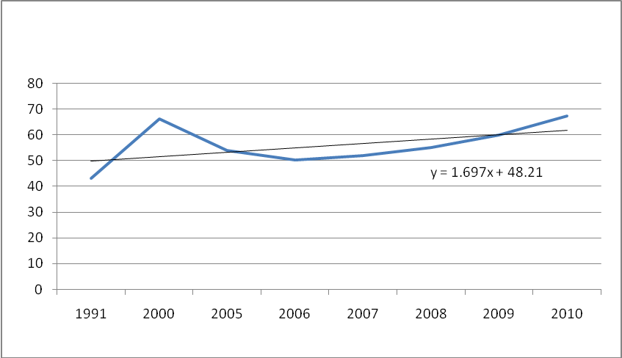
Source: Department of Primary Education
- Net enrollment rates: In terms of the second indicator, in 2011 the SFYP set a target of net enrolment in secondary education to 50% with gender parity. According to the latest information provided by the Ministry of Education, in 2011 the rate was 55.74% with 47% enrolment for girls and 53% enrolment for boys. Thus, till now, the country seems to be on track in terms of this indicator.
Looking more broadly at the overall education sector, the most impressive outcome is in terms of gender equity. Both in primary and secondary education, Bangladesh has already attained gender parity and according to the information provided by BANBEIS (2010), the ratio of girls to boys in primary and secondary education was 1.02 and 1.14 respectively. This positive development has occurred due to some specific public interventions that are focused on girl students, such as stipends and exemption of tuition fees for girls in rural areas, and the stipend scheme for girls at the secondary level. At tertiary level, however, the picture is not encouraging - gender parity at the tertiary education level is very low and the ratio has been hovering around 0.32 (76% boys vs. 24% girls). Low level of participation of girls in tertiary education is an obstacle to their achieving good jobs and thereby an obstacle to attaining economic freedom. With a view to increasing participation of female at tertiary level, the government is planning to make girls education free up to degree level. Besides, the number and amount of general scholarship for the meritorious students and scholarship for technical and vocational education have been increased reasonably in recent years. The textbooks have been distributed at free of cost to the secondary level students like the primary level students, which is expected to promote female education.
Another achievement in the education sector is increasing intake at primary level, reduction of drop-out rates and improvement of quality at primary level. There has been steady improvement in net enrolment and in 2010 the ratio was 94.89%, with an increase from 87.2% in 2005 and from a moderate rate of 60.50% in 1990. Such an achievement can be attributable to the initiatives undertaken by the government such as food for education, stipends for primary school children, media outreach, expansion of community or satellite schools etc. However, as discussed in terms of RF, the success at increasing net primary level has been compromised by the rate of drop out at various level of primary education and at the transition towards secondary education. In spite of some improvement in this area, the current status is still not promising, especially when we compare in terms of MDG or SFYP targets. The inherent reason for low completion rate at primary level can be related to several factors, e.g. household poverty, socio-cultural backwardness etc. However, a substantial percentage of these drop-out students tend to continue their education in non-formal or unregistered schools such as Madrasas and non-formal education projects. The Government needs a stronger effort to monitor school drop-outs and take mitigating measures address this problem.
One of the crucial areas that government need to focus more attention is the quality of education at all levels. Although it is difficult to come to any clear-cut conclusion regarding current status, there are concerns regarding the quality of teachers, text-books, curriculum etc. There is also a gap between the learning emerging from the education system and the skill requirements in the market place. In order to improve he present status, the Government has initiated several steps including: (i) school based assessment (SBA) at secondary level, (ii) privatization of textbook writing and publication, (iii) formation of oversight committee for supervision of teaching at classrooms, (iv) strengthening of teachers training, (v) delivery of textbooks on time, (vi) distribution of 20,000 computers in secondary institutions, (vii) training of secondary teachers in computer applications, (viii) establishment of retirement and welfare fund for non-government teachers, (ix) Introduction of Junior Secondary Certificate (JSC) examination, (x) Introduction of Technical and Vocational Education at secondary and higher secondary level, (xi) Establishment of technical school in each upazila and more polytechnic Institutes at the districts where such institutes are not available and (xii) restructuring of the Directorate of Secondary and Higher Education, the National Academy for Education Management and the personnel of Boards of Intermediate and Secondary Education. These are welcome initiatives. Continued monitoring of quality improvements in education and additional measures needed to improve quality will be necessary.
The balance between quantity and quality in policy discourse cannot be over-emphasized. More often than not, the quality issue tends to get side-tracked. So, the issue of quality should also be highlighted while setting goals and targets of the education sector. Progress only with the relatively satisfactory quantitative performance of education sector is not enough; rather we should evaluate sectoral targets, performance and future trends from a broader perspective involving both quantity and quality. For example, completion of primary education is expected to entail a pupil with basic skills of computing and language and the failure to implant such skills though the education system would indicate a basic flaw of the system. On the whole, a country can be regarded to have made satisfactory progress in education sector if it can produce students possessing knowledge and skills of certain standard.
Health, Population and Nutrition (HPN)
The goal of the health, population and nutrition (HPN) sector in the Sixth Plan is to achieve sustainable improvement in health, nutrition, and reproductive health, including family planning, for the people, particularly of vulnerable groups, including women, children, the elderly, and the poor. The HPN sector emphasizes reducing severe malnutrition, high mortality, and fertility, promoting healthy life styles, and reducing risk factors to human health from environmental, economic, social and behavioral causes with a sharp focus on improving the health of the poor. More specifically, with regard to MDG the main emphasis is on the human dimension of poverty, i.e. deprivation in health, deprivation in nutrition including water and sanitation, as well as related gender gaps.
Despite several shortcomings some important results in terms of improved health outcomes were achieved, as evidenced by the findings of successive Bangladesh Demographic and Health Surveys:
- Total fertility rate declined to 2.3 in 2011 from 3.3 in 1996-1997.
- Percentage of children underweight for age declined to 36 in 2011 from 56.3 in 1996-1997.
- Percentage of children underweight for height declined from 17.7 in 1996-1997 to 16.0 in 2011.
- Percentage of children short for age was 54.6 in 1996-1997, which has reduced to 41 in 2011.
- Under-five mortality rate per 1000 live births declined to 53 in 2011 from 116 in 1996-1997.
- Infant mortality rate per 1000 live births declined to 43 in 2011 from 82 in 1996-1997.
- Percentage of children’s vaccination has improved to 83.0 in 2011 from 54.1 in 1996-1997.
- Percentage of ante-natal check –ups by the trained providers has improved from 29 in 1996-1997 to 54.6 in 2011.
- Percentage of delivery by trained person also increased from 8 in 1996-1997 to 31.7 in 2011.

Nevertheless, the achievement of universal health coverage, the removal of rural-urban, rich-poor and other form of inequities and the provision of essential services for vast majority of the population continue to remain as major challenges for the health sector. More specifically, issues such as poverty related infectious diseases, mothers suffering from nutritional deficiency, children suffering from malnutrition, pregnant women not receiving delivery assistance by trained providers, poor maternal and child health, unmet need for family planning and the rise in STD infections constitute major challenges.

In the RF the SFYP set two key targets:
- To increase the percentage of births attended by skilled personnel from 26% in the base year to 31% in FY11 and to 50% by the end of the plan period (FY15).
- To increase the percent of women using modern contraceptives in low performing areas as follows: (a) base year (FY10) – 35.7% in Sylhet, 46.8% in Chittagong; (b) FY11 targets – 38% in Sylhet and 48% in Chittagong. FY15 target- 65% in Sylhet and Chittagong.

As shown in Figure 5, there has been moderate improvement in terms of skilled delivery and according to Bangladesh Demographic and Health Surveys, from less than 10% in 1993-94, coverage has increased to 18% as of 2007. Latest statistics provided by Bangladesh Maternal Mortality Survey (BMMS, 2010) indicate an impressive increase in last couple of years and as of 2010 the rate is 26.5%. The preliminary finding of the BDHS 2011 reveals that in 2011 the rate has gone up to 32%, which exceeds the target for FY11 in the RF. However, despite this recent increase, the target rate of 50% is quite an ambitious one. For the last 10 years the average growth was around 11.9% and if we assume this growth to prevail then in 2015, we can expect around 46.5% coverage, which is shorter than the target (Figure 3.2). We conclude that this target is achievable but needs monitoring and follow up as necessary.
Figure 3.2: % of Births Attended by Skilled Personnel
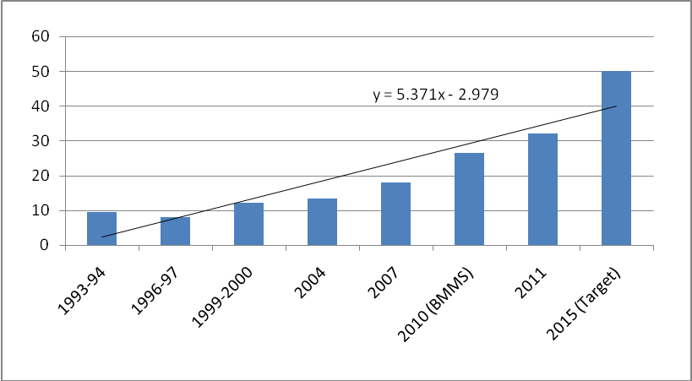
Source: BDHS, BMMS.

Regarding the target for modern contraceptive use, the contraceptive prevalence rate is 61.2%. So, the evidence suggests that Bangladesh is on track for achieving the target for FY15.

Looking more broadly and strategically at the health sector, the key indicators are: maternal mortality rate (143 per 100,000 live births), infant mortality rate (31 per 1000 live births), under 5 mortality rate (50 per 1000 live births), life expectancy (70 years), improved child nutrition etc. are the most crucial ones to pursue. In terms of these indicators, recent trends suggest good results. There has been a significant progress in under-five mortality rate over the last two decades. Between the periods 1989-1993 and 2002-06, Bangladesh experienced average annual reduction in under -5 mortality by 9.3% for 12-59 months child (Figure 3.3). Recent statistics of 2009 shows that under-five mortality has decreased to 50 per 1000 live births (Sample Vital Registration System, 2009) with almost similar status for boys and girls. Therefore, Bangladesh seems to have achieved the target set by the SFYP and MDG in under-five mortality. Another remarkable progress has been achieved in Maternal Mortality and from as high as 574 (per 100000 live births) in 1990 the rate declined to 322 in 2001 and 194 in 2010. As reported in MDG progress Report 2011, average rate of decline was about 3.3% per year, compared to the average annual required rate of reduction of 3.0% for achieving the target in 2015. Therefore, although we do not have information for 2011 but we can infer from previous year’s statistics that the country is more or less in track to achieve the target of 143 MMR in 2015.
Figure 3.3: Under 5 Mortality (per 1000 live births)
Source: BDHS, BMMS, SVRS
The main area where progress has been limited in the past and where careful watch is needed concerns child nutrition. A part of the problem is limited budget. Both the population and child nutrition program needs careful review to check for delivery capacity and budget resources.

Water and Sanitation
Providing safe drinking water and improved sanitation facilities are of paramount importance for ensuring healthy living condition of the poor. In order to cope with the present and future demand of safe water supply and sanitation, the Government of Bangladesh has formulated and adopted several policies and strategies, e.g. national policy for safe water supply and sanitation 1998 (WSS policy), national water policy 1998 (NWP), national water management plan 2004 (NWMP), national policy for arsenic mitigation & it’s implementation procedure 2004 (Arsenic policy), sector development framework on water supply and sanitation 2004 (SDF), national sanitation strategy 2005, pro-poor strategy for water and sanitation sector in Bangladesh 2005 etc. The Local Government Division of the Ministry of LGRD&C is preparing a Sector Development Plan (SDP) for the Water and Sanitation sector for the period of 2010-2025 which is now in the process of approval. The objective of the SDP is to provide a framework for planning, implementing, coordinating and monitoring all activities in the sector. The SDP is a strategic planning document to meet emerging and future challenges and includes a road map for development and a corresponding investment plan.
The 15 year period of SDP will have three 5-year terms: short-term, medium- term and long- term – these terms coincide with the Sixth and the forthcoming Seventh and Eighth Five Year Plans respectively. In these three terms gradual development of the sector will be taken up. During the short-term, i.e. in the Sixth Five Year Plan period, the aim is to provide at least minimum levels of service for water and sanitation to all. In parallel, institutional strengthening will be initiated. The sector governance instruments, such as establishing legal and regulatory framework and preparing new or revising existing policies and strategies, will be done. Platforms for cooperation and coordination among the sector stakeholders would also be established and a step by step approach towards Sector wide Approach (SWA) will be initiated.
Full coverage by providing minimum basic level of service in water supply sector is expected to be achieved by 2011. However, programs and projects will be undertaken during 6th Five Year Plan to increase and sustain the service level. One hundred percent access to minimum level of service in the sanitation sector is expected to be achieved by 2013 by a combination effort of DPHE, Local Governments, NGOs, CBOs, private sector and individual household owners. The 6th Five Year Plan is aimed to increase the service level in a sustainable manner. In Table 3.1 and Table 3.2, targets set in the SFYP are shown.
Table 3.1: Water Supply- Target Coverage at the end of SFYP*
Sl. No | Service Area | Target Coverage at the end of SFYP
Sl. No | Service Area | By Piped Water | By Water Points | Total
1 | City Corporation | 70% | 30% | 100%
2 | District HQs Pourashava | 70% | 30% | 100%
3 | Upazila HQs Pourashava | 30% | 70% | 100%
4 | Growth Centre & Other Pourashava | 20% | 80% | 100%
5 | Rural Areas | 1% | 99% | 100%
Source: The SFYP; *Reflecting National Policy for Safe Water Supply
Table 3.2: Sanitation- Target Coverage at the end of SFYP
Sl No | Service Area | Target Coverage by Sanitation Options at the end of SFYP
1 | City Corporation
 | Onsite Sanitation | 100%
 | Sewerage | 10%
 | Drainage | 50%
2 | District HQs Pourashava
 | Onsite Sanitation | 100%
 | Sewerage | 5%
 | Drainage | 50%
3 | Upazila HQs Pourashava
 | Onsite Sanitation | 100%
 | Drainage | 50%
4 | Growth Centre & Other Pourashava
 | Onsite Sanitation | 100%
 | Drainage | 50%
5 | Rural Areas
 | Onsite Sanitation | 100%
 | Drainage | 50%
 | Solid Waste Management | 75%
6 | Transport Sanitation (River, Road, Railway)
 | On Board | 100%
Source: The SFYP

In the RF two key targets were included to assess performance in this sector:
- To increase the percent of population using improved drinking water from 93.3% for urban and 83.8% for rural in the base year (FY10) to 95% and 85% respectively in FY11 and100% and 96.5% respectively by FY15.
- To increase the percent of population using improved sanitation facilities from 53.5% for urban and 54.3% for rural in the base year (FY10) to 60% and 65% respectively in FY11 and 100% and 90% respectively by FY15.

According to the data of Household Income and Expenditure Survey 2010, around 96% households have access to safe drinking water, e.g. tap water or tube well water. The corresponding figure for urban dwellers was 94.75% and for rural people it was 96.44%. Therefore the base year data used in the RF appear outdated. In view of progress already made, the Sixth Plan targets for access to safe water are achievable. However, the problem with arsenic in water supply in rural areas suggests the need to constant monitoring and testing of tube well water in rural areas. In the urban areas, the main challenge is to ensure the quality and reliability of water supply. Simply having piped water connection is no guarantee that water is available 24/7 round the year. As a result of growing urbanization, the reliability of piped water has been falling. Capacity constraints in WASA have often shown up in terms of supply disruptions. Progress with urban sector reforms is critical to ensure satisfactory water service for the growing urban population.
In the context of sanitation, available data shows 86.6% coverage for urban areas and 78.9% for rural areas. However, the data does not seem to reflect the reality as the actual picture for urban as well as rural sanitation is quite disappointing. Without major institutional reforms of the urban institutions including the municipalities and WASA, the sanitation targets of 100% coverage for urban areas and 90% coverage for rural areas would be difficult to achieve.

Energy and Infrastructure
In order to attain the targeted growth of 8% by the end of SFYP and to attain middle income status, one of the most crucial ingredients is to improve transportation facilities and to ensure electricity facilities both in rural as well as in urban areas. An adequate and efficient transport system is a pre-requisite for initiating and sustaining economic development. Transport efficiency is the key to the expansion and integration of markets - sub-national, national and international. It also helps the generation of economies of scale, increased competition, reduced cost, systematic urbanization, export-led faster growth and a larger share of international trade. An efficient transport system is a key element of trade logistics cost and as such is a major determinant of export competitiveness. Efficient transport reduces the commuting time of citizens thereby contributing to their welfare. Securing improvement in transport system is therefore a major strategic objective to accelerate growth during the Sixth Plan.
A comparison of infrastructure quality among Asian countries places Bangladesh in the second last position after Nepal (Table 3.3). This infrastructure constraint is duly recognized by the Government and priorities have been given in the annual budgets to scaling up infrastructural investment. The problem has been weak implementation.

Table 3.3: Comparison of Infrastructure Quality, 2010-11
Country/Region | Country Ranking/1 | Overall Infrastructure | Electricity | Roads | Railroads | Port
World | 66 | 4.3 | 4.5 | 4.0 | 3.2 | 4.3
East Asia(average) | 65 | 4.5 | 4.6 | 4.4 | 3.2 | 4.5
South Asia (average) | 104 | 3.3 | 2.5 | 3.3 | 3.0 | 3.8
Bangladesh | 130 | 2.7 | 1.6 | 3.0 | 2.5 | 3.4
China | 72 | 4.1 | 5.3 | 4.3 | 4.3 | 4.3
India | 91 | 3.6 | 3.1 | 3.3 | 4.6 | 3.9
Sources: 2010 World Economic Forum, the Global Competitiveness Report 2011-12
1/ Ranking out of 139 countries
Transport: The transport system of Bangladesh consists of roads, railways, inland waterways, sea ports, maritime shipping and civil aviation catering for both domestic and international traffic. Presently there are about 20,948 km of paved roads; 2,835.04 route-kilometers of railways (BG-659.33km, MG – 1,800.88km and DG – 374.83 km); 3,800 km of perennial waterways which increases to 6,000 km during the monsoon, 2 seaports and 2 international airports (i.e. Dhaka and Chittagong) and 8 domestic airports.
Bangladesh witnessed rapid growth of transport sector since independence. The overall annual growth rate was nearly 8.2 percent for freight transport and 8.4 percent for passenger transport. The relative roles of transport modes are evolving with road transport expanding at the expense of railways and inland water transport because of its inherent technical and cost advantages.
Despite the observed growth of transport sector, the overall performance of the transport sector has been generally weak and is now considered a major constraint to the expansion of exports and economic growth. Estimates of trade logistic performance show that Bangladesh performs at the lower end as compared with most of its competitors. One important factor underlying this weaker performance is high transport costs. Urban transport system, especially in the capital city Dhaka, has become outdated and inefficient owing to both a lack of adequate infrastructure but also due to weak management. The development of surface transport system in Bangladesh is constrained by three distinct sets of factors. These are:
- physical (e.g., difficult terrain, periodic flooding, poor soil condition, siltation and erosion of rivers, inherited management weaknesses of BR etc.);
- low investments and maintenance, and
- inadequate institutional framework (involving four ministries, nine transport sector SOEs and lack of co-ordination and autonomy of transport SOEs).

The Roads and Highways Department (RHD) is a major public sector agency directly responsible for planning, design, construction, improvement and maintenance of primary and secondary road network in the country, which include National and Regional Highways and Zila Roads. RHD has set the following physical targets for the SFYP (Table 3.4).

Table 3.4: RHD Physical Targets of the SFYP
 | Physical Activities | SFYP Targets(2011-15)
i. | Construction of new roads | 4,672 km
ii. | Improvement/ Rehabilitation of roads | 8,433 km
iii. | Construction of new bridges/culverts /overpass | 23,777 meter
iv. | Reconstruction of bridges/culverts | 10,362 meter
v. | Construction of Tunnel | 3,600 meter
Source: Roads and Highways Division
In terms of evaluating performance of transportation sector, the RF set the following targets:
- Increase the percent of road network into a ‘good to fair condition’ from 66% in base year to 80% in FY11 and 95% by the end of the Sixth Plan (FY15).
- Increase the kilometer of railways in usable condition from 2835 kilometer in FY10 to 2857 kilometer in FY11 and 4237 kilometer in FY15.
Data to assess the progress with road improvement indicates that only 40% instead of 66% of road network was in ‘good to fair’ condition in the base year (FY10). So, the rapid pace of progress targeted for F11 (14 percentage point improvement in one year) and for the entire plan period appears optimistic and is likely to be a stretch target. The O&M needs of the road sector are large. There are also concerns with the quality of maintenance work and the frequent road damages in rainy season. The absence of proper road user charges linked to road damage, especially by trucks and buses, suggest that this target may need to be reassessed.
Regarding the target for railways, data provided by Bangladesh Railway suggests that the actual figure was 2856.00 km in June 2011, which is on target. However, the target set for 2015 is much more ambitious that will require substantial new investments. While efforts are underway to strengthen Bangladesh Railways through financing support by India, it is unlikely that the large investment requirements entailed in the ambitious expansion program for rail tracks will be possible. So, this target is a stretch target and may need to be scaled down.

Table 3.4a: BR Physical Targets of the SFYP
 | Physical Activities | SFYP Targets(2011-15)
 | Construction of new railway tracks | 1,210.42 km
 | Improvement/ Rehabilitation of railway tracks | 1,535.73 km
 | Construction of Double Tracking | 506.20 km
 | Procurement of locomotives | 324 Nos.
 | Procurement of Coaches | 771 Nos.
 | Procurement of Wagons | 1430 Nos.
 | Procurement of Signaling System | 113 Stations.
 | Procurement of DEMU/DHMU (Rail Car) | 50 Sets
 | Rehabilitation of locomotives | 143 Nos.
 | Rehabilitation of Coaches | 560 Nos.
 | Rehabilitation of Wagons | 377 Nos.

More broadly, the transport sector requires substantial investments and reforms to meet the requirements of the Sixth Plan’s GDP and growth targets. The investment needs to upgrade the transport network including roads, rails, ports and inland water transport are huge. In recognition, of the huge financing needs the Government is looking for donor funding of mega projects and also targeting PPP financing. While several initiatives are underway, progress with implementation has been slow. As a result, progress with the transport sector will likely be a major bottleneck to the achievement of the Sixth plan growth target. On the reform side, the biggest challenge is urban transport. Despite strong emphasis of the Sixth Plan on urban transport reforms, progress has been very weak. The Government needs to make strong efforts to address the transport bottleneck without which the achievement of the Sixth Plan’s growth target will be very difficult.
Power: Inadequate and unstable power supply has by far been the most important concern in facilitating new domestic investments and attracting foreign direct investments as well. Under-pricing and continuing subsidy make the power sector operationally inefficient and impedes future development. Bangladesh has the second lowest per capita consumption of energy in the region with only less than half of the population having access to electricity in FY10. The electricity shortages in FY10 amounted to 1400 MW a day during peak hours, which was as high as one-third of the generating capacity. Frequent load-shedding (averaging 1000- 1200 MW a day) caused serious disruptions in production process and consequently reduces productivity in both industrial and agricultural production. Moreover intensive use of generators as backup power source costs firms up to 50 percent more than usual electricity costs. Recurrent power outages also forced the farmers to heavily depend on more costly option of diesel for running irrigation pumps.

Recognizing the critical role of the power sector, the Sixth Plan put top priority to the power sector. The RF identified two major performance indicators:
- Increase per capita electricity consumption from 170 Kwh in FY10 to 196 Kwh in FY11 and 390 Kwh by FY15.
- Improve access to electricity from 47% in FY10 to 48.5% in FY11 and 65% inFY15.

To achieve these targets the Government adopted a comprehensive power sector development plan (Table 3.5). The Government has given top priority to power sector in the past three annual development programs. The Government has also sought to mobilize private sector investment through PPP arrangements). However, the implementation record in terms of new power production of the first two years of the plan shows a substantial shortfall (Tables 3.5 and 3.6). Progress has been made in adjusting power tariffs, improving billing and collection, lowering line losses and reducing load shedding. These are laudable achievements, but there is still a long way to go address the energy constraint to GDP growth. Load shedding remains a serious problem; there is excessive reliance on expensive rental power plants; and the availability of primary fuel continues to pose a major challenge. For example, the prospects for new gas discoveries and coal mining remain highly uncertain. Similarly, the option of getting hydro-power through energy trade with neighbors including India remains unexplored.
Table 3.5: Bangladesh: New Electricity Production Plan (In MW)
Year | Public Sectors | Private Sectors | Total Production | Actual Production
2010 | 255 | 520 | 775 | 194
2011 | 851 | 1343 | 2194 | 300
2012 | 838 | 1319 | 2157 | 1200
2013 1/ | 1540 | 1134 | 2674
2014 | 1270 | 1053 | 2323
2015 | 450 | 1900 | 2350
2016 | 1500 | 1300 | 2800
Total | 6704 | 8569 | 15273
Source: Power and Energy Sector Road Map: An Update, 2011 1/ Includes 500 MW of imported electricity from India

Table 3.6: Power Sector Performance: FY09-FY12
Categories | Jan-09 | Apr-10 | Apr-11 | Apr-12 | Increase/Decrease (from April, 2011 to April, 2012)
Installed Capacity (MW) | 5464 | 5873 | 6658 | 8625 | 1967(+)
Derated Capacity (MW) | 4942 | 5376 | 6208 | 8005 | 1797(+)
Generation (MW) | 3500-4000 | 3700-4300 | 4000-4600 | 5000-5800 | 1000-1200 (+)
Maximum Generation (MW) | 4130 | 4406 | 4699 | 6066 | 1367(+)
Electricity Demand (Peak)(MW) | 4600 | 5800 | 6500 | 7518 | 1000(+)
Population under electricity coverage (%) | 47 | 47 | 49 | 53 | 4(+)
Per capita electricity consumption (KWH) | 183 | 220 | 236 | 265 | 29(+)
Load Shedding (MW) | 1000-1300 | 1200-1500 | 1000-1200 | 500-800 | 400-500(-)
Source: Power Division

In terms of the RF, both the indicators regarding per capita consumption and access are in track for FY12, but the shortfall in meeting the production targets unless quickly reversed could create problems for the plan period as a whole. The main problem faced in expanding supply is the inability to reach closure on most large projects. As a result, actual new production has fallen significantly short of planned production. The country continues to rely on small rental power units that are highly expensive and have created tremendous fiscal problems. Inability to mobilize foreign financing either from multilateral development agencies or from private sources has emerged as a major constraint to the successful implementation of the ambitious power sector program.

Gender Equality
Women frequently experience poverty differently, have different poverty reduction priorities and are affected differently by development interventions. In addressing gender based discrimination, the SFYP is following a two-step approach. Firstly, gender will be integrated into all sectoral interventions. Secondly, attention will be given to remove all policy and social biases against women with a view to ensuring gender equality as enshrined in the National Constitution.
The Government adopted the ‘National Women Development Policy (NWDP), 2011 that aims at eliminating all forms of discrimination against women by empowering them to become equal partners of development. Bangladesh has made measurable progress in women’s advancement and rights in a number of areas including education, participation in labor force, health and nutrition, and participation in public services. In the area of women’s advancement and rights, the government has made strong commitments and undertaken various initiatives to reduce the gap between men and women. However, on the path towards achieving the desired goals of gender equality and gender mainstreaming, some challenges in terms of labor market participation, safe health, better nutrition, greater participation in tertiary education etc still, remain.
Equal participation of women in every spheres of life has been emphasized strongly in the SFYP and the target is to achieve an equal status for both sexes so that they enjoy equal opportunities. In this context, the target set in the RF is to increase the percent of women employed in the formal sector from 24% in FY10 to 29% in FY11 and to 49% by 2015. The data for the base year seems off-track and not supported by proper evidence. According to the 2010 Labor Force Survey, only 7.7% women were employed in formal sector. Moreover, the target has to be redefined in light of the fact that only 12% of the total labor force is in the formal sector and an overwhelming 88% is in the informal sector. The targets for FY11 and FY15 therefore need to be appropriately modified.

From a qualitative perspective, female labor force participation is increasing progressively in Bangladesh owing to the spread of education. With the progress in education, including the achievement of gender parity in primary and secondary education, the female labor force has been growing. The prospects for further increases are large. However, the availability of training facilities especially for women is a constraint. Policy attention needs to address this constraint to support female entry in labor force, especially for formal sector jobs. The other issue where policy attention is needed is to eliminate gender bias in wage setting and employment. There is evidence that wages for female workers are lower than male for similar work. Legislative action may be needed to end wage discrimination against women.

Environmental Sustainability
Despite substantial initiatives taken by the Government of Bangladesh, development partners and the NGOs, the state of environment, climate change and disaster occurrence in Bangladesh is quite alarming. The Ministry of Environment and Forests has taken several environmental management initiatives to facilitate sustainable development including National Environmental Management Action Plan, Sustainable Environment Management Program, Climate Change Strategy and Action Plan, National Adaptation Program of Action (NAPA) to address climate change, National Biodiversity Strategy and Action Plan (NBSAP), National Bio-safety Framework (NBF), National Action Plan (NAP) to combat desertification and National Implementation Plan (NIP) for Phase out of Persistent Organic Pollutant (POPs) management. In addition, actions relating to the phasing out of Ozone Depleting Substances, control of air pollution, social forestry, coastal aforestation, promotion of concrete compressed block bricks kiln have been taken. At the same time, the Ministry of Food and Disaster Management has been successful in shifting the paradigm from relief culture to risk reduction management involving comprehensive disaster management program, cyclone preparedness program in coastal areas, and a huge safety net support program. All these initiatives have yielded a number of encouraging results in terms of environmental protection and disaster management. Nevertheless, the challenge for environmental management remains huge and requires continuous efforts over the longer term.
Building resilience to ongoing and future climate change calls for adaptation as well as mitigation measures by addressing existing problems in environment, land and water management. Climate change, and increased climate variability, impact primarily through water and biological processes with implications for land use. Disaster risk reduction and climate change adaptation efforts reduce people’s exposure to climate-related disasters and, early warning and enhanced coping capacity limit their impact on people’s lives. In this context, strengthening institutions for environment, disaster, land and water management have been given emphasis in the SFYP for effective adaptation and such effort should build on the principles of participation of community.
The agenda for attaining a sustainable environment for the long-term is daunting and it can hardly be over-emphasized. To translate the above objectives into reality, the Government is undertaking the following policies, strategies and programs for the environment sub-sector during the SFYP of which few of them are already been initiated for implementation:
  - Council for National Environment headed by the Prime Minister and executive committee of Council for National Environment headed by the Minister for Planning have been activated.
  - Environment committees at Division, District and Upazila levels already have been activated with the participation of all stakeholders.
  - Existing environmental laws and regulations have been amended to address new environmental issues.
  - Initiatives for strengthening Department of Environment (DoE) has been undertaken in the light of existing environmental Policy, Environmental Act, Rules and Environment Management Action Plan in order to coordinate, monitor and implement these activities. Manpower of DoE has been increased from 265 to 735. Therefore, towards the strengthening of DoE more manpower will be needed to recruit for improving the status and quality of the services of DoE.
  - Drafting of EIA guidelines for all sectors under the Environment Conservation Act (ECA) 1995 will be formulated.
  - Sectoral legislations are to be reviewed and redrafted in light of Bangladesh’s commitments expressed through signing and ratifying of a number of International Conventions and Protocols on environment.
  - ‘Polluters Pay Principle’ will be followed in order to ensure strict compliance of environment legislation.
  - Incentives, in the form of tax-rebate, tax-holiday etc. will be provided and incremental cost incurred by the Environment-friendly entrepreneurs will be met in various forms/sources.
  - ‘National Environment Fund’ will be established in order to provide assistance to the victims of environment degradation caused by the natural disasters and anthropogenic activities.
  - Environmental Impact Assessment will be made while processing each development project requiring approval of the Government.
  - Enhance whole of government’s capacity to mainstream poverty-environment-climate nexus in the development project design, budgetary process, project implementation and monitoring process.

Environmental targets: In the RF of the SFYP two key targets were set to monitor progress on environmental protection:
- Increasing forest coverage from 13.14% in FY10 to 13.84% in FY11 and eventually to 15% in FY15.
- Increasing kilometers of waterways navigable year round from 3800 km in FY10 to 3810 km in FY11 and 3910 km by FY15.

In terms of forest coverage, in 2010, 13.14% area was covered by forest therefore, achieving 13.84% coverage by 2011 and 15% by 2015 appears to be feasible. As for waterways, according to the information provided by Bangladesh Inland Water Transport Authority, in June 2011, the corresponding figure was 3805 kms, which is somewhat short of RF target for FY11. As such, it is likely that achieving the Sixth Plan target of 3910 will require significant effort from the government.
Looking more broadly at the progress on the environmental front, there is much that needs to be done. The quality of water and air are major health hazards in Bangladesh. Urban waste management is a substantial challenge. River and lake pollution through industrial and household waste dumping continues unabated. River dredging on a large scale is needed to improve navigability of waterways. There is also a substantial unmet policy agenda. Fiscal and pricing policies for environmental management are conspicuously absent from policy discussions and discourse. Availability of funding for waste management, urban slums upgrading, lake water treatment and river dredging is also a substantial challenge.
Disaster management: Bangladesh, because of its geo-physical location, topography and high population density is at risk of recurring natural and human induced hazards with an average 10 million people affected every year. Bangladesh is in the top of the list of 10 most disaster affected countries. Climate change is adding a new dimension to the current risk environment with global predications suggesting that the country could expect more intense cyclones, storm surge and flooding (disaster)-and that a rise in sea levels could have a significant impact on the lives and livelihoods of up to 30 million people.
The SFYP will carry forward the implementation of the approved National Disaster Management Plan 2010-2015. It will continue the comprehensive all hazard, all risk and all sector approach and be built on the foundations laid in the last several years and learn from the positive experiences. The Bangladesh Disaster Management Model which made the basis for revising the disaster management policy and planning documents has mainly comprised of two inter-related elements: Disaster Risk Reduction and Emergency Response. The SFYP will focus more on Disaster Risk Reduction (DRR) in order for reducing the relief and recovery needs and also be prepared to deal with any emergencies.

For disaster management, two basic targets have been set in the RF:
  - To increase the number of usable cyclone centers to 5352 from the base year number of 2852 in 2010 and
  - To increase the number of rural communities with disaster resilient habitats and community assets to 300 by 2015.

According to the Department of Relief and Disaster Management, till 2011, 3286 shelters have been constructed, which is greater than the FY11 target. Therefore, the target for FY15 is likely to be met. In terms of the second target, the progress is not that encouraging. From 2010 to 2011, only 2 communities have been added to the base year number of 90, which is considerably lower than the FY11 target of 100 communities. The target of reaching out to 300 communities for FY15 therefore seems to be rather optimistic, accomplishment of which will present a challenge.

Information Communications Technology (ICT)
The present government has put special emphasis on the improvement and up gradation of ICT sector for moving towards a ‘digital Bangladesh.’ The Sixth Plan has a detailed strategy and associated policies for implementing this program. Two quantitative targets are identified in the RF to measure progress on ICT:
- increase the percent of people who has telephone from 46% in FY10 to 56% in FY11 and to 70% by FY15.
- increase the percent of people with broadband connection from 47% in FY10 to 48.5% in FY11 and to 30% in FY15.
According to the information provided by Bangladesh Telecom Regulatory Commission, in 2011some 59.26% people had a telephone. This indicates that the country is on track in terms of this indicator and will likely fulfill the F15 target of 70% access. In terms of internet access, the performance is quite impressive and around 19.26% people had broadband connection till 2011 (Bangladesh Telecom Regulatory Commission), which is greater than the target of 5%. If this pace of expansion of internet continues, it is plausible that we would be able to increase the coverage to 30% by 2015.
The impressive progress with ICT is over a low base. Nevertheless, this progress is underscored by substantial investment by private providers. The cell phone coverage revolution is changing people’s lives in dramatic ways by making communications easy and affordable. The sector also has high profitability and attracted considerable foreign private investment. It is important for the Government to take advantage of this favorable outcome and keep the incentive framework attractive for the private sector. The option of promoting ICT services exports as done successfully by India should be carefully reviewed and pursued to diversify the export base and create income and employment.

Urban
It is widely acknowledged that Bangladesh is a rapidly urbanizing country where urban base has expanded from 7.6% to nearly 25% between 1970 and 2005. A combination of socio-economic, political and demographic factors is responsible for this. With a population of about 14.3 million, Dhaka mega city currently ranks as the world’s 9th largest city (World Urbanization Prospects: The 2009 Revision, UN). The population density is now believed to have reached around 34,000 people per square kilometer, making Dhaka amongst the most densely populated cities in the world. At the same time, it is consistently ranked as one of the world’s least livable city. Although income growth is higher and the poverty incidence is lower than the rest of Bangladesh, Dhaka still is a low income city with large numbers of poor when compared with most mega cities of the world.
Poor city management, low efficiency and large scale corruption are exacerbating the problems. Urban traffic has reached nightmare proportions, often causing huge delays in covering small distances with associated productivity losses. Water and air pollution from poor waste and traffic management poses serious health risks. The already acute slum population is growing further, contributing to serious human and law and order problems. Similar problems are emerging in other major urban centers, especially Chittagong. The urbanization challenge unless managed well could pose a serious problem to the future growth prospects for Bangladesh.
The SFYP sets targets to reduce urban poverty and to improve living conditions through better city governance and service improvements. To measure progress on this, the RF of the Sixth Plan has set two specific targets:
- To increase percent of City Corporations’ expenditure raised autonomously from 38.5% in FY10 to 41% in FY11 and 51% by FY15.
- To increase the percent of urban population with regular employment from 55.6% in 2006 to 77% in FY11 and 100% by FY15.
Unfortunately the data on municipal finances are not available to measure progress. Regarding the second indicator there is a definitional problem. The meaning of regular employment is unclear and does not correspond with labor force data mobilized by the Bangladesh Bureau of Statistics through the annual labor force surveys. It is not obvious that these two indicators are a good representative of the issues and challenges in the urban sector and needs to be thought through for modification.
At a qualitative level, there seems to be little evidence of progress towards addressing concertedly the urban challenge in Bangladesh. The available evidence in terms of availability of basic urban services and the quality of urban transport suggests that the urban reform is going to be a problem area for the Sixth Plan. While the government has given priority to the financing of urban programs through the budget, the implementation record is not strong. Importantly, the urban sector has serious governance and institutional problems that were identified in depth in the Sixth Plan along with suggestions for reforms. It does not appear that the institutional and policy reform agenda has received much attention from the Government so far.

Governance
There is no denying the fact that effective implementation of any policies or plan depends crucially on the governance and institutional set up of an economy. Along with sound development strategy, good programs and good policies, the ability to implement the Plan and evaluate the results of the Plan are critical determinants of the success of the planning effort. Proper implementation of the Plan requires attention to good governance, public administration capacity and monitoring and evaluation. Low public administration capacity, occasional weaknesses in economic management and persistent corruption lie at the heart of the overall shortcoming in national governance. As a result, the public sector has not been able to play as effective a role as could have been the case in providing services and creating an environment for growth.
From a pragmatic point of view the quality of governance depends on the quality of institutions. A country that has good governance also has good institutions. Effectiveness of government institutions is imperative for good governance through which a country could achieve its policy targets and development goals. The governance issues, particularly the quality of government institutions, have important implications for long-term economic growth and poverty reduction in Bangladesh and other developing countries.
Governance, which mostly deals with institutions, is a long-term challenge. Bangladesh has instituted good policies and made progress with a number of institutions that have helped secure progress with development since independence. But there is a long way to go to achieve middle class status and further progress with the development of good institutions will be critical for that. So, the governance challenge moving forward is the need to establish institutions that support the sustainability of the development effort including restoring the gains from missed opportunities. These require that governance, measured in terms of progress with institution building and reduction of corruption, must improve continuously. Good institutions like the rule of law, a functioning judiciary, accountable and effective public service agencies, sound government agencies dealing with finance, taxation, planning, public administration and monetary policies are essential to ensure sustained progress with development.
The RF for the SFYP identified a number of indicators to measure progress towards improved governance.
- Number of ministry oversight hearings held by the Parliament.
- Reduce the percent difference between actual and budgeted expenditure on primary school to 5% in real terms.
- To increase percent of contracts awarded within the initial bid validity period for key agencies to 60%.
- To increase of Local Government Institutions’ share of public expenditures to 2%;
- To reduce number of case backlogs in the formal justice system.
- To increase number of UPR agreed Human Right principles institutionalized in national policy frameworks.
The RF’s attempt to quantify progress with governance is laudable but the list of indicators in the RF need to be revisited in order to better align this to the governance challenges in Bangladesh and the Sixth Plan targets and strategies. Problems of measuring institutional progress and related paucity of data make a quantitative assessment of progress rather difficult. Accordingly only a qualitative assessment of progress will be possible.
The governance challenge for Bangladesh is complicated and complex. It primarily concerns quality of institutions and public administration. On the institutional side progress has been made in establishing parliamentary oversight bodies, separating the judiciary from administration, and improving the electoral process. However, progress in establishing strong local governments has been mixed. While local government elections have been conducted, these institutions are weak and do not have financial autonomy. Regarding public administration, the government has adopted an ambitious program for merit based recruitment and performance based promotions. Nevertheless, the capacity of administration and quality of civil service remains fragile. The corruption problem in public recruitment and public spending remains a serious problem and requires substantial long-term attention.

Chapter 4: Strengthening Institutional Arrangements for Monitoring and Evaluation

Overview
Broadly conceived, M&E is a critical instrument of ensuring the accountability of the government. For example, this is the spirit with which the government of South Africa approached the challenge and institutionalized this process. This level of political commitment is not easy to get in many developing countries. Even where this political will prevails, technical capacity and data limitations will likely constrain the breadth, scope and approach to M&E. Accordingly, more pragmatic solutions need to be adopted.

Institutional Arrangements for M&E
Government Institutions

An effective M&E strategy calls for a combination of institutions, quantitative targets and benchmark, data and political commitment. In Bangladesh, the Government has provided political support and interest in developing an effective results-based M&E as articulated in the Sixth Plan. This is an encouraging beginning and needs to be cashed in with a well articulated strategy for M&E. The assignment of the Planning Commission as the focal point for M&E strategy is a welcome development. Simultaneously with the adoption of the medium-term budgetary framework (MTBF) as the main instrument for coordination with national planning and fiscal management, the role of M&E at the line ministry level also gains significance. While the Planning Commission should rightly focus on developing a nation-wide M&E framework in coordination with the Ministry of Finance and the line ministries, its own M&E focus ought to be on high level outcomes related to the implementation of the national plans and major policies. Specific project level M&E ought to be the responsibility of the line ministries. The relationship between M&E at the national level and at the specific project/program level is well illustrated by the experience of South Africa and the Government of Bangladesh can learn from that experience.

Proper institutional arrangements are important to obtain good analysis of results. These arrangements involve establishing responsible agencies for conducting M&E of defined programs and projects on a regular cycle. Typically, a large number of agencies will be involved but a lead agency is needed to play the coordinating role. To get accurate and unbiased results it is important to ensure that the coordinating agency is as independent as possible. While agencies who are responsible for project and program implementation will need to be involved to provide timely and accurate information and other inputs to support the M&E exercise, the same agency should not be the implementer and evaluator of own performance.
In thinking proper institutional arrangements for M&E, Bangladesh can learn from the examples of several developing countries. Two particularly useful experiences are those of South Africa and India. Both countries have placed considerable emphasis on securing result based M&E of major publicly funded projects and programs. South Africa in particular is moving ahead with a comprehensive program for mainstreaming M&E. The dynamics of challenges faced and how they are being addressed will be of special interest in establishing a results-based M&E framework in Bangladesh.
While learning from other country experiences are helpful, the nature and scope of the M&E exercise will emerge from the practical limitations imposed by resource, data and capacity constraints. The institutional reform process for M&E should therefore be thought as an on-going and dynamic process. A core minimum program could be the first phase of the effort. In the case of Bangladesh, the M&E exercise will involve three main actors:
- the line Ministries
- the IMED of Planning Ministry
- the General Economics Division of the Planning Commission
The line Ministries constitutes the main agencies who implement government policies and programs. They play the key role in developing and implementing projects. As such, they are a critical player in revamping the M&E framework. On the other hand, performance evaluation is assigned primarily to IMED. The IMED presently does only financial and physical monitoring of ongoing projects. They do not undertake evaluation or any results-based M&E of projects. At the program level, there is no M&E effort at all, except reviews done by donor agencies in the context of program-based financing. Overall, the M&E gap is yawning and will require concerted effort over a long period of time.
At the project level, M&E coordination should be assigned to IMED. However, to enable IMED do proper results-based M&E an over-haul of this entity will be necessary. This will entail a thorough review of the present functions, accountabilities and capacities of IMED. Based on a proper diagnostics, the IMED role will have to be redefined. Along with this redefined role, the capacity of IMED will have to be developed with proper staffing, technology and other resources. This is clearly a long-term effort. Yet, the IMED reform program will need to identify intermediate incremental steps to move forward with its proper implementation.
The macro-level M&E is best assigned to the General Economics Division (GED) of the Planning Commission. Indeed, this new role was already envisaged in the Sixth Plan. It is now necessary to give specific shape to this idea. The effort again will be long-term, but it is possible to start in a phased manner. GED already has developed some capacity in the context of this first Implementation Review. This could be used as a starting point to scale up effort. As a first step, GED could be assigned responsibility for doing the mid-term review of the Sixth Plan in year 2013, followed by a full Sixth Plan M&E in 2016. To make this possible, some minimum institutional rearrangements will be needed. For example the work program of the present macroeconomic monitoring unit of GED could be redefined to make Sixth Plan related M&Es as a key part of its accountability. To deliver this accountability, GED will require technical assistance that could be funded through donor support. Over time, the capacity of GED will need to be built up with proper staffing, skills and technology.
In addition to reforming the coordinating units in the Planning Commission, the M&E capabilities of the line ministries themselves will need to be strengthened. This responsibility could be assigned to the planning wings of the line ministries. These wings may need to be strengthened with trained officials and technology to prepare project performance reports and results data. They in turn will coordinate with the responsible unit of the Planning Commission (i.e. IMED and GED as relevant). IMED/GED will provide beforehand the agreed M&E results framework to each line ministry so that each ministry knows its commitments and the benchmark against which performance will be evaluated. The M&E framework will be some combination of quantitative benchmarks and targets as well as illustrative qualitative assessment. Such assessment will initially be provided by the line ministries based on constraints, financial resources and other factors that underlie the delivery of results. An iterative process might be necessary to get the required information for doing proper M&E.
In order to operationalise an effective M&E framework it is important to have an efficient, well trained and highly skilled team, comprising of staffs of GED, line ministries and IMED. The first step in the implementation of the M&E strategy will need to focus on training of staff responsible for conducting M&E. In the specific context of doing the M&E of the Sixth Plan implementation, staffs should be trained on theoretical as well as empirical issues and models of the macro structure of the economy. In addition, it is important to provide essential training for evaluation and monitoring of the existing targets and ability to forecast future trends of different macro variables. In specific terms, the relevant training programs concern Computable General Equilibrium modeling, Social Accounting Matrix, Input-Output modeling, time series and panel data econometrics, particularly that of forecasting, and impact evaluation of different programs .
Local governments
The vision for the Sixth Plan is to have local governments delivering greater volume and quality of public services to their respective communities. The main elements of the strategy to achieve this vision for local governments are:
- Enhancing the legal framework for the functioning of local governments at the union, Pourashava, city corporation, and upazila levels through establishing clear service responsibilities, ensuring discretion of local governments to carry out their service responsibilities within national standards, devolution of administrative control over ensuring service provision in the areas which are assigned to respective local governments, providing for a greater discretionary financial base including robust local revenues and a transparent, a predictable system of intergovernmental fiscal transfers with, and provision of greater discretion in staffing to meet the administrative responsibilities at the local level.
- Building the capacity of local governments through assignment of proper officials, technical assistance and training programs.
- Developing planning and budgeting capacities at the local level to help design and implement local level programs.
This is a major institutional reform and a key driver of results in the social sector. Accordingly, the effective monitoring and evaluation of how the devolution process is moving and what results are emerging is essential. The Sixth Plan recognizes this challenge and accordingly identifies the following key institutional ingredients of an effective M&E strategy at the local level:
- Increasing the transparency and improving the accountability of local governments by establishing indicators and standards for measuring performance in service delivery at local level, broadening the role of oversight institutions which would perform financial and service delivery audits, and investigating corruption and irregularities and make the reports available to public.
- Expanding the role of citizen committees and strengthening participation of the citizens from different groups, including women and the poor, in prioritizing, implementing and monitoring of development program and other functions of the local government to ensure that local level development programs are appropriate and that these are well implemented.
- Establishing E-governance at the local level through a well designed program of ICT hardware and software, technical assistance and training programs.
This is a very good initiative. However, implementation has not started because the local government reforms are moving very slowly. As progress is made, the M&E of local governments will become very important.

Partnership with Stakeholders, NGOs, CSOs, Independent Academic/Research Organizations/Institutions
A solid M&E effort involves building partnerships with stakeholders, NGOs, CSOs and independent academic/research institutions. This is of special importance in an environment of limited capacity to do M&Es at the government level. NGOs involved in sectoral programs can provide very helpful information and feedback on results on the ground that can substantially improve the quality of concerned sectoral M&Es. Partnership with research organizations including research conducted at universities can substantially expand the national capacity to do good M&E. These institutions have professional and analytical strengths that can be tapped by the GED and IMED to outsource a significant amount of the M&E effort, particularly at the early years when in-house capacity is severely constrained. Additionally, this partnership can result in hands-on training for GED and IMED staff through their active involvement with the M&E exercise.
The GED has already started collaboration with a range of research institutions in the context of the Sixth Plan. This first implementation review itself is a good example of how collaborative effort between GED and a research institution (PRI) can help with the delivery of an important M&E exercise (the first of its kind in Bangladesh) while also supporting capacity building. The GED’s resources need to be beefed up to enable a strengthening of this collaboration effort on a continuous basis.
The evolution of a sound M&E framework also requires strong partnerships between government agencies, the non-government sectors and the research institutions. As was evident from the review of experience with M&E at the micro level in Bangladesh, many of these M&Es were done by NGOS and research organizations. With proper partnership, the quality, relevance and usefulness of these M&E exercises will increase. More importantly, this is a major way to build national capacities, both in terms of the learning experience of the government institutions concerned with M&E as well as in terms of augmenting the available national capacities to do M&E.

Proper Setting of Goals and Targets

Setting proper measurable goals, targets, outputs, inputs, and outcomes requires properly designed monitoring matrices. These will differ by the type of projects, programs and policies. But without quantitative indicators of performance and a measurable baseline against which performance will be monitored, a useful results-based M&E is not possible. A monitoring matrix is useful to monitor performance but this need to be beefed up with an evaluation framework to assess the performance. The process of linking inputs to outputs and outcomes is as important as the related quantitative indicators. At the micro level the evaluation process is much more developed than at the macro level. Here some degree of qualitative assessments and pragmatism are unavoidable.

The RF of the Sixth Plan is the first attempt to establish a set of quantitative goals, targets and performance indicators for macro-type M&E. This is an important step forward. When the RF was adopted it was done with a view to use this as an indicative rather than definitive framework because the relevant information needed to properly define a baseline was not available. Based on the experience of this first implementation review, it will be important to revisit the RF and redefine some of the goals, targets and indicators, particularly those that are long-term in nature and involve institutional changes.

Critical Role of Good and Timely Data
The quality and relevance of a results-based M&E are critically dependent on the timeliness and quality of data. Once proper indicators are identified for the M&E framework, there is both a need to establish a baseline and the end-period results that will establish progress against the agreed baseline. This quantitative framework is critical for a proper M&E and can only be implemented if the required database is available.
At the national level, the Bangladesh Bureau of Statistics (BBS) is the primary data institution in Bangladesh. The BBS role has slowly evolved and over time has developed substantial experience and competence in providing a range of data at a national, district, and sectoral basis. In particular, the BBS has developed commendable competence in conducting Household Income and Expenditure Surveys (HIES) and doing poverty and income distribution estimates based on these surveys.
Despite the progress, the data effort needed to do proper results-based M&E at the sectoral or program level is quite weak. This is well illustrated by the limitations of this first implementation review. While major macroeconomic data is on an annual cycle is relatively easily available, sectoral data relating to outcomes in social sector is only available with considerable gap and on a 3-5 year cycle. The data base to measure the performance of public institutions and governance hardly exists. These are serious limitations to the conduct of proper M&E of sectoral and national programs and will need to be addressed on an urgent basis. Strengthening of the BBS is probably the topmost priority for instituting a result based M&E.
A related area where database is weak and serious effort is needed concerns data at the district level. BBS provides some data at the district level, but this is not adequate. National accounts and budget data at the district level is weak and not up-to-date. The quality of data at the national level, which is supposed to represent an aggregation of district level data, can be cross-checked and improved through a proper reconciliation of district and national level data. The M&E effort can also be extended to district level with the availability of this database.
Strategy for Strengthening BBS: The BBS has already taken the initiative to prepare National Strategy for the Development of the Statistics (NSDS) under the project Capacity Building of BBS (Phase-2: NSDS Preparation) Project. NSDS is a policy document for the statistical development, which will be comprehensive, inclusive, realistic, pragmatic and nationally-owned. It is a participatory approach with substantial scope for consultation, negotiation, mediation, and consensus building on priority issues. It will make the data producer more responsive to users’ needs and demand, and will also focus on emerging issues like environment, gender etc. NSDS will significantly assist the concept of ‘Digital Bangladesh’ providing huge volume of data.
NSDS is a holistic approach which will cover the entire National Statistical System (NSS) i.e. the other agencies that produce data will also be involved into the process with BBS. It involves situation analysis, formulation of policies, time-bound & result-based action plans, implementation & monitoring and evaluation & follow-up.
The major objective of introducing NSDS in Bangladesh is to strengthen NSS with a view to producing timely, reliable and accurate statistics so that the policies can be formulated on the basis of statistics, and integrate statistics into the mainstream of planning and development processes.
One of the important aspects of preparing NSDS is to assess the current statistical system effectively. BBS has developed an assessment tool-The Assessment Framework with two parts: Part-I Assessment of the Bangladesh Bureau of Statistics and Part-2 Assessment of Statistical Activities, Processes and Products and has placed in its website in order to receive the views of the planner, policy-makers, researches, academics, users and other stakeholders, and public as well.
Once these feedbacks are available, BBS aims to produce an actionable report for providing the strategic directions, policies and institutional reforms for strengthening the BBS. In the meanwhile, continuous effort should made to strengthen data collection in a few major areas that are particularly important to support an M&E effort: special surveys to supplement HIES at a more frequent interval (ideally on a yearly basis), national accounts and budget data at a district level, data on private investment, data on capital stock, data on selected indicators of governance.
Strategy for Technical Assistance: Several countries have sought technical assistance from Development Partners to help strengthen their statistical capacity. A good example of this is the World Bank funded TA credit for India to help strengthen statistical capacities at the state level and the Union Territories (see Box 1). The ongoing work in the context of NSDS provides an excellent opportunity to review strategically the performance of BBS and how this might be enhanced based on the finding of the NSDS exercise. The scope and amount of the TA will be a function of the scope and coverage of the reform of the BBS. Strengthening effort will entail some minimum degree of institutional reorganization of the BBS. A professional BBS that has quality staff in the areas of statistical techniques, quantitative analysis can be very helpful in strengthening the timeliness and quality of the data mobilization effort.

Coordination with Development Partners
Bangladesh is committed to make aid more effective to realize her socio-economic development goals/targets in the spirit of the Paris Declaration. In this context a Joint Cooperation Strategy (JCS) signed on 2nd June 2010 is a major step towards strengthening partnership between the Government and its development partners. It will intensify mutual collaboration to improve aid delivery and thereby enhance the prospects for sustained growth and poverty reduction. The JCS sets standards for the effective management and dialogue of development assistance through joint programming, greater use of government’s administrative and financial systems, joint appraisal and analytical work for co-financed programmes and joint review of progress in implementing programmes.

Box 4.1: India Statistical Strengthening Project

The India Statistical Strengthening Project (ISSP) initiated in 2010 is a comprehensive Project of the Ministry of Statistics & Programme Implementation, Government of India, designed to strengthen State Statistical Systems by way of providing adequate technical and financial support to improve their statistical capacity and infrastructure for collecting, compiling and disseminating reliable official statistics for policy planning purposes, particularly at the State and Sub-State levels. With proper and effective implementation of ISSP, it is hoped that there would be a significant improvement in the relevance, utility, user-friendliness, adequacy, credibility, timeliness and reliability of state, sub-state and in turn, the national level data, particularly in respect of 20 key identified statistical indicators besides improvement in terms of adherence to prescribed statistical standards.
ISSP was formulated as a sequel to the Recommendations made by the National Statistical Commission (NSC) headed by Dr. C. Rangarajan, constituted for effecting necessary improvements in the Indian Statistical System. ISSP has been initiated in the 11th Plan period as a Centrally Sponsored Scheme, with an approved outlay of Rs.650 crores (US $ 140), of which 80% was funded through a World Bank Loan and 20% borne by the Government of India.
ISSP aims to cover certain key areas of support to the States/Union Territories:
(i) improving management and coordination of statistical activities
(ii) developing statistical skills and capacity (human resource development)
(iii) developing statistical infrastructure including civil works and ICT facilities
(iv) conducting Surveys and Studies, and
(v) improving statistical operations (data collection, processing, management and dissemination), particularly for identified 20 key statistical activities.
The Statistical Strengthening Loan Program supports an institution and policy based reform of Government of India for strengthening the state statistical systems within a national policy framework. The four main policy areas which the operation supports are: (I) strengthening the institutions of leadership and coordination of the National Statistical System - this policy area addresses the deterioration in coordination and organizational functioning over the past few decades that has reduced the effectiveness of the Indian Statistical System (ISS); (II) improving and increasing the support from the Central Government and the Ministry of Statistics to the statistical systems of State/Union Territories (UTs) - the support being provided to states is in two main areas: first, a process to establish standards, norms and benchmarks for key statistical activities that contribute to important national data series; and second, technical and financial support for the implementation of the reforms; (III) strengthening the capacity and performance of the statistical systems in a majority of States/UTs in India; and (IV) improving the coverage, quality, timeliness and credibility of statistics generated by States and UTs - this policy area places emphasis on improvements in the timeliness, coverage, accuracy, consistency and usefulness of the statistics produced by states.

Source: Government of India and the World Bank

The overall goal of JCS is to make aid in Bangladesh more effective by creating common platforms for national and sectoral dialogues as well as a country owned change process for improving delivery of aid. Specifically it aims at:
- Reducing project fragmentation and high transaction costs for all partners by strengthening national lead and coordination.
- Focusing more on donor alignment to the GoB priorities and systems.
- Ensuring more accountability and predictability of aid flows.
- Augmenting common agreement of expected development outcomes at national and sector levels for the coming years.
- Agreeing on a common development results framework for expected development outcomes at national and sector levels for the coming years.

At the macroeconomic level the Sixth Plan and its implementation provide the platform for coordinating the national level M&E effort. In fact, the quantitative RF provided in the Sixth Plan and used in the first implementation review is an indication of this coordination. The process, however, needs to be improved with stronger dialogue and input from the Development Partners on the RF with a view to making that sharper and more focused on areas of mutual interest. The Development Partners should also stand ready to support GED to improve the M&E effort with technical inputs in the areas of their competence as well as through financial support.

Making Effective Use of M&E Findings
An M&E effort is only useful if this is used as an active tool for learning and response for making projects and programs better and more results focused. The culture of getting feedback and using this to improve future results requires emphasis from the top political leadership to make this a mainstream phenomenon. As a first step, the M&E results must be properly disseminated.
The central purpose of any evaluation is to inform the appropriate audiences about the findings and conclusions resulting from the collection, analysis, and interpretation of evaluation information. In some countries, such as Australia and Chile, M&E reports are demanded by the legislature.
Monitoring and evaluation findings are supposed to improve the performance of public service delivery. The usefulness of M&E findings can be seen in many areas; these can be used for justifying the budget request, providing data for in depth evaluation, identifying the performance problems, responding to public demand for accountability, and building public trust.
The performance evaluation implies that public sector managers will be under scrutiny and they will be expecting rewards for improved service and there will be penalty for poor performance. Since the private sector gets involved with the development process through public procurement, the M&E findings also keeps the contractors and grantees under supervision.
One major objective and usage of the M&E findings is to ensure transparency and accountability. A major function of the legislature is to hold the executive into account. The M&E findings are factual evidences which can be used by the legislature. Dissemination of these findings through media and other means implies that the information is in the public domain. This in turn, will generate greater scrutiny and feedback. By bringing all the stakeholders into cooperation this enhances public trust of the government.

The Sixth Plan had laid down the following dissemination strategy of the M&E. The findings of M&E will be reviewed through workshops and training programs. The dissemination effort will include sending the reports to all the stakeholders including the Parliamentary committees, the various ministries and also published as reports and posted on the website of the Planning Commission for general public review.

Conclusion
The M&E framework should be best seen as a dynamic process. Given data and capacity limitations, the M&E process will evolve and mature over time. International experience with good practice M&E will be helpful in starting the process on the right track, but these experiences will have to be tailored to the specific country context and the underlying constraints.

The sustainability of the results-based M&E system depends on a number of factors. First, there is the need to ensure demand for an effective results-based M&E. The government in isolation cannot ensure the sustainability of demand. The other stakeholders have to reciprocate by imposing more pressure and feedback. Second, there is a need to ensure trustworthy and credible information. The official channels of collating information should be maintained and their dissemination needs to be looked at. The data should be valid, credible and time consistent. Lack of credibility in information flow will not only invalidate the M&E findings but also reduce credibility of the system. Third, is the need to ensure accountability of the government to own the M&E effort. By ensuring accountability of all the ministries/division, autonomous bodies, central and local government bodies, we can ensure both the demand and the incentives for a results-based M&E. Fourth and finally, continuous capacity building efforts are necessary.
The M&E tools are evolving and practices are taking new shapes. The staff involved in M&E needs continuous support in the form of training and capacity building. Without appropriately trained officials it will become increasingly difficult to run a results-based M&E system. Not least is the need to develop appropriate incentive mechanisms for compliance with the M&E system. Lack of incentives implies lack of morale and less productivity, which in turn will lead to poor M&E.
ANNEX 1
Sixth Plan Results Framework
Table A1.1: Monitoring and Evaluation Framework for the Sixth Five Year Plan of GoB
DRF |  | Outcomes |  |  |  |  |  |  | Indicators |  | Baseline | Target 2011 |  |  |  | Target 2015 | Source for 2011 |  |  | Actual 2011 | Comment
 |  | Macro-economy |  | Prudent macroeconomic environment conducive to growth and poverty reduction, boosted by private sector development and trade |  |  |  |  | Tax Revenue as % of GDP |  | 9.0 % (2010) | 10% |  |  |  | 12.4% | BBS National Accounts |  |  | 10.1% | On track. Tax ratio increased to 10.6% in FY12
Income and Poverty |  |  |  |  |  |  |  |  | Average annual CPI Inflation rate |  | 7.3% (2010) | 8% |  |  |  | 6% | BBS National Accounts |  |  | 8.5% | Needs attention. Inflation accelerated to 10.6% in FY12.
 |  | Private Sector and Trade |  |  |  |  |  |  | Annual amount of remittances (in USD) |  | 10.9 billion (2010) | 11.54 billion |  |  |  | 17.83 billion | Bangladesh Bank |  |  | 11.65 billion | On track. Remittances increased to $12.9 billion in FY12.
 |  |  |  |  |  |  |  |  | Private investment as % of GDP |  | 19.4% (2010) | 19.5% |  |  |  | 25% | BBS, National Accounts |  |  | 19.5% | Needs attention. private investment fell significantly below FY12 target
 |  |  |  |  |  |  |  |  | Total export as % of GDP |  | 16.2% (2010) | 20.3% |  |  |  | 23.9% | Export Statistics, EPB |  |  | 22% | Needs attention. Exports slumped to 6% growth in FY12, compared with FY12 target of 14.5%
 |  | Poverty |  | Reduction in poverty, across all groups and regions, while offering effective social protection to marginalized groups, including access to food |  |  |  |  | Government Spending on Social Protection (excluding pensions) as % of GDP |  | 1.7% (2010 Est.) | 2.0% |  |  |  | 3.0% | Department of Food |  |  | 1.44% | Needs attention
 |  |  |  |  |  |  |  |  | Poverty Headcount Ratio (CBN Basis)i |  | 31.5% (2010) | 29.7% |  |  |  | 22.5% | BBS |  |  |  | Needs attention. GDP growth lower than target in FY12
 |  | Agriculture, Food Security and Rural Development |  |  |  |  |  |  | Rate of growth of agricultural GDP (constant) |  | 5.20% (2010) | 5% |  |  |  | 4.3% | Ministry of Agriculture & BBS National Accounts |  |  | 4.96% | Needs attention. Agriculture growth slumped to 2.5% in FY12.
 |  |  |  |  |  |  |  |  | Average growth of wages in Kg of rice iii |  | 6.4% (07/08-09/10) | ≥GDP growth + 0.5 |  |  |  | ≥GDP growth + 0.5 | BBS, National Accounts |  |  |  | On track. Real wages in agriculture are rising. Indicator needs revision
 |  |  |  |  |  |  |  |  | Prevalence of underweight in children under five years |  | 41% (2007) | TBDiv |  |  |  | 33% |  |  |  | 45% (2009), 42% (2011); GED | On track
Human Resource Development |  | Educat-ion | Quality education for all to reduce poverty and increase economic growth |  |  |  |  | Grade V completion rate, by gender |  |  | Total: 60.2% (2010) Girls: 57% Boys:53% |  |  | 59% (gender parity) | 75% (gender parity) |  |  | DPE |  | 70.4% | On track
 |  |  |  |  |  |  |  | Net enrolment rate in secondary education, by gender |  |  | Total: 44.8% (2009) Girls: 50.8 Boys: 39.5 |  |  | 50% (gender parity) | 75% (gender parity) |  |  | Ministry of Education |  | Total: 55.74% (2011) Girls:  53% Boys:  47% | On track
 |  | Health | Sustainable improvements in health, including family planning, particularly of vulnerable groups |  |  |  |  | % of births attended by skilled health personnel |  |  | 26% (2010) |  |  | 31% | 50% |  |  | BDHS 2011 |  | 32% (2011) | Needs attention
 |  |  |  |  |  |  |  | % of people using modern contraceptives in HPNSDP low performing areas, by gender |  |  | Women: Sylhet: 35.7%/ Chitt: 46.8% Male: Sylhet: 4.7%/ Chitt: 3.1% (2010) |  |  | Women: Sylhet: 38%/ Chitt: 48% Male: n/a Chitt: n/a (2010) | Women Sylhet and Chitt. 65% Men Sylhet and Chitt.n/a |  |  | BDHS 2011 |  | 61.2%  (2011) | On track
Water &Sanitation |  | Increased availability of safe water and good sanitation facilities, particularly of the poor | % of population using improved drinking water sources (urban/rural) |  |  |  |  |  |  | Urban 93.3%/ Rural 83.8% (2009) |  |  | Urban 95%/ Rural 85% |  | Urban 100% Rural 96.5% |  |  | DPHE |  | Urban 96%  Rural 88%  (Dec 2011, except WASA) | On track. Water quality and reliability of supply needs attention
 |  |  | % of population using improved sanitary facilities (urban/rural) |  |  |  |  |  |  | Urban 53.5%/ Rural 54.3% (2009) |  |  | Urban 60% Rural 65% |  | Urban 100% Rural 90% |  |  | DPHE |  | Urban 86.6%  Rural 78.9%  (Dec'2011)  Except WASA | Needs attention
Energy and Infrastructure |  | Transport | Improved infrastructure for higher economic growth |  |  | % of road network in “Good to Fair” condition |  |  |  | 66% (2010) |  |  | 80% |  | 95% |  |  | Roads & Highways Department |  | 40% (R&H)  70% (LGED) | Needs attention
 |  | Transport |  |  |  | Kms of railway in usable condition |  |  |  | 2835.04 km (2010) |  |  | 2857 km |  | 3252.35km |  |  | BR |  | 2856.00  (June 2011) | Needs attention
 |  | Energy |  |  |  | Per capita consumption of electricity |  |  |  | 170 KWh (2010) |  |  | 196 KWh |  | 390 KWh |  |  | Power Cell |  | 212 Kwh | Needs attention. While RF indicators for FY11 and FY12 are on track, the production level is much below target
 |  | Energy |  |  |  | Access to electricity |  |  |  | 47% (2010) |  |  | 48.5% |  | 65% |  |  | Power Cell |  | 50% | Same as above
Gender  Equality |  | Women and men enjoy equal opportunities | % of women employed in the formal sector |  |  |  |  |  |  | 24%  (2009) |  |  | 29% |  | 49% |  |  |  |  |  | LFS 2010 data show that only 12% of total labor force is in the formal sector. So target needs redefinition
Environmental Sustainability |  | Environment & Climate Change | The environment is preserved and prevented from degradation and a disaster management strategy exists |  |  |  | Hectare of forest coverage |  |  | 13.14% (2010) |  |  | 13.84% |  | 13.01%  (June 2011) |  |  | DOE | 13.01% |  | On track
 |  | Water Management |  |  |  |  | Km of waterways navigable year round |  |  | 3800 km (2010) |  |  | 3810 km |  | 3910 km |  |  | BIWT | 3805 km  (June 2011) |  | Needs attention
 |  | Disaster Management |  |  |  |  | Number of usable cyclone shelters |  |  | 2,852 shelters (2010) |  |  | 3352 shelters |  | 5,352 shelters |  |  | Relief & Disaster Management Department | 3286 |  | Needs attention
 |  |  |  |  |  |  | No. of rural communities with disaster resilient habitats and community assets |  |  | 90 (2010) |  |  | 100 |  | 300 |  |  | Relief & Disaster Management Department | 92 |  | Needs attention
ICT |  | Increased access to telephone and broadband services |  |  |  |  | % of people with phone |  |  | 46% (2010) |  |  | 55% |  | 70% |  |  | ITU Annual Report | 59.26% (Dec 2011) |  | On track
 |  |  |  |  |  |  | % of people with broadband connection |  |  | 2% (2010) |  |  | 5% |  | 30% |  |  | ITU Annual Report | 19.26% (Dec 2011) |  | On track
Urban |  |  |  |  |  |  | % of urban population with regular employment |  |  | 31.2% (2005) |  |  | 77% |  | 100% |  |  | LFS & Wage Survey |  |  | LFS 2010 data show that only 12% of total labor force is in the formal sector. So target needs redefinition
 | Democratic Governance |  |  |  | Good governance reforms |  | Number of ministry oversight hearings held by the Parliament |  |  | 0 (2010) |  |  | TBD |  | TBD |  |  | TBC |  |  | The governance indicators need review and redesign.
 |  |  |  |  |  |  | % difference between actual primary expenditure and budgeted primary expenditure in real terms |  |  | 9.6% (2010) |  |  | 8% |  | 5% |  |  | CGA | 0.67%
 |  |  |  |  |  |  | % of contracts awarded
Governance | Service Delivery |  |  |  | institutionalized at all levels and institutional capacity of public |  | within the initial bid validity period for key agencies (RHD, LGED, BWDB, REB) |  |  | 30% (2010) |  |  | 40% |  | 60% |  |  | Agency’s M &E report | 98.14% (BWDB)
Governance |  |  |  |  |  |  | % of Local Government |  |  | 0% |  |  | 0.5% |  | 2% |  |  | LG Annual Audits
 |  |  |  |  | institutions enhanced |  | Institutions’ share of public expenditures |  |  | (2010) |  |  |  |  |  |  |  |  |  |  | Needs attention
 | Justice and Human Rights |  |  |  |  |  | Number of Case backlogs in the formal justice system (lower and upper judiciary) |  |  | 1.8 million (2010) |  |  | TBD |  | TBD |  |  | Supreme Court MoLJPA
 |  |  |  |  |  |  | Number of UPR agreed Human Right principles institutionalized in national policy frameworks |  |  | 0 (2010) |  |  | 0 |  | 6 |  |  | TBC
i) Poverty refers to upper poverty line. ii) Actual data is available through HIES every 5 years.iii) A rice wage growth greater than the growth of GDP would entail an increased access to food by wage earners which include the poorest both in urban and rural areas. The average GDP growth was 0.5 percentage points higher than the rice wage growth over the last 3 years. This difference has been taken as the target to ensure increased purchasing power of wage earners over the next five years. iv) A target for 2011 is not available. Given the proposal to utilize a different source compared to the baseline year – i.e. more accurate and produced on a yearly basis (see note 5 below), the reference year for the baseline will most likely be 2011. Despite the difficulty in determining these values at the moment of formulation of the result-framework, the indicator has a large consensus as very appropriate to measure nutritional levels and is among those chosen by SFYP v) These data are only available every three years through the BDHS. However, BBS/HKI will shortly produce indicators that are nationally representative on an at least bi-annual basis. As soon as this is available, this will become the new source of information.

ANNEX 2

Regional Comparison of Macroeconomic Performance

A comparative picture of macroeconomic performance in Bangladesh relative to neighbors in South Asia will be helpful in providing international perspective to achievements and challenges. In comparison to the neighboring countries in South Asia, Bangladesh has been performing well in several socioeconomic areas. However, there are opportunities to advance in a number of areas as well.

During 1980’s annual average growth rate of Bangladesh was the lowest among major South Asian economies – merely 3.7 percent against that of 5.5 percent in India, 6.1 percent in Pakistan, and 4.7 percent in Sri Lanka. The average annual growth rate gradually increased to 4.8 percent in 1990’s and further to 5.8 percent in the 2000’s exceeding that of Pakistan and Sri Lanka (figure A2.1). Real GDP growth of Bangladesh in FY2011 is estimated to be 6.7 percent which is lower than that of India, but comparable with Sri Lanka and considerably higher than that of Pakistan.

Figure A2.1: Average Annual GDP Growth Rates in Selected South Asian Countries
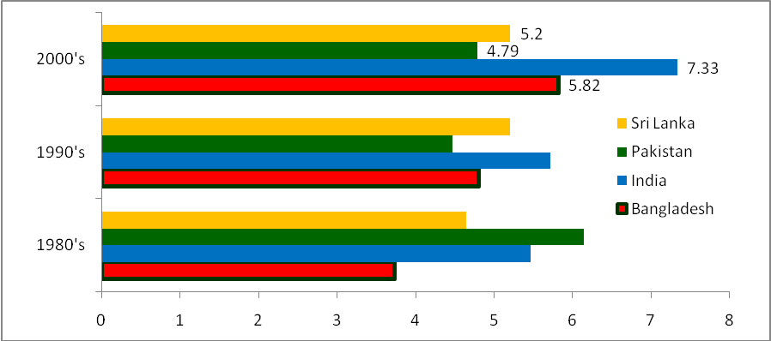
Source: Bangladesh Bureau of Statistics, State Bank of Pakistan, Reserve Bank of India and Central Bank of Sri Lanka

The structure of the economy in South Asian countries including Bangladesh has gradually been shifting from agricultural sector to industrial and services sector over the last couple of decades (Table A2.1). Average contribution of agricultural sector in GDP has declined by around 10 percentage points from 1980’s to 2000’s in India, Pakistan, and Bangladesh. Consequently services sector has emerged as the driving force of the South Asian economies in recent years. The average proportion of services sector has increased from 47 percent in 1980’s to 52 percent
Table A2.1: Trends in Sectoral Share of GDP in South Asian Countries
 | 1990-2004* | 2005-06 | 2006-07 | 2007-08 | 2008-09 | 2009-10 | 2010-11^{P}
India
Agriculture | 25.6 | 18.8 | 18.3 | 18.3 | 17.6 | 17.8 | 19.0
Industry | 20.9 | 20.2 | 20.7 | 20.5 | 19.7 | 18.8 | 18.2
Services | 53.5 | 61.0 | 61.0 | 61.2 | 62.7 | 63.5 | 62.8
Pakistan
Agriculture | 25.0 | 20.4 | 20.5 | 20.3 | 21.6 | 21.8 | 21.6
Industry | 24.7 | 26.9 | 26.9 | 26.8 | 24.3 | 23.6 | 25.3
Services | 50.4 | 52.8 | 52.6 | 52.9 | 54.2 | 54.6 | 53.1
Sri Lanka
Agriculture | 20.1 | 11.3 | 11.7 | 13.4 | 12.7 | 12.8 | 11.2
Industry | 27.1 | 30.6 | 29.9 | 29.4 | 29.7 | 29.4 | 29.3
Services | 52.7 | 58.0 | 58.4 | 57.2 | 57.6 | 57.8 | 59.5
* Average of annual data

in 2000’s in Bangladesh. However, in India the average share of services exceeds 60 percent during the last decade resulting in declines in average shares of both industrial and agricultural sectors. On the other hand industrial sector’s average share in GDP increases from 25 percent during 1990-2004 in Bangladesh to 28.6 percent in FY2011. India’s tremendous growth performance in 2000’s was propelled by a staggering average annual growth of the services sector (9 percent). Bangladesh registered a decent 6.1 percent average annual service sector

Table A2.2: Trends in Sectoral Growth Rates in Selected South Asian Economies
 | 1990-2004* | 2005-06 | 2006-07 | 2007-08 | 2008-09 | 2009-10 | 2010-11^{P}
Bangladesh
Agriculture | 3.0 | 4.9 | 4.6 | 3.2 | 4.1 | 5.2 | 5.0
Industry | 7.1 | 9.7 | 8.4 | 6.8 | 6.5 | 6.5 | 8.2
Services | 4.9 | 6.4 | 6.9 | 6.5 | 6.3 | 6.5 | 6.6
India
Agriculture | 2.7 | 5.1 | 4.2 | 5.8 | -0.1 | 0.6 | 6.6
Industry | 5.8 | 8.5 | 12.9 | 9.2 | 4.0 | 5.5 | 7.8
Services | 7.3 | 11.2 | 10.1 | 10.4 | 9.5 | 2.9 | 9.2
Pakistan
Agriculture | 3.8 | 6.3 | 4.1 | 1.0 | 4.0 | 2.0 | 1.2
Industry | 5.4 | 4.1 | 8.8 | 1.4 | -1.9 | 4.9 | 3.0
Services | 4.8 | 6.5 | 7.0 | 6.0 | 1.6 | 4.6 | 4.1
Sri Lanka
Agriculture | 1.4 | 6.3 | 3.4 | 7.5 | 3.2 | 7.0 | 1.5
Industry | 5.7 | 8.1 | 7.6 | 5.9 | 4.2 | 8.4 | 10.3
Services | 5.5 | 7.7 | 7.1 | 5.6 | 3.3 | 8.0 | 8.6
* Average of annual growth rate
Source: Bangladesh Bureau of Statistics, State Bank of Pakistan, Reserve Bank of India, and Central Bank of Sri Lanka

growth during this period which is the second highest among major South Asian economies.
Bangladesh also achieved the second highest average annual growth in industries (7.6 percent)
after India (8.6 percent) in the second half of the 2000’s; and the second highest average annual growth in agriculture (4.4 percent) after Sri Lanka (5.3 percent) during 2006 to 2010. In FY2011 Bangladesh was the only major South Asian economy other than India to achieve 5 percent or more growth in each of the three sectors of economy (Table A2.2).

Though Bangladesh has demonstrated a steady and persistent growth performance, the investment scenario in Bangladesh is weak as compared to other South Asian economies. Except Pakistan other major South Asian economies are way ahead of Bangladesh in terms of investment as percentage of GDP (figure A2.2). In FY2010 India’s investment as percentage of GDP was 36.5 percent, 11.6 percentage point higher than that of Bangladesh. Enhancing investment to the level of India will be a major macroeconomic challenge for Bangladesh in successful implementation of the SFYP.

Figure A2.2: Trends in Investment in Selected South Asian Countries
(% of GDP)
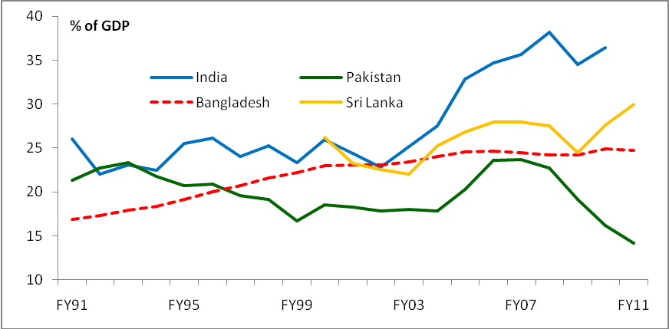
Source: Data from Central Bank and the Bureau of Statistics of respective countries

Savings is considered to be the key source of investment. Despite having savings more than that of Pakistan and Sri Lanka as percentage of GDP, Bangladesh is lagging far behind India on the savings front. While the gross domestic savings as percentage of GDP in India is more than 30 percent in FY2011, it is less than 20 percent in Bangladesh during that period (figure 2.3(a)). Similar is the case for gross national saving where Bangladesh saves around 26 percent of the GDP which is considerably lower than the Indian rate as well (figure 2.3(b)).

Figure A2.3: Trends in Saving in Selected South Asian countries
(a) gross domestic saving | (b) gross national saving
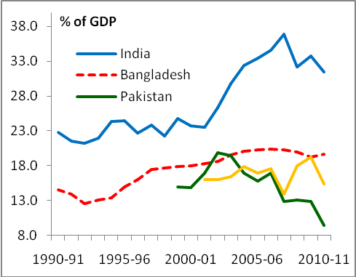 | 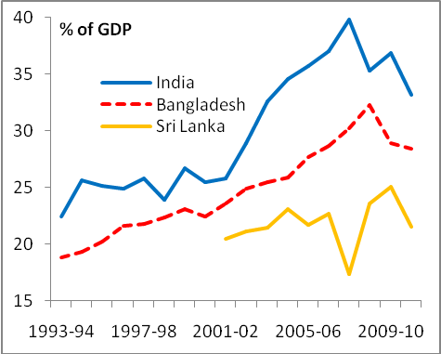
Source: Data from Central Bank and the Bureau of Statistics of respective countries, ADB database

The story of the external sector openness has been quite promising. Before 1980’s South Asia was one of the least globally integrated regions and since 1990’s trade has increased markedly in the region. The trade to GDP ratio of Bangladesh has increased from less than 20 percent in the early 1980’s to more than 50 percent in FY2011. Bangladesh’s trade openness, measured by trade to GDP ratio, is in fact the highest among the three largest South Asian economies (Figure 2.4).

Figure A2.4: Trends in Trade-to-GDP Ratio in Selected South Asian Countries
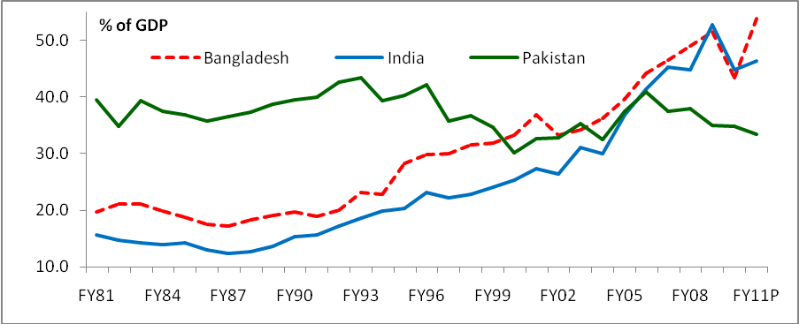
Source: Data from Central Bank and the Bureau of Statistics of respective countries

The export performance of Bangladesh as compared to other South Asian countries is quite remarkable as well. During 1990-2004 the average export of Bangladesh as percentage of GDP was merely 11 percent which has now almost doubled in the recent years (Table A2.3). In FY2011 Bangladesh’s export as percentage of GDP was 22.7 percent, which is 1.2 percentage points higher than that of India.

Table A2.3: Trends in Export and Imports in Selected South Asian Countries
(% of GDP)
 | 1990-2004* | 2004-05 | 2005-06 | 2006-07 | 2007-08 | 2008-09 | 2009-10 | 2010-11^{P}
Bangladesh
Export | 11.5 | 16.6 | 19.0 | 19.8 | 20.3 | 20.9 | 18.5 | 22.7
Import | 17.2 | 23.0 | 25.2 | 26.7 | 28.8 | 30.5 | 24.9 | 31.2
India
Export | 10.8 | 17.6 | 19.3 | 21.1 | 20.4 | 23.8 | 19.8 | 21.5
Import | 11.8 | 19.3 | 22.0 | 24.2 | 24.4 | 28.9 | 25.0 | 24.8
Pakistan
Export | 17.2 | 16.7 | 16.2 | 14.9 | 13.3 | 13.5 | 14.3 | 12.6
Import | 20.0 | 20.8 | 24.7 | 22.5 | 24.7 | 21.4 | 20.5 | 20.9
Sri Lanka
Export | - | 32.3 | 30.1 | 29.1 | 24.8 | 21.3 | 22.4 | 23.1
Import | - | 41.3 | 41.1 | 39.5 | 38.5 | 27.8 | 30.7 | 37.6
* average of annual data
Source: Data from Central Bank and the Bureau of Statistics of respective countries

The strong export performance in recent years along with remittance earning of the expatriate workers have resulted surpluses in the current account balance as well. Bangladesh is the only major South Asian economy that has achieved a positive current account balance in most of the financial years during 2000’s (Table A2.4).

Table A2.4: Trends in Current Account Balance in Selected South Asian Countries
(% of GDP)
 | Bangladesh | India | Pakistan | Sri Lanka
2000-01 | -2.3 | -0.6 | -0.7 | -
2001-02 | 0.3 | 0.7 | -1.9 | -1.4
2002-03 | 0.1 | 1.3 | -3.8 | -0.4
2003-04 | 0.6 | 2.3 | -1.3 | -3.1
2004-05 | -0.6 | -0.4 | -1.6 | -2.7
2005-06 | 1.2 | -1.2 | -4.5 | -5.3
2006-07 | 1.4 | -1.0 | -5.1 | -4.3
2007-08 | 1.0 | -1.3 | -8.5 | -9.5
2008-09 | 2.4 | -2.3 | -5.7 | -0.5
2009-10 | 3.3 | -2.8 | -2.2 | -2.9
2010-11 | 1.0 | 2.5 | - | -
Source: Data from Central Bank and the Bureau of Statistics of respective countries

The performance of the fiscal sector is quite opposite from the impressive achievements in external sector. Despite recent progress, Bangladesh’s tax to GDP ratio is the lowest among major South Asian economies (figure 25). This insipid tax effort is a prime concern of the government and immediate interventions are required to eliminate the bottlenecks of the tax system.

In terms of fiscal balance, Bangladesh appears to hold a relatively better position. Over the years, Fiscal deficit in Bangladesh has been considerably lower than that of India and Sri Lanka (figure 26). However this fiscal prudence is not matched by efficient management of public expenditure. Part of the fiscal prudence is attributable to the lack of capacity in utilizing budgetary allocations and the availability of foreign project financing. Failure to spend the allocated funds in various public development projects and the inability to mobilize foreign funding for major development projects result in lower availability of infrastructure and human development services. This is a serious concern and one of the major impediments of economic growth and development. Capacity building and mobilizing funding for major infrastructure projects are, therefore, vital for successful implementation of the SFYP.

Figure A2.5: Trends in Tax-to-GDP Ratio in Selected South Asian Countries
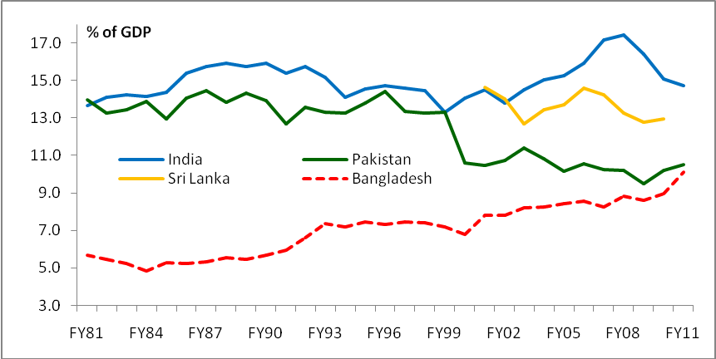
Source: Data from Ministry of Finance, Central Bank and the Bureau of Statistics of respective countries

Figure A2.6: Trends in Fiscal Deficit in selected South Asian Countries
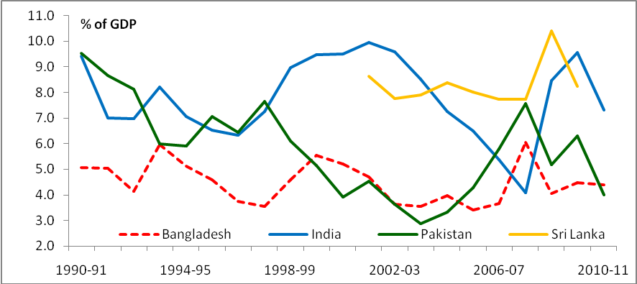
*Gross fiscal deficit for India; total expenditure less total revenue for all other countries
Source: Data from Ministry of Finance, Central Bank and the Bureau of Statistics of respective countries

Finally the outcome of the poverty alleviation endeavor is another success story of Bangladesh. Poverty has declined by 25 percentage points in Bangladesh from 1991-92 to 2010. This is the largest decline in the percentage of population living under national poverty line in South Asian countries (Table A2.4).

Table A2.5: Trends in Poverty in Selected South Asian Countries (percent of population)

(Head Count Ratios) | 1991-92 | 1995-96 | 2000 | 2005 | 2010
Bangladesh | 56.6 | 50.1 | 48.9 | 40 | 31.5
 | 1990-91 | 1995-96 | 2002 | 2006-07 | 2009-10
Sri Lanka | 26.1 | 28.8 | 22.7 | 15.2 | 8.9
 | 1992-93 | 1996-97 | 2000-01 | 2004-05 | 2005-06
Pakistan | 22.2 | 21.8 | 34.5 | 23.9 | 22.3
 | 1993-94 |  | 1999-2000 | 2004-05¹ | 2004-05²
India | 36 |  | 26.1 | 27.5 | 21.8
Source: Data from Planning Commission, Central Bank and the Bureau of Statistics of respective countries.

ANNEX 3

Relationship between GDP Growth and Employment

Data Assumptions

Since we have employment and labor force data on a three to four year interval and not on yearly basis, we need to generate yearly employment data under the following assumption –

If employment increases (decreases) by x units in n years then the increase (decrease) is evenly distributed over the n years, i.e. increment (decrement) in each of the n years is x/n.

To clarify the data generation process let’s look at the following example –

Let,
Employment in year y₁ was x₁.
Employment in year y₃ is x₃.
So, the change in employment, Δx = x₃ – x₁

Hence, according to our assumption employment in year y₂ is x₁ + Δx/2.

Model

We want to estimate the employment elasticity with respect to GDP. Hence our model is following –

ln Employment_{t} = β₀ + β₁ ln RGDP_{t} + error_{t} …………………………….. (1)

Here, the coefficient β₁ shows the elasticity of employment with respect to real GDP.

Since this is a time series model we need to check the stationary condition of the variables. We also need to perform cointegration test accordingly.

Estimation and Result

It turns out that ln employment is not stationary and ln RGDP is not trend stationary and first differences of both variables are stationary (Table 1). Hence lemployment and lrgdp are both I(1).

Table A3.1: Dickey Fuller test for unit roots
*, **, and *** indicate 10%, 5%, and 1% level of significance respectively.

Since variables are I(1) we can apply cointegration test.

From equation (1):

error_{t} = lemployment_{t} – β₀ – β₁ lrgdp_{t}

If error_{t} is stationary then the variables are cointegrated. It appears that error_{t} is stationary at 10% level of significance and hence lemployment and lrgdp are cointegrated.

Equation (1), therefore, provides the long run relationship between employment and real GDP. The estimation result of equation (1) is following –

lnEmployment_{t}^ = - 4.65 + 0.573 ln RGDP_{t} (adjusted R-squared = 0.993)
(0.1413) (0.0098)

Figure A3.1: Regression Results

Discussion

Estimation results show that if real GDP increases by 1 percent then employment increases by 0.573 percent. Based on this result we can project associated employment growth rates under different GDP growth rate scenario. For projection we assume that trend employment growth rate is 2.5 percent and additional changes occur due to GDP growth rate.

If growth rate of FY12 decreases to 6.2 percent as per ADB estimates then there will 2.51 lac less employment in FY12. Different scenarios are shown in the following table.

Table A3.2: Employment projection and less employment under different growth scenarios

Accelerating Growth and Reducing Poverty, the 6th Five Year Plan, Volume 1, the Planning Commission, Government of Bangladesh, Dhaka, December 2011.
For details on micro level system please see Ahmed and Haque, “Towards a Results-Based Monitoring and Evaluation in Bangladesh”, Report Prepared for the Planning Commission, Government of Bangladesh, Dhaka, June 2011.
For detailed discussion of the indicators and matrices see, “United Nations Development Assistance Framework for Uganda, 2010-14”, The United Nations, New York, 2009.
See Kusek, J.Z., and, Rist, R.C. 2004), “Building a Performance-Based Monitoring and Evaluation System”, Evaluation Journal of Australasia, vol 1 (new series), issue 2, pp. 14-23.
Toffolon-Weisis, M. M., Bertrand, J. T., & Terrell, S. S. (1999), The Results Framework - An Innovative Tool for Program Planning and Evaluation. Evaluation Review , 23 (3), 336-359.
In spite of several initiatives for the financial sector reforms during the past decade, opening up of the financial sectors measured in terms of (i) entry of foreign financial institutions; (ii) the emergence of private external creditors and investors; and (iii) the breadth, diversification, and competitiveness of LICs’ financial systems has been slow and shallow.
Chapter 3 provides a detailed review of the infrastructure constraint and underlying issues.
Consistent with standard accounting practice, national saving is derived as the difference between total investment less foreign current account deficit (foreign savings)
Consistent with standard accounting practice, public saving is defined as public investment minus fiscal deficit.
This much slower-than-planned export growth is still better than average growth in world exports and that in South Asia.
Development Partners (2009): Donor Coordination and Harmonisation in Bangladesh: A Joint Evaluation Paper. Dhaka: ADB, DFID, JICA, World Bank.
DAC (2010): Evaluation of the Implementation of the Paris Declaration: Phase II. PD Evaluation Secretariat.
NRP (2008): Evaluation of the Implementation of the Paris Declaration: Case Study at Country Level Bangladesh. Dhaka: Natural Resources Planners Ltd.
Nadoll, J. and N. Hussain (2008): Fragmentation and Proliferation in the Delivery of Foreign Assistance to Pakistan. Discussion Paper, Islamabad: UNDP Pakistan.
There are unresolved issues regarding the FY12 import data. The import figure based on payments recorded in BB is $1.4 billion lower than the import figure from NBR sources. The IMF has used an estimate that lies between these two figures, which is also used in this Table. Once a full reconciliation is done, the true import figure might change.
Foreign reserves were over-estimated by $0.5 billion in FY11by not taking into account overdrafts in commercial banks. Hence true reserves in FY11 stood at $10.5 billion and not $10.9 billion.
See Sadiq Ahmed (2012). “ Real Wages, Productivity, Employment and Labor Markets in Bangladesh”, Draft mimeo, Policy Research Institute Working Paper, PRI: Dhaka
It is not obvious that the real wage indicator in the RF is based on sound analytical foundations and needs to be revisited.
Preliminary estimate of BDHS 2011 shows the rate as 53 per 1000 live births.
Pakistan and Sri Lanka’s service sector grew at average annual rates of 5.3 percent and 4.9 percent respectively during the 2000’s.

